Isotopic signals (¹⁸O, ²H, ³H) of six major rivers discharging into the Arctic Ocean

Y. Yi^{1,2}, J.J. Gibson^{1,2}, L.W. Cooper³, J-F. Hélie⁴, S.J. Birks⁵, J.W. McClelland⁶,
R.M. Holmes⁷, B.J. Peterson⁸

¹ Alberta Innovates – Technology Futures, Vancouver Island Technology Park,
Victoria, BC, V8Z 7X8, Canada

² Department of Geography, University of Victoria,
Victoria, BC, V8W 3R4, Canada

³Chesapeake Biological Laboratory, University of Maryland
Center for Environmental Sciences, Solomons, MD, 20688, USA

⁴Centre GEOTOP-UQAM-McGill,
Montréal, QC, H2X 3Y7, Canada

⁵Alberta Innovates – Technology Futures
Calgary, AB, T2L 2A6, Canada

⁶Marine Science Institute, University of Texas at Austin,
Port Aransas, TX, 78373, USA

⁷Woods Hole Research Center,
Falmouth, MA, 02540, USA

⁸The Ecosystem Center, Marine Biological Laboratory,
Woods Hole, MA, 02543 USA

Draft#5 Nov-8-2010
In preparation for Global Biogeochemical Cycles

Corresponding author:
Yi Yi, PhD
Alberta Innovates – Technology Futures
Vancouver Island Technology Park
3-4476 Markham St.
Victoria, BC, V8Z 7X8 Canada

Tel: 250 483 3291
Fax: 250 483 1989
Email: yiyi@uvic.ca

We present the results of a 4-year collaborative sampling program that measured δ¹⁸O, δ²H and ³H concentrations in the six largest Arctic rivers (the Ob, Yenisey, Lena, Kolyma, Yukon and Mackenzie). These new data improve our understanding of the mechanisms controlling flow-weighted δ¹⁸O values previously reported at each river mouth. The correlations between δ¹⁸O and δ²H provide insights useful for identifying water sources, mixing and evaporation losses in these Arctic basin rivers. For example, an inverse correlation between the slope of the δ¹⁸O-δ²H relation and wetland extent indicates that wetlands play comparatively more important roles affecting evaporation losses in the Yukon and Mackenzie basins. Estimates of tritium areal yields and seasonal variations suggest that a tritium-rich water resource is a relatively important component during low flow in the Lena and Yenisey basins.. This Pan-Arctic survey of isotope-discharge relationships has revealed both linear and non-linear isotope responses to hydrological variations and suggest future detailed studies to evaluate on-going changes in the Arctic hydrologic system.

- Introduction
Dramatic changes have been observed in the Arctic Ocean hydrological cycle over the last century. Many of these observations involve the storage and cycling of fresh water including increased precipitation and river discharge, melting of ice stacks on land and sea, and steric sea level changes in the Arctic Ocean (Lewis et al., 2000; Peterson et al., 2002; Scharroo et al., 2006; Steele and Ermold, 2007). These observed changes may have profound consequences on the global oceanic circulation and climate system. For example, a significant change in water column structure in the Arctic Ocean can impact the formation of North Atlantic Deep Water and consequently influence the transport and distribution of heat over the entire northern hemisphere (Aagaard and Carmack, 1989; Rahmstorf, 1995; Peterson et al., 2002; Clark et al., 2002). Because there are multiple sources of freshwater inputs that sustain stratification of the Arctic Ocean, including river discharge, sea-ice meltwater, low-salinity Pacific water imported through the Bering Strait and in-situ precipitation, it is important, but challenging, to distinguish and assess the transport and dynamics of individual freshwater components in the Arctic watershed (Carmack, 2000; Serreze et al., 2006).

Water isotopes (mainly δ¹⁸O) have been widely used as tracers to identify and quantify freshwater components to separate water mass contribution and movement in the Arctic Ocean (e.g. Schlosser et al., 2000). The first comprehensive stable isotope investigation of the Arctic Ocean was made by Friedman et al. (1961) as part of global surveys of water isotope compositions in natural waters. Seminal work by Östlund and Hut (1984) subsequently demonstrated that δ¹⁸O end-member analysis can be used to separate meteoric water (including runoff) from the sea ice meltwater. The method was successfully used in the Canada Basin (Macdonald et al., 1995; Melling and Moore, 1995), the Eurasian Basin (Bauch et al., 1995) and across basins in the Arctic Ocean as a whole (Ekwurzel et al., 2001). Interestingly, these studies used varying δ¹⁸O values for the river runoff end-member. For example, Östlund and Hut (1984) used -21.0‰ for continental runoff based on the Global Network of Isotopes in Precipitation (GNIP). This value was subsequently used by Melling and Moore (1995) and Bauch et al. (1995). However, Ekwurzel et al. (2001) estimated the overall Arctic basin river end-member composition to be -18.0‰, based upon new river data from the Ob and Yenisey while Macdonald et al. (1995) used values of -20.3‰ and -18.3‰ to differentiate summer and winter signatures of Mackenzie River water. This more recent differentiation reflects an appreciation that there are temporal and spatial variations in the stable isotope composition of continental runoff and that there is a need for better constraints on these estimations.

A large dataset documenting δ¹⁸O values of seawater in the Arctic Ocean has become available due to collective efforts within the oceanographic research community (Biggs and Rohling, 2000; LeGrande and Schmidt, 2006). At the same time, interdisciplinary approaches to using multiple tracers in large scale hydrological investigations are making it possible to achieve differentiation of the contributions from multiple components of continental runoff (e.g. Guay et al., 2009). Nevertheless, current estimates of isotopic end-members in these multi-tracer studies are often dependent upon a small number of snapshot measurements, without a systematic consideration of temporal variability. When considering the inputs from high-latitude watersheds, integrating tracer concentrations during the spring freshet (high flow) and under winter ice (low flow) are critical for correctly labeling the fluxes of water, but these are also periods when it is challenging to obtain samples. The Pan-Arctic River Transport of Nutrients, Organic Matter and Suspended Sediments (PARTNERS) project was undertaken between 2003 and 2006 to address this shortage of high temporal resolution data for tracer concentrations in the six largest Arctic rivers by a series of coordinated sampling campaigns (McClelland et al., 2008).

Flow-weighted estimates of several runoff constituents (δ¹⁸O, DOC, Ba and alkalinity) for the PARTNERS project have been reported by Cooper et al (2008). Here, we report additional new data on water isotope tracers, including δ¹⁸O, δ²H and ³H, which offers new insights on the origin of the isotopic signals and isotopic responses to hydrologic variability in the six largest river basins flowing to the Arctic Ocean.

- Sampling and Isotopic Analysis
Sampling conducted during the PARTNERS project included river water samples collected near the mouth, but above most tidal influence, thus integrating the overall isotopic content of runoff. These stations located at Salekhard (Ob River), Dudinka (Yenisey River), Zhigansk (Lena River), Cherskii (Kolyma River), Tsiigehthchic (Mackenzie River) and Pilot Station (Yukon). Daily discharge for each river was measured by United States Geological Survey (USGS, Yukon), Water Survey of Canada (Mackenzie) and Russian Federal Service of Hydrometeorology and Environmental Monitoring (Ob, Yenisey, Lena and Kolyma). It should be noted that permanent gauges are not available for river stations located at Dudinka (Yenisey), Zhigansk (Lena) and Cherskii (Kolyma), so discharge from nearby gauged sites (i.e., Igarka for Yenisey, Kyusyur for Lena and Kolymskoye for Kolyma) are used in this paper.

Rivers were sampled in all seasons between 2003 and 2006, in order to facilitate collecting representative water samples under various flow regimes. Sampling included low-flows in winter, high-flows during the spring freshet declining flow regimes during summer and fall. Sampling protocols followed United States Geological Survey (USGS guidelines to obtain flow-weighted, depth-integrated samples at each river channel transect. More details are provided in McClelland et al. (2008) and Cooper et al. (2008).

During the open-water season, five sampling locations at every transect were chosen for the deployment of depth integrating samplers (US D-96). The five depth-integrated samples across the river channel were then mixed in a churn to yield a single composite water sample representative of the river, and the composite sample was submitted for laboratory analyses. For all rivers but the Yukon, the five sampling locations were chosen at equal intervals across the river channel, and the transit rate of the sampler through the water column was adjusted to be constant during the sampling moment (Equal Width Increment method according to USGS terminology). This sampling method results in fairly large volume (3 L) sample from deep locations or in fast currents, but considerable small volume samples from shallow locations or in slow currents. In the case of the Yukon River, the channel transect was divided into five sections, each of which accounts for 20% of the total discharge (Equal Discharge Increment method according to USGS terminology). In the deployment of US D-96, the sampler transit rate was adjusted such that a 3L sample was collected at each location.

The sampling during ice-covered season differed from the open-water season sampling, in that only one location in the middle of each river channel was drilled to collect near-surface water samples. The elaborate depth-integrated sampling strategy employed during the open water season was designed to accurately quantify suspended sediment flux. The uneven distribution of sediment through the water column made this approach necessary. However, comparison of preliminary geochemical and isotopic results between two sampling methods indicated that there were no significant differences between near-surface and depth-integrated samples for geochemistry (Raymond et al., 2007). As a result, near-surface samples obtained during ice-covered season are considered representative as those depth-integrated ones obtained during open water season, although extra cautions may be applied.

Isotopic analyses of water samples, including δ¹⁸O, δ²H and ³H concentration, were conducted at the University of Waterloo – Environmental Isotope Laboratory. δ²H in water was determined on a CF-IRMS system, by reduction of water to H₂ gas using chromium metal as active reducing agent (Morrison et al., 2001); δ¹⁸O in water was measured on a dual-inlet VG-Micromass 903 mass spectrometer via the CO₂ equilibration method (Epstein and Mayeda, 1953). Results are reported as δ values (‰) relative to the international reference V-SMOW (Coplen, 1996). Analytical uncertainties are ±0.05‰ for δ¹⁸O and ±0.3‰ for δ²H. Water samples for ³H analysis were subjected to electrolytic enrichment and then analyzed by liquid scintillation counting (Thatcher et al., 1977). Results are reported in TU (Tritium Units; 1TU = 1 tritium atom / 10¹⁸ hydrogen atoms, which is equivalent to 0.118 Bq/L. Typical analytical uncertainties are ~ ±3%.

- Results
Seasonal ranges in δ¹⁸O and δ²H values in the six rivers are shown in Figure 2a. Updated flux-weighted δ¹⁸O and δ²H values (Table 1) were also estimated using the method of Cooper et al. (2008). The Ob in general contributes the most heavy-isotope enriched freshwater to the Arctic Ocean (-15.42 ‰ for δ¹⁸O and -117.3 ‰ for δ²H), while the Kolyma river provides the least (-22.38 ‰ for δ¹⁸O and -173.2 ‰ for δ²H). The other four rivers contribute freshwaters with intermediate isotopic signals.

As expected, δ¹⁸O values are highly correlated with δ²H values, but δ¹⁸O-δ²H correlations are in some cases river specific and distinct (Figure 2a and Table 1).

The variability of isotopic signals in the six large Arctic rivers over the 4-year program is summarized in Table 1. The Ob varied between -13.36‰ and -16.82‰ in δ¹⁸O (between -100.8‰ and -126.4‰ in δ²H), whereas Kolyma varied from -20.64‰ to -23.91‰ in δ¹⁸O (from -161.0‰ to -184.8‰ in δ²H). In δ¹⁸O-δ²H space (Figure 2a), the Ob has the most enriched isotopic distributions, while Lena and Kolyma have the most depleted isotopic signals. Looking at the Eurasia basins, the Ob and Kolyma Rivers are offset from the Global Meteoric Water Line (GMWL), while the Yenisey and Lena Rivers vary along the GMWL in δ¹⁸O-δ²H space. The isotopic labeling of the Eurasian river basins show a general west-to-east decrease in the δ¹⁸O and δ²H values in river discharge, confirming the observations by Ekwurzel (1998). In contrast, samples from the North American rivers (Yukon and Mackenzie) show conspicuous deviations from the GMWL (Figure 2a). The slope of the δ¹⁸O-δ²H correlations among basins appear to be associated with land cover characteristics. For example, river basins with with the highest percentages of wetland cover tended to have the lowest slopes (m) in the equation δ¹⁸O=mδ²H + d and these isotopic correlations also deviated the most from the GMWL (Figure 2b). (Wetland land cover was obtained from the Water Resources Institute eAtlas; Revenga et al., 1998; UNEP-WCMC, 1998).

Variations in these slopes in the equation δ¹⁸O=mδ²H + d are diagnostic of the greater importance of evaporative enrichment of heavy isotopes that occurs in wetlands as the surface area available for evaporation is expanded.

The d-excess, a derived parameter based on measurements of both δ¹⁸O and δ²H (d=δ²H-8×δ¹⁸O), can be used as an index of the degree of evaporative enrichment of a water sample with lower d-excess corresponding to a higher degree of evaporative enrichment in the hydrographic history of a water parcel (give some references; Figure 2a). The sample with the lowest d-excess value in the entire dataset was from the Mackenzie River (-3.5 ‰ ), while the sample with the highest d-excess value was from the Yenisey River (11.4 ‰ ). From highest mean d-excess to lowest, the order of the rivers is: Yenisey (8.2 ‰), Lena (7.2 ‰), Ob (5.8 ‰) and Kolyma (5.7 ‰), Yukon (3.5 ‰) and Mackenzie (-0.7 ‰). The significantly lower d-excess values determined for the two North American rivers suggest a higher importance for evaporation in these two basins.

For tritium (³H), the statistical distribution of the data (Table 1, Figure 3a) allow for several generalizations to be made among river basins. The highest ³H concentration (34.9 TU) was measured in the Lena River, and the lowest ³H concentration (3.0 TU) was observed in the Yukon River. The Ob, Mackenzie, Kolyma and Yukon Rivers demonstrated a high degree of kurtosis (i.e. a distinct peak near the mean value) in the distribution of tritium concentrations, whereas the Lena and Yenisey Rivers demonstrated low kurtosis in their data distribution. Fourré et al. (2006) estimated recent natural background concentrations of tritium in precipitation in the high-latitude northern hemisphere to be between 10 and 20 TU. Based upon this estimate, 4 of the 6 rivers (Yenisey, Ob, Mackenzie and Kolyma) are well within the background range. The Lena River had anomalously high ³H concentrations, while the Yukon River had anomalously low ³H concentrations (Figure 3a).

The mass flux of tritium through each Arctic basin studied was estimated using the tritium concentrations and specific discharges for each river. Flux weighting the mean concentration of ³H in the rivers results in an estimated contribution of ~11.91 g/year of tritium from the six rivers to the Arctic Ocean (Table 1). Estimates for the ³H mass contributions from individual basin (ranging from 0.56 g to 4.14 g) are comparable to those from Mississippi River, which is on the order of 1-2 g per year (Michel, 2004). The tritium fluxes from different basins can be more readily compared by scaling the mass flux to the size of the river basin (mass flux per contributing area) (Table 1). The Lena and Yenisey drainage basins for example, have high tritium areal yields, 1.663×10⁻⁶ and 1.189×10⁻⁶ g/km² respectively, whereas the other four drainage basins have relatively low (~0.7×10⁻⁶ g/km²) tritium areal yields. A close examination of the seasonal variation in areal yields demonstrates significant seasonal variation (Figure 3b). For high areal yield river basins (i.e., Lena and Yenisey), the tritium flux during the low flow season (i.e. winter months) is significantly higher (~25%) than those in the high flow season (i.e. freshet period). In contrast, there is no significant difference between seasons for low areal yields river basins (Ob, Kolyma, Mackenzie and Yukon).

- Discussions
Tritium, with a half-life of 12.43 years, was introduced into the atmosphere by thermonuclear weapons testing in the 1950s and 60s, and has been a valuable diagnostic tracer of circulation and exchange processes in world oceans (Dorsey and Peterson, 1976; Östlund, 1994; Frank et la., 1998). Unfortunately, the thermonuclear input function is poorly constrained for the Arctic region (England and Maier-Reimer, 2001). First-hand records of tritium concentration in precipitation and freshwater components are sparse. This is the first study that systematically reports the contemporary flux-weighted tritium concentrations and areal yields in Pan-Arctic drainage basins. The results reveal a pattern of tritium distribution and underlying differences in hydrological processes among the six largest Arctic watersheds.

In a snowmelt-driven hydrological regime, river discharge is typically generated from contemporary precipitation (i.e., snowmelt during freshet and rainfall during summer). In this type of hydrological setting expected river tritium concentrations should fall within the range found in modern precipitation, as was the case for the Ob, Kolyma and Mackenzie basins (Figure 3a). Similar ³H areal yields (Table 1) and the lack of seasonality in the ³H areal yields (Figure 3b) in these basins also support control by similar hydrological processes. The tritium concentrations measured in the Yukon River are lower than in modern precipitation and consistent with other longer term tritium measurements (Robert Michel, USGS, pers. comm). It is reasonable to expect that this is due to dilution by tritium-free glacial meltwater in the Yukon basin, which is a much less important component of the other rivers studied. Higher concentrations and areal yields in the mid-continental Eurasian basins (Lena and Yenisey) are consistent with previous observations that mid-continental locations (despite draining northward into the Arctic) have higher concentrations of tritium in precipitation and subsequently in river discharges (Vakulovskii et al., 1978; Michel, 2004). Seasonal enrichment of tritium during low flow (Figure 3b) suggests that tritium-rich (post-1950s origin) groundwater or permafrost meltwater may form a significant component of flow in these basins. On the other hand, muted seasonality in the other four rivers indicates that permafrost thaw is less important, or the variations are buffered by wetlands which tend to blend early and late season differences.

The potential role of permafrost thaw in the Lena and Yenisey River basins is noteworthy, given that permafrost accounts for approximately 78%-93% of the Lena River basin, and 36%-55% of the Yenisey River basin (Brown et al., 1998; Serreze et al., 2002). The Lena and Yenisey basins also have proportionally the lowest extent of wetlands relative to river basin size (Figure 2b). Recent increases in streamflow during winter months have been reported for the Lena and Yenisey Rivers (Serreze et al., 2002). This may be due to thawing/releasing of excess ground ice and the contribution of subsurface flow due to increasing thickness of the active layer (Yang et al., 2002; Ye et al., 2004). A recent review of the impacts of permafrost degradation on Arctic river biogeochemistry also emphasizes the potential shift from a surface water-dominated system to a groundwater-dominated system in the Pan-Arctic region (Frey and McClelland, 2009). Our observation of high tritium flux (i.e. mass contribution and areal yields) during low flow in the Lena and Yenisey may be a consequence of permafrost degradation, because ground-ice and groundwater are likely to be high in tritium concentration (Burn and Michel, 1988). More importantly, our results highlight differences in hydrological processes between the Lena/Yenisey and other rivers. These results suggest tritium may be a useful tool to identify and potentially quantify the contribution of degrading permafrost to the Yenisey and Lena River basins, as the permafrost, an effective recharge barrier, continues to decay (Smith et al., 2007).

Table 1 reports a summary of the flow-weighted values of δ¹⁸O and δ²H, representing integrated isotopic signals in continental discharges from individual rivers. The flow-weighted values of δ¹⁸O for the 6 rivers (Table 1) differs slightly from the values reported by Cooper et al.(2008) (differences range from 0.18‰ for the Kolyma River, to 1.37‰ for the Yenisey River), due to new data. In addition to the flow-weighted values of δ¹⁸O, we also estimate the flow-weighted δ²H values, which have not previously been reported. Combining the δ²H and δ¹⁸O signals provides insight into the significance of evaporation losses, identifiable in δ²H-δ¹⁸O space by an offset from the GMWL and measureable by the slope and d-excess. North American river basins show significantly lower d-excess values than Eurasian rivers (Figure 2a). The negative correlation between the δ¹⁸O-δ²H slopes for each basin and the areal coverage of wetlands (Figure 2b) further suggests wetlands play an important role in the water balance of these basins. In general, the extent of wetlands in the two North American watersheds (27.8% for the Yukon and 48.9% for the Mackenzie) is greater than those in Eurasia (0.6 to 11.2%) (Revenga et al., 1998; UNEP-WCMC, 1998). These results suggest that different factors need to be considered for monitoring hydrological change in Pan-Arctic watersheds. Changes in groundwater storage and degradation of permafrost appear to be relevant for the Lena and Yenisey River basins, whereas changes in wetland hydrology and input from glaciers may be important parameters for the Makenzie and Yukon River basins.

In addition to the indication of evaporation by dual isotopes, δ²H results can also serve as a conservative tracer independent of δ¹⁸O. Efforts to refine our understanding of the fate and transport of continental runoff into the Arctic Ocean require multiple independent tracers to match the number of unknowns when solve mass balance equations (Schlosser et al., 2000). The flow-weighted δ²H values reported in this paper are expected to provide end-member references for future application of δ²H in multi-tracer investigations.

The discharge and isotopic data from each river were used to examine the temporal response of stable water isotope signals to hydrological variations. The overall PARTNERS dataset shows an inverse relation between δ¹⁸O values and specific discharge (Q). In general, as Q increases the δ¹⁸O values of runoff tend to decrease (Figure 4a). However, a close examination of individual rivers suggests that there are significant differences in response patterns among watersheds. For example, the isotopic variation in discharge in the Yenisey (Figure 4b) is dissimilar to the Ob (Figure 4c). Alternatively, we use discharge anomaly (ΔQ) to facilitate the cross-watershed comparisons (Figure4 d-f) (Yi et al., 2010).

Normalizing the discharge data to produce ΔQ, an index of discharge intensity faciliates comparisons among watersheds. A general trend of decreasing δ¹⁸O with increasing flow intensity (i.e., ΔQ) is evident in Figure 4d. More importantly, two types of δ¹⁸O-ΔQ relation can be described. Isotopic variation in the Yenisey, Kolyma, Mackenzie and Yukon responds to discharge intensities in a linear fashion (Figure 4e). The correlation coefficients of liner regressions are usually high, indicating strong linear patterns in these watersheds. On the other hand, isotopic variation in the Ob and Lena are decidedly non-linear (Figure 4f). A quadratic fitting yields a significant correlation coefficient (R²=0.8757) for the Ob River.

An inverse correlation between δ¹⁸O and ΔQ is expected in snowmelt-driven systems where high flows are associated with melting of the isotope-depleted snowpack, and low flows are fed by groundwater that tends to be more heavy isotope-enriched (reference?). The strong linear correlations demonstrated in Figure 4e suggest that isotopic variation in four of the river basins (i.e., Yenisey, Kolyma, Yukon and Mackenzie) are dominated by snowmelt-driven runoff. Slopes of least-squared regressions are higher for the Eurasian rivers than for the North American rivers, indicating a more rapid freshet response in the Yenisey and Kolyma. The linear pattern in the Yenisey (Figure 4e) is mainly due to two clusters of data: one in the range of normal flow intensity (ΔQ~0) and the other in the range of extreme-high flow intensity (ΔQ>2). There are only two samples not included in the two clusters. The isotopic variability during the period of normal flow intensity is also much larger in the Yenisey River than in the other three rivers. Moreover, the Yenisey was also atypical in that tritium areal yield was greater than the range predicted by discharge of modern precipitation, and included strong seasonal differences. If the Yenisey can be sampled more frequently during normal to high flow transitions (better representing the complete spectrum of flow intensities), it is possible that a more complicated δ¹⁸O-ΔQ response maybe observed.

δ¹⁸O variability in response to hydrological variations for the Lena and Ob Rivers is not as would be expected for river basins more heavily influenced by snowmelt (Fig 4f). Instead of a gradual decrease in δ¹⁸O values as flow intensity increases, the Lena δ¹⁸O data demonstrate abrupt shifts between high and low flows without any apparent transition. The Ob, in contrast, can be explained by a quadratic formulation (R²=0.8757) similar to what was observed for the Liard River, a mountain-wetland transitional basin situated within the Mackenzie Basin (Yi et al. 2010). In the Liard River, lowest flows are likely fed by groundwater, whereas normal flows (ΔQ ~0) are fed by mixtures of groundwater, precipitation and surface water that is typically enriched in δ¹⁸O. This may explain the initial increase in δ¹⁸O values in both the Ob and Lena basins as ΔQ increases from -1 to 0. The quadratic overturn in the δ¹⁸O-ΔQ relationship for the Ob was probably driven by proportional increase in snowmelt contribution. At extremely high flow conditions (ΔQ≥2), the Lena basin discharge had consistent, very low δ¹⁸O values (~-23.20‰), which is different from the Liard river, while no data were available for the Ob basin. It is also worth noting that the two rivers (the Lena and Yenisey Rivers) that had elevated tritium concentrations in the low-flow discharge are significantly different in their δ¹⁸O-ΔQ response. This suggests a possible distinction between the two basins. In the Yenisey basin, the linear response may be a result of flushing of the active layer with snowmelt as the dominant process. In contrast, the non-linear response of the Lena basin suggests that the release of ground-ice through the active layer can be important, because ground-ices are likely to have a small range of isotopic variability (reference?). The contrast between the two types of basins will be related to the strength of snowmelt and degree of connection to surface/subsurface water sources.

Conclusions: Flow-weighted isotopic signatures (δ¹⁸O, δ²H and ³H), as well as river specific δ¹⁸O-δ²H correlations, provide a useful reference for understanding the continental discharge of individual rivers to the Arctic Ocean. River-specific slopes of the δ¹⁸O-δ²H relation are inversely correlated with areal coverage of wetlands within each drainage basin, suggesting that wetlands could play an important role in controlling evaporative losses, particularly for the Yukon and Mackenzie basins. The Lena and Yenisey have comparatively high ³H concentrations and high ³H areal yields, possibly explained by inputs of tritium-rich groundwater or degrading permafrost. Finally, we also observed two types of isotopic variability in response to hydrological variations for the six Pan-Arctic basins, one was linear, and the other was non-linear in relation to discharge. These different types of responses highlight the variability and complexity of hydrological processes in Arctic drainage basins. These results indicate that hydrological change is not driven by a single factor (e.g snowmelt), and that identifying and monitoring hydrological change will require a drainage-basin specific approach. Our results suggest that the Lena and Yenisey basins may require detailed isotopic investigations targeting groundwater and permafrost impact to capture important hydrological changes in these basins. In contrast, monitoring hydrological change in the Yukon and Mackenzie basins could profit from attention to the role of wetlands and numerous basin lakes that apparently influence watershed-wide water balance budgets.

Acknowledgement: We thank the PARTNERS team for the field efforts that made this valuable dataset available. We are also grateful to the Environmental Isotope Laboratory – University of Waterloo for undertaking the stable water isotope and tritium analysis of water samples. Funding for this research was provided by the U.S. National Science Foundation (OPP-0229302), the National Science and Engineering Research Council of Canada (Discovery grant to JJG), the U.S. Geological Survey and the Water Resources Division in the Department of Indian Affairs and Northern Development, Canada.

Figure Captions:

Figure 1: Circumpolar map of the six river basins sampled in this study. Outlines of the boundary of each watershed are illustrated by black solid lines. Sampling locations are indicated by red circles. The solid red line delineates the contiguous southern boundary of the area contributing freshwater into the Arctic Ocean.

Figure 2:¹⁸O and ²H signals in river discharge. a) δ¹⁸O-δ²H space. Results from six rivers are plotted in different colors and shapes as indicated in the legend. The solid grey line represents the Global Meteoric Water Line (GMWL). Three dashed lines are examples of river-specific δ¹⁸O-δ²H correlations, which are distinctive among rivers (Table 1). From the blue to black and dark brown, the three lines are indicative of Ob, Lena and Kolyma rivers. The inset in top-left corner is the box-whisker plot of d-excess distribution, calculated from every pair of δ¹⁸O and δ²H measurements. The dash line indicates the reference value of 10 from GMWL. b) The relation between wetland percentage coverage in river basins and the slope of δ¹⁸O-δ²H correlation. River basins are indicated by the text in the plot.

Figure 3: ³H signals in river discharge. a) the box-whisker plot of tritium concentration measured in each river. b) the estimated areal yields from individual river basins. The estimations are presented in two seasons, freshet season (black bar) from May to June, and low flow season (white bar) between July and December pulsing the period from January and March in the following year.

Figure 4: Isotopic variation-discharge relations. This figure presents a series of plots on δ¹⁸O values vs. discharge in the six river basins. Since δ²H signals linearly correlate with δ¹⁸O values in a river-specific fashion, a similar relation using δ²H is available (data not shown). The left column of the figure is based on δ¹⁸O vs. specific discharge (Q): a) is the composite plot that do not distinguish datum from individual rivers; b) and c) are the river-specific plot that annotate results from individual rivers as indicated by the legend. The right column of the figure is based on δ¹⁸O vs. discharge anomaly (ΔQ): d) is the composite plot that do not distinguish datum from individual rivers; e) and f) are the river-specific plot that annotate results from individual rivers. ΔQ is a normalized measurement of specific discharges in relative to the mean and standard deviation (Yi et al. 2010). It is an indicator of flow intensity.
Reference
Aagaard, K., and E.C. Carmack (1989), The role of sea ice and other fresh water in the arctic circulation, Journal of Geophysical Research, 94, 14485-14498.

Bauch, D., P. Schlosser, and R. G. Fairbanks (1995), Freshwater balance and the sources of deep and bottom waters in the Arctic Ocean inferred from the distribution of H₂¹⁸O, Progress in Oceanography, 35, 53-80.

Biggs, G.R., and E. J. Rohling (2000), An oxygen isotope data set for marine waters, Journal of Geophysical Research – Ocean, 105, 8527-8535.

Brown, J., O. J. Ferrians Jr., J. A. Heginbottom, and E. A. Melnikov (1998), Circum-Arctic map of permafrost and ground-ice conditions. National Snow and Ice Data Center/World Data Center for Glaciology, Boulder, CO, Digital Media. [Available online at http://nsidc.org/data/ggd318.html.]

Burn, C.R., and F.A. Michel (1988), Evidence for recent temperature-induced water migration into permafrost from the tritium content of ground ice near Mayo, Yukon Territory, Canada, Canadian Journal of Earth Sciences, 25, 909-915.

Carmack, E. C. (2000), The Arctic Ocean’s freshwater budget: sources, storage and export. pp 91-126 in E.L. Lewis, editor. The freshwater budget of the Arctic Ocean. Kluwer Academic Publishers, Dordrecht.

Clark, P.U., U. G. Pisias, T.F. Stocker, and A.J. Weaver (2002), The role of the thermohaline circulation in abrupt climate change, Nature, 415, 863-869.

Cooper, L.W., J.W. McClelland, R.M. Holmes, P.A. Raymond, J.J. Gibson, C.K. Guay, and B.J. Peterson (2008), Flow-weighted values of runoff tracers (δ¹⁸O, DOC, Ba, alkalinity) from the six largest Arctic rivers, Geophysical Research Letters, 35, doi:10.1029/2008GL035007.

Coplen, T.B. (1996), New guidelines for reporting stable hydrogen, carbon, and oxygen isotope-ratio data, Geochimica et Cosmochimica Acta, 60, 3359-3360.

Dorsey, H. G., and W. H. Peterson (1976), Tritium in Arctic Ocean and East Greenland Current, Earth and Planetary Science Letters, 32, 342-350.

Ekwurzel, B. (1998), Arctic Ocean water mass circulation and ventilation ages derived from tritium, helium and oxygen-18 tracers. PhD Thesis, Columbia University, New York.

Ekwurzel, B., P. Schlosser, R. A. Mortlock, R. G. Fairbanks, and J. H. Swift (2001), River runoff, sea ice meltwater, and Pacific water distribution and mean residence times in the Arctic Ocean, Journal of Geophysical Research-Oceans, 106, 9075-9092.

England, M. H., and E. Maier-Reimer (2001), Using chemical tracers to assess ocean models, Reviews of Geophysics, 39, 29-70.

Epstein, S., and T. Mayeda (1953), Variation of 18O content of water from natural sources, Geochimica et Cosmochimica Acta, 42, 213-224.

Fourré, E., P. Jean-Baptiste, A. Dapoigny, D. Baumier, J.R. Petit, and J. Jouzel (2006), Past and recent tritium levels in Arctic and Antarctic polar caps, Earth and Planetary Science Letters, 245, 56-64.

Frank, M., W.M. Smethie, R. Bayer (1998), Investigation of subsurface water flow along the continental margin of the Eurasian Basin using the transient tracers tritium, He-3, and CFCs, Journal of Geophysical Research – Oceans, 103, 30773-30792.

Frey, K. E., and J. W. McClelland (2009), Impacts of permafrost degradation on arctic river biogeochemistry, Hydrological Processes, 23, 169-182.

Friedman, I., B. Schoen, and J. Harris (1961), The deuterium concentration in Arctic sea ice, Journal of Geophysical Research, 66, 1861-1864.

Gibson, J.J., and B. Reid (2009), Stable isotope fingerprint of open-water evaporation losses and effective drainage area fluctuations in a subarctic Shield watershed, Journal of Hydrology, 381, 142-150.

Guay, C.K.H., F.A. McLaughlin, and M. Yamamoto-kawai (2009), Differentiating fluvial components of upper Canada Basin waters on the basis of measurements of dissolved barium combined with other physical and chemical tracers, Journal of Geophysical Research-Oceans, 114.page numbers?

LeGrande, A.N., and G.A. Schmidt (2006), Global gridded data set of the oxygen isotopic composition in seawater, Geophysical Research Letters, 33. Page numbers?

Lewis, E.L., E.P. Jones, P. Lemke, T.D. Prowse, and P. Wadhams (2000), The freshwater budget of the Arctic Ocean, Kluwer Academic Publishers, Dordrecht. Pp. 1-623.

Macdonald, R.W., D.W. Paton, E.C. Carmack, and A. Omstedt (1995), The freshwater budget and under-ice spreading of Mackenzie River water in the Canadian Beaufort Sea based on salinity and 18O/16O measurements in water and ice, Journal of Geophysical Research, 100, 895-919.

McClelland, J.W., R.M. Holmes, B.J. Peterson, R. Amon, T. Brabets, L. Cooper, J.J. Gibson, V.V. Gordeev, C. Guay, D. Milburn, R. Staples, P.A. Raymond, I. Shiklomanov, R. Striegl, A. Zhulidov, T. Gurtovaya, and S. Zimov (2008) Development of Pan-Arctic database for river chemistry, Eos, 89, 217-218. Transactions AGU

Melling, H., and R.M. Moore (1995), Modification of halocline source waters during freezing on the Beaufort Sea Shelf: evidence from oxygen isotopes and dissolved nutrients, Continental Shelf Research, 15, 89-113.

Michel, R. L. (2004), Tritium hydrology of the Mississippi River basin, Hydrological Processes, 18, 1255-1269.

Morrison, J., T. Brockwell, T. Merren, F. Fourel, and A.M. Philips (2001), On-line high precision stable hydrogen isotopic analyses on nanoliter water samples, Analytical Chemistry, 73, 3570-3575.

Östlund, H. G., and G. Hut (1984), Arctic Ocean water mass balance from isotope data, Journal of Geophysical Research, 89, 6373-6381.

Östlund, G. (1994), Isotope Tracing of Siberian River Water in the Arctic-Ocean, Journal of Environmental Radioactivity, 25, 57-63.

Peterson, B.J., R.M. Holmes, J.W. McClelland, C.J. Vorosmarty, R.B. Lammers, A.I. Shiklomanov, and S. Rahmstorf (2002), Increasing river discharge to the Arctic Ocean, Science, 298, 2171-2173.

Rahmstorf, S. (1995), Bifurcations of the Atlantic thermohaline circulation in response to changes in the hydrological cycle, Nature, 378, 145-149.

Raymond, P.A., J.M. McClelland, R.M. Holmes, A.V. Zhulidov, K. Mull, B.J. Peterson, R.G. Striegl, G.R. Aiken, and T.Y. Gurtovaya (2007), Flux and age of dissolved organic carbon exported to the Arctic Ocean: A carbon isotopic study of the five largest arctic rivers, Global Biogeochemical Cycles, 21, doi:10.1029/2007GB002934.

Revenga, C., S. Murray, J. Abramovitz, and A. Hammond (1998), Watersheds of the World: Ecological Value and Vulnerability, Washington, DC: World Resources Institute.

Scharroo, R., A. L. Ridout, and S.W. Laxon (2006), Arctic sea level change from satellite altimetry, Eos Trans. AGU, 87(36), Jt. Assem. Suppl., Abstract G21A-02.

Schlosser, P., B. Ekwurzel, S. Khatiwala, B. Newton, W. Maslowski, and S. Pfirman (2000), Tracer studies of the arctic freshwater budget. pp 453-478 in E.L. Lewis, editor. The freshwater budget of the Arctic Ocean, Kluwer Academic Publishers, Dordrecht.

Serreze, M.C., D.H. Bromwich, M.P. Clark, A.J. Etringer, T.J. Zhang, and R. Lammers (2002), Large-scale hydro-climatology of the terrestrial Arctic drainage system, Journal of Geophysical Research-Atmospheres, 108, 28.

Serreze, M.C., P.B. Andrew, A.G. Slater, R.A. Woodgate, K. Aagaard, R.B. Lammers, M. Steele, R. Moritz, M. Meredith and C.M. Lee (2006), The large-scale freshwater cycle of the Arctic, Journal of Geophysical Research-Oceans, 111, 19.

Smith, L.C., T.M. Pavelsky, G.M. MacDonald, A.I. Shiklomanov, and R.B. Lammers (2007), Rising minimum daily flows in northern Eurasian rivers: a growing influence of groundwater in the high-latitude hydrological cycle, Journal of Geophysical Research, 112, G04S47, doi:10.1029/2006JG000327.

Steele, M., and W. Ermold (2007), Steric sea level change in the Northern Seas, Journal of Climate, 20(3), 403–417.

Thatcher, L.L., V.J. Janzer, and K.W. Edwards (1977), Methods for determination of radioactive substances in water and fluvial sediments. Techniques of Water-resources Investigations of the U.S. Geological Survey Denver, CO; Book 5, Chapter A5; 79-81.

UNEP-WCMC (World Conservation Monitoring Centre of the United Nations Environment Programme). (1998), Biodiversity Map Library Cambridge, U.K.: UNEP-WCMC.

Vakulovskii, S., A.I. Vorontsov, I.Y. Katrich, I.A. Koloskov, F.Y. Rovinskii, and E.I. Roslyi (1978), Tritium in atmospheric precipitations, rivers and seas in and around the USSR Territory, Atomnaya Énergiya, 44 432-435.

Yang, D.Q., D.L. Kane, L.D. Hinzman, X.B. Zhang, T.J. Zhang, and H.C. Ye (2002), Siberian Lena River hydrologic regime and recent change, Journal of Geophysical Research-Atmospheres, 107.

Ye, H.C., D.Q. Yang, T.J. Zhang, X.B. Zhang, S. Ladochy, and M. Ellison (2004), The impact of climatic conditions on seasonal river discharges in Siberia, Journal of Hydrometeorology, 5, 286-295.

Yi, Y., J.J. Gibson, J-F. Hélie and T.A. Dick (2010), Synoptic and time-series stable isotope surveys of the Mackenzie River from Great Slave Lake to the Arctic Ocean, 2003 to 2006, Journal of Hydrology, 383, 223-232.
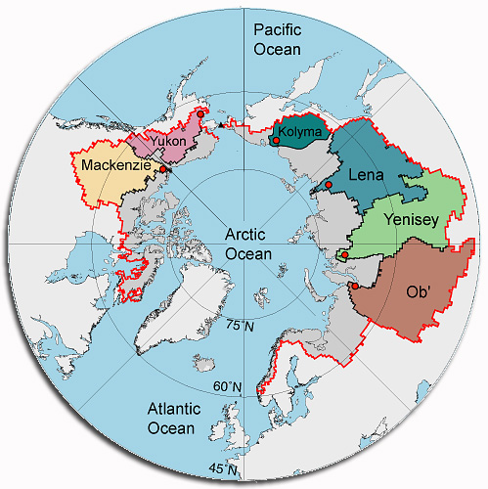

Figure 1

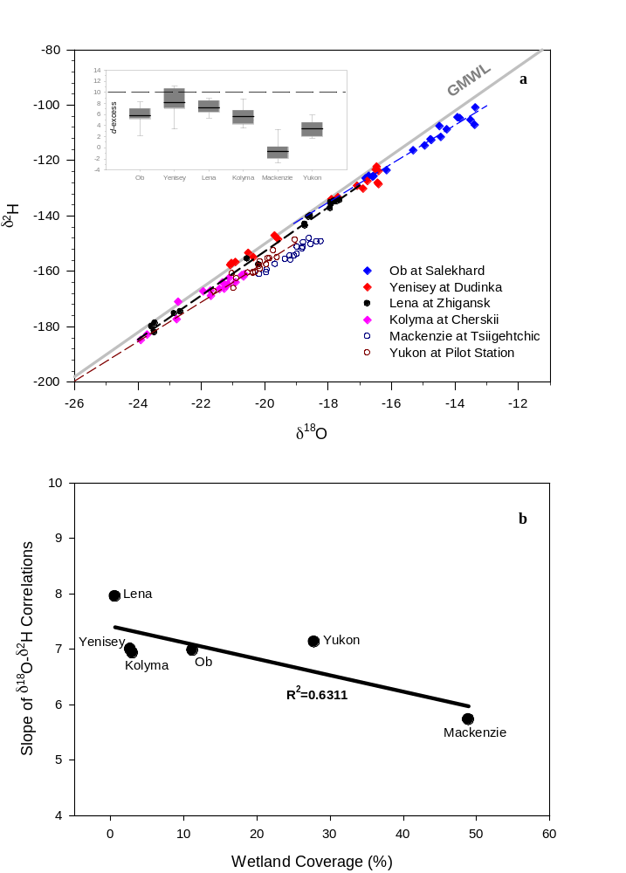

Figure 2
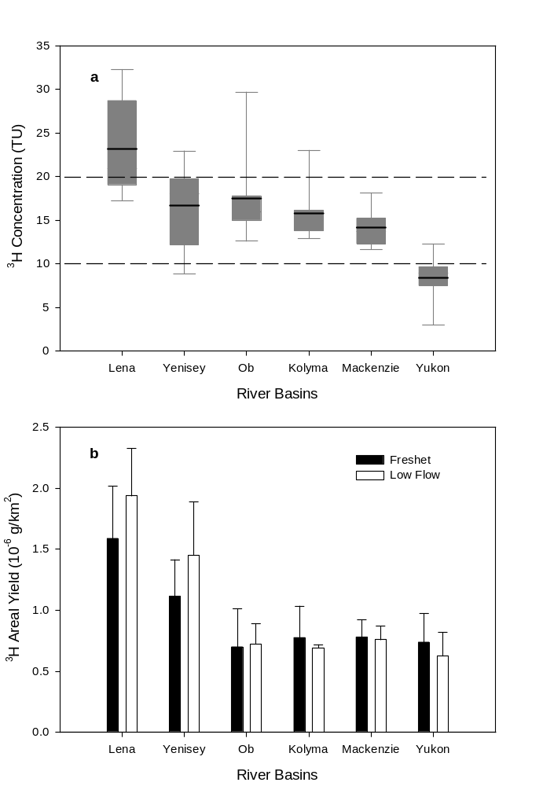
Figure 3

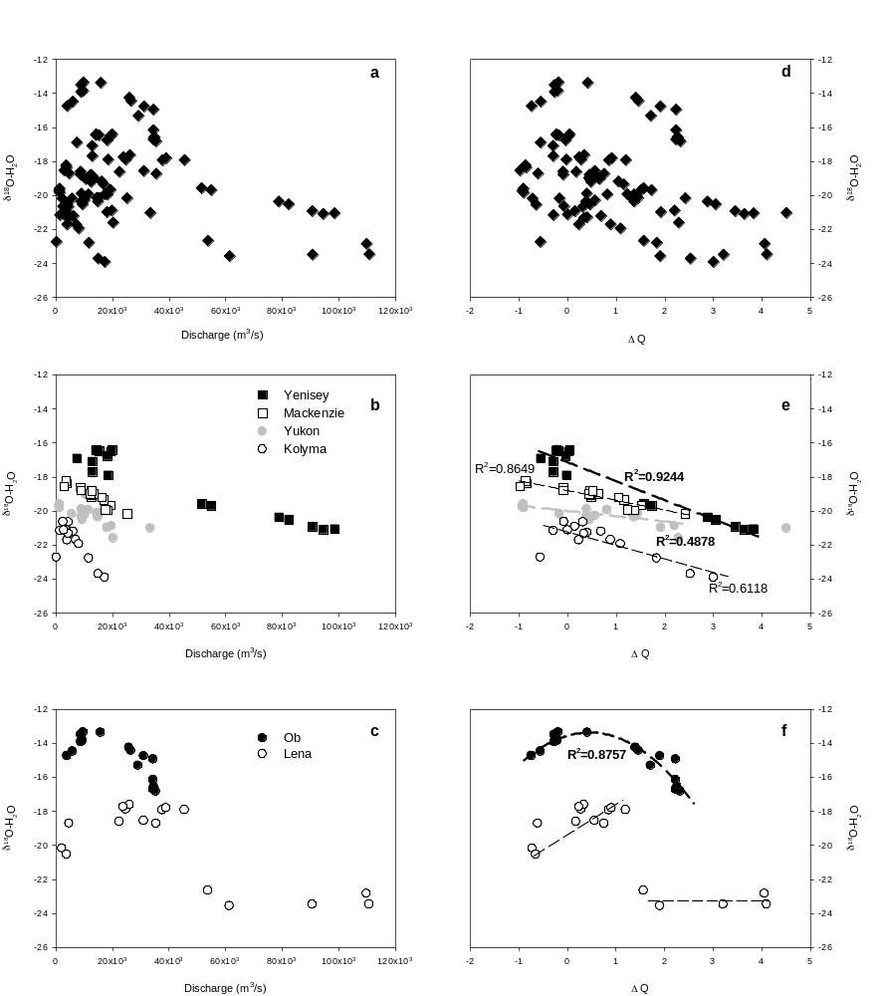

Figure 4

Table 1: A summary of variability and flux-weighted δ¹⁸O, δ²H values and ³H concentrations in the six largest Arctic rivers



