Grant No. NNX10AH71G
The Potential Impacts of Sea Ice Decline and River Discharge Shifts
on Biological Productivity in the Chukchi and Beaufort Seas

Annual Progress Report
Period Covered: 29 March 2010 – 29 January 2011

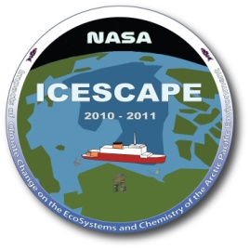

Karen E. Frey, Assistant Professor (PI)
Graduate School of Geography, Clark University
950 Main Street, Worcester, Massachusetts 01610 USA

Lee W. Cooper, Research Professor (co-PI)
Jacqueline M. Grebmeier, Research Professor (co-PI)
Chesapeake Biological Laboratory, University of Maryland Center for Environmental Science
1 Williams Street, Solomons, Maryland 20688 USA

TABLE OF CONTENTS:

1. Project Motivation and Background 2

2. Collaborators and Participants 2

3. Resulting Conference Presentations 2

4. Summary of the ICESCAPE HLY1001 Field Collections 3
4.1. Stable Oxygen Isotope Ratios (δ¹⁸O) 3
4.2. Sediment Samples 3
4.3. Ice Station Data and Samples 4
4.3.1. Under-ice water column and melt pond measurements 5
4.3.2. Under-ice water column profiles 5
4.3.3. Ice core measurements 6
4.3.4. Under-ice optical measurements 6

5. Highlights of Results 7
5.1. Under-ice optical measurements 7
5.2. Biogeochemical measurements 10

6. Next Steps 11

1. Project Motivation and Background

Continued climate warming in the Arctic will likely have profound consequences for many systems throughout the region, including declines in sea ice cover and shifts in the quantity and quality of river discharge. It is widely expected that these changes in sea ice cover and river discharge will in turn have significant impacts on ecosystem productivity and biogeochemistry in arctic shelf seas, with globally significant consequences for carbon cycling and food web dynamics. This project seeks to investigate the potential impacts of sea ice decline and river discharge shifts on the biology and biogeochemistry of shelf seas in the Pacific Arctic Region, which is a critical crossroads for the Arctic. Not only is this region a globally important marine mammal migration pathway, but the Pacific water transiting the system is one of the largest point sources of nutrients, heat, and freshwater to the Arctic Ocean. We focus our field efforts in the Chukchi/Beaufort Sea region as part of NASA’s Impacts of Climate Change on the Ecosystems and Chemistry of the Arctic Pacific Environment (ICESCAPE) project. Through ICESCAPE, the first of two field collections was carried out during the HLY1001 cruise onboard the USCGC Healy icebreaker in June-July 2010. Multiple datasets were collected, with a focus on the 12 ice stations occupied over the course of the cruise. Primary datasets collected and analyzed include optical profiles under the sea ice cover as well as a suite of water and ice samples for subsequent physical and biogeochemical analyses. The following sections provide further details on the field data collected and highlights of results thus far.

2. Collaborators and Participants

Frey is the lead PI for this project, with Cooper and Grebmeier serving as co-PIs. Dr. Jinping Zhao, a a faculty member at the Ocean University of China (Qingdao) is also involved and we are exporing options for additional collaborative efforts including participation in the next Chinese Arctic Expedition in 2012. Christie Wood (a Ph.D. student in the Graduate School of Geography at Clark University) has worked as a graduate research assistant with Frey towards the goals of this project since September 2010. Christie will also focus on this ICESCAPE project for her Ph.D. dissertation research, furthering the sea ice biogeochemistry work. Along with Frey, Christie Wood and Luke Trusel (also a Ph.D. student in the Graduate School of Geography at Clark University) were onboard the USCGC Healy for the first ICESCAPE cruise in June-July 2010.

3. Resulting Conference Presentations

Frey, K. E., Grebmeier, J. M., Cooper, L. W., Wood, C. L. & Panday, P. K. Satellite-Derived Trends across a Marine Distributed Observatory in the Pacific Arctic Region. 2011 Arctic Science Summit Week. Seoul, Korea, 27 March – 1 April 2011.

Frey, K. E., Wood, C. L., Trusel, L. D., Cooper, L. W. & Grebmeier, J. M. Optical properties of ocean waters beneath melt-season first-year sea ice in the Chukchi Sea. 2010 Fall American Geophysical Union Meeting. San Francisco, California, 13–17 December 2010.

INVITED: Grebmeier, J. M., Cooper, L. W., Frey, K. E. & Moore, S. E. Pacific Arctic Sector: Biological and ecosystem response to climate warming. Second International Symposium on Arctic Research. Tokyo, Japan, 7–9 December 2010.

Grebmeier, J. M., Cooper, L. W. & Frey, K. E. Biological Time Series Observations in the Pacific Arctic. 2011 Arctic Science Summit Week. Seoul, Korea, 27 March – 1 April 2011.

Polashenski, C., Perovich, D. K., Claffey, K., Frey, K. E., Trusel, L. D. & Wood, C. The fresh meltwater in the sea ice system. 2010 Fall American Geophysical Union Meeting. San Francisco, California, 13–17 December 2010.

4. Summary of the ICESCAPE HLY1001 Field Collections

Onboard HLY1001, our group collected samples in three major categories: (a) Oxygen isotope samples from CTD deployments; (b) Sediment samples from Van Veen grabs; and (c) Multiple parameters at each of the 12 ice stations. More detail about each of these categories can be found below:

4.1. Stable Oxygen Isotope Ratios (δ¹⁸O)
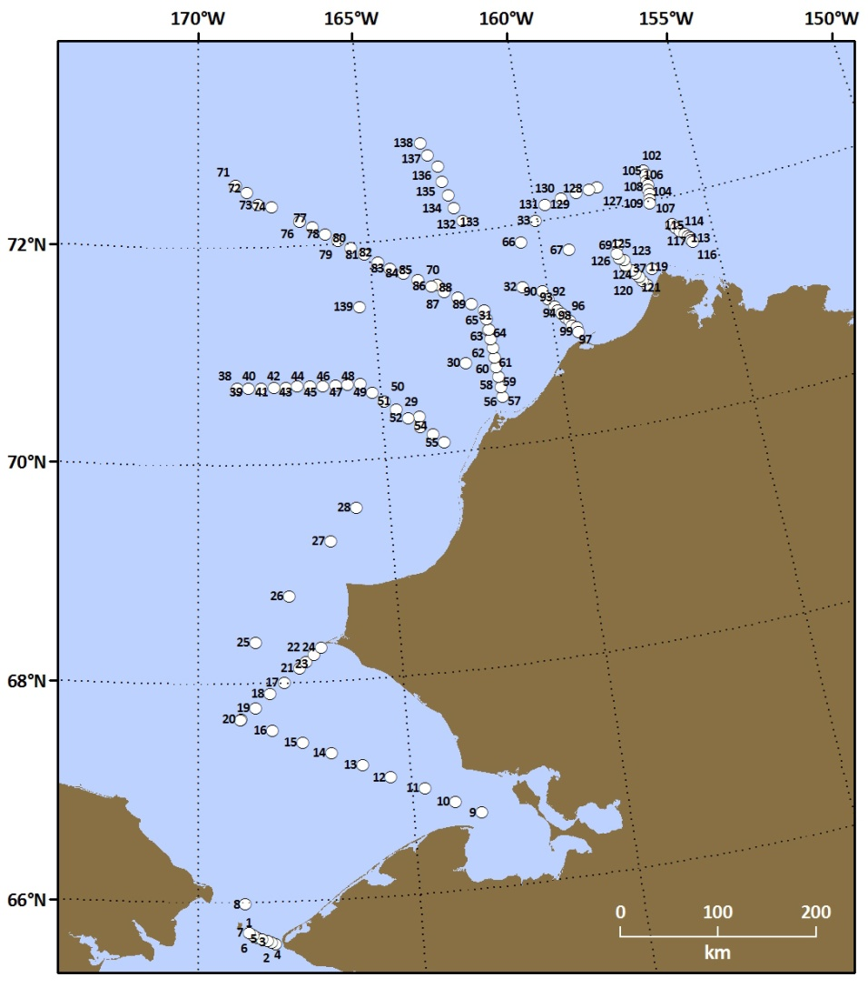
Samples for oxygen isotope measurements were collected without headspace in 20 mL scintillation vials from every level at each station. Samples were collected at 135 stations total (Figure 1), as 5 of the 140 total stations were ice stations only (where the CTD was not deployed). In total, 657 samples were collected and subsequently stored in the dark in the main lab refrigerator. Samples were shipped to the University of Maryland Center for Environmental Science for analyses on a stable isotope ratio mass spectrometer. Co-PI Cooper has recently acquired a new Thermo stable ratio mass spectrometer through an NSF Major Research Instrumentation grant. Once the instrument has completed its set-up and calibration procedures, we expect that these samples will be analyzed for oxygen isotopes this spring.
Figure 1. Locations of the 135 stations in the Chukchi Sea where waters for δ¹⁸O analysis were collected.
HLY1001 δ¹⁸O Sampling Sites

4.2. Sediment Samples
Sediment samples from the undisturbed top layer of a Van Veen grab were collected at full stations only (22 stations total; Table 1, Figure 2). Triplicate samples for sediment chlorophyll (1 cm³), single samples for Th-234 (3 cm³), and single samples for sediment high-performance liquid chromatography (HPLC) analyses (1 cm³) were collected at each site. Sediment chlorophyll concentrations were determined shipboard on a Turner Designs fluorometer, while Th-234 and HPLC analyses will be performed by additional groups once samples are shipped to home institutions.
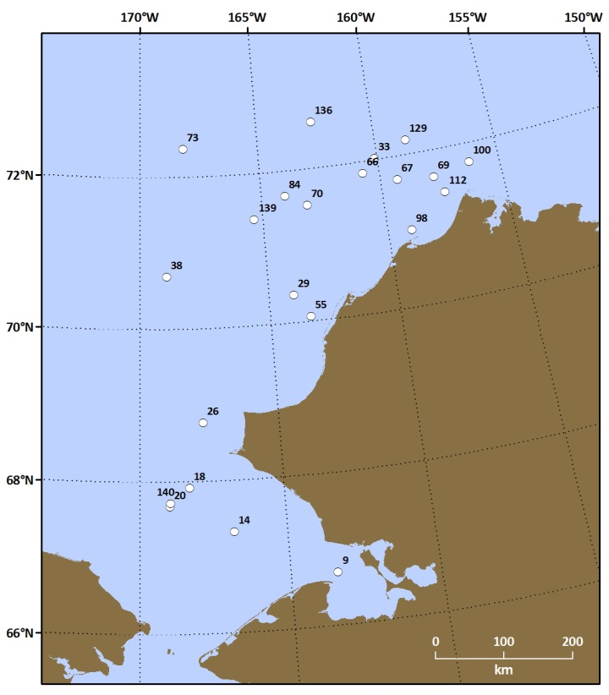
Table 1. Sediment Sampling Sites.
HLY1001 Sediment Sampling Sites
Station No. | Date (UTC) | Latitude | Longitude | Depth (m)
9 | 6/20/2010 | 66.6978 | -163.4087 | 23
14 | 6/21/2010 | 67.3290 | -166.7718 | 44
18 | 6/21/2010 | 67.9172 | -168.2552 | 58
20 | 6/21/2010 | 67.6760 | -168.9526 | 51
26 | 6/23/2010 | 68.7681 | -167.7105 | 50
29 | 6/24/2010 | 70.3646 | -164.0028 | 37
33 | 6/25/2010 | 72.0162 | -160.0647 | 31
38 | 6/29/2010 | 70.6904 | -168.9380 | 35
55 | 7/1/2010 | 70.0617 | -163.4261 | 28
66 | 7/2/2010 | 71.8461 | -160.6560 | 42
67 | 7/3/2010 | 71.6911 | -159.2603 | 54
69 | 7/4/2010 | 71.6456 | -157.7638 | 64
70 | 7/5/2010 | 71.5224 | -163.0984 | 41
73 | 7/7/2010 | 72.3684 | -168.1456 | 56
84 | 7/7/2010 | 71.6682 | -163.9920 | 41
98 | 7/8/2010 | 71.0052 | -159.0347 | 38
100 | 7/10/2010 | 71.7421 | -156.2152 | 97
112 | 7/12/2010 | 71.4160 | -157.4360 | 130
129 | 7/13/2010 | 72.1876 | -158.6629 | 54
136 | 7/14/2010 | 72.6078 | -162.5607 | 41
139 | 7/15/2010 | 71.3920 | -165.3206 | 42
140 | 7/16/2010 | 67.7168 | -168.9245 | 52
Figure 2. Locations of the 22 stations in the Chukchi Sea where sediment samples were collected.

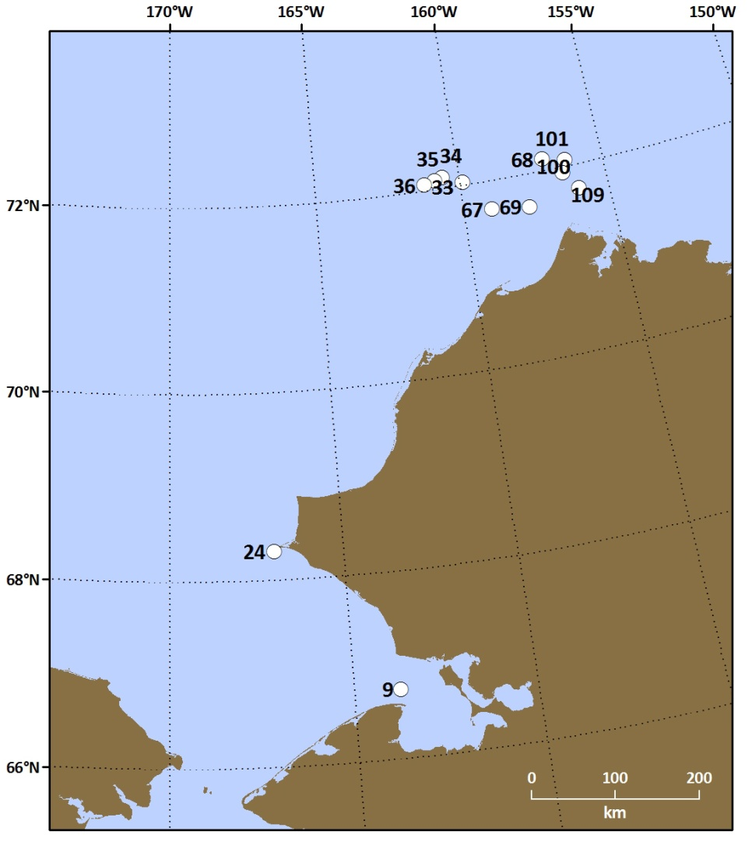
4.3. Ice Station Data and Samples
HLY1001 Sea Ice Stations
A total of 12 ice stations (2 short stations without optics and 10 longer stations with optics) were visited over the course of HLY1001 (Figure 3). A number of samples and datasets were collected at each of the sites, to include: (i) under-ice water column and melt pond measurements; (ii) under-ice water column profiles; (iii) ice core measurements; and (iv) under-ice optical measurements. In addition, our group contributed to under-way sea ice observations from the ship’s bridge (along with the Perovich group). Table 2 provides greater details on the samples and measurements made at each ice station, which include δ¹⁸O, chromophoric dissolved organic carbon (CDOM), dissolved organic carbon (DOC), high-precision salinity, alkalinity, and suspended particulate matter (SPM). Optical and additional profiles of the under-ice water column (see sections 4.3.2. and 4.3.3.) were also collected.
Figure 3. Locations of the 12 ice stations in the Chukchi Sea occupied over the course of HLY1001.
Table 2. Ice station sampling sites and associated data collections.
Station No. | Date (UTC) | Latitude | Longitude | Under-Ice & Melt Pond Waters | Ice Cores  (10cm sections) | Optics
9-ice  (shakedown) | 6/20/2010 | 66.7402 | -163.7172 | δ¹⁸O, CDOM, DOC | δ¹⁸O, Salinity  (1 bare ice core) | None
24-ice | 6/22/2010 | 68.3032 | -166.9810 | δ¹⁸O, CDOM, DOC, Salinity | δ¹⁸O, CDOM, DOC, Salinity  (2 bare ice cores) | None
33-ice | 6/24/2010 | 72.0303 | -159.8770 | δ¹⁸O, CDOM, DOC, Salinity, Alkalinity, Nutrients, SPM | δ¹⁸O, CDOM, DOC, Salinity, SPM  (1 bare ice/1 melt pond core) | Bare Ice Optics
34-ice | 6/25/2010 | 72.1148 | -160.5380 | δ¹⁸O, CDOM, DOC, Salinity, Alkalinity, Nutrients, SPM | δ¹⁸O, CDOM, DOC, Salinity, SPM  (1 bare ice/1 melt pond core) | Bare Ice Optics
35-ice | 6/26/2010 | 72.0905 | -160.8135 | δ¹⁸O, CDOM, DOC, Salinity, Alkalinity, Nutrients, SPM | δ¹⁸O, CDOM, DOC, Salinity, SPM  (1 bare ice/1 melt pond core) | Bare Ice Optics
36-ice | 6/27/2010 | 72.0607 | -161.1993 | δ¹⁸O, CDOM, DOC, Salinity, Alkalinity, Nutrients, SPM | δ¹⁸O, CDOM, DOC, Salinity, SPM  (1 bare ice/1 melt pond core) | Bare Ice & Melt Pond Optics
67-ice | 7/2/2010 | 71.6922 | -159.0397 | δ¹⁸O, CDOM, DOC, Salinity, Alkalinity, Nutrients, SPM | δ¹⁸O, CDOM, DOC, Salinity, SPM  (1 bare ice/1 melt pond core) | Bare Ice & Melt Pond Optics
68-ice | 7/3/2010 | 72.1185 | -157.0263 | δ¹⁸O, CDOM, DOC, Salinity, Alkalinity, Nutrients, SPM | δ¹⁸O, CDOM, DOC, Salinity, SPM  (1 bare ice/1 melt pond core) | Bare Ice & Melt Pond Optics
69-ice | 7/4/2010 | 71.6452 | -157.7547 | δ¹⁸O, CDOM, DOC, Salinity, Alkalinity, Nutrients, SPM | δ¹⁸O, CDOM, DOC, Salinity, SPM  (1 bare ice/1 melt pond core) | Bare Ice & Melt Pond Optics
100-ice | 7/9/2010 | 71.7322 | -156.0065 | δ¹⁸O, CDOM, DOC, Salinity, Alkalinity, Nutrients, SPM | δ¹⁸O, CDOM, DOC, Salinity, SPM  (1 bare ice/1 melt pond core) | Bare Ice & Melt Pond Optics
101-ice | 7/10/2010 | 72.0615 | -156.2808 | δ¹⁸O, CDOM, DOC, Salinity, Alkalinity, Nutrients, SPM | δ¹⁸O, CDOM, DOC, Salinity, SPM  (1 bare ice/1 melt pond core) | Bare Ice & Melt Pond Optics
109-ice | 7/11/2010 | 71.9342 | -156.4278 | δ¹⁸O, CDOM, DOC, Salinity, Alkalinity, Nutrients, SPM | δ¹⁸O, CDOM, DOC, Salinity, SPM  (1 bare ice/1 melt pond core) | 3 Bare Ice Optics Sites

4.3.1. Under-ice water column and melt pond measurements:
At each ice station, waters were collected at six depths: 0m (ice-water interface), 1m, 5m, 10m, 20m, and 30m. Additional waters were collected from a representative melt pond at each ice station. These waters were analyzed for CDOM, alkalinity, nutrients, and salinity shipboard, while δ¹⁸O and DOC are determined at the University of Maryland. In addition, a select number of ice-water interface and melt pond waters were filtered and frozen for subsequent potential photo-oxidation experiments and HPLC-based mycosporine-like amino acid (MAA) analyses. MAAs (which act as UV sunscreens) were commonly found via absorbance measurements in the melted sea ice and under-ice water samples. Additional measurements (chlorophyll, SPM, etc.) were also made by other associated groups (e.g., Arrigo, Mitchell, etc.). SPM and particulate organic matter (POM) measurements were determined at Clark University. A total of 76 under-ice and melt pond samples were generated for CDOM/DOC analyses. A total of 76 under-ice and melt pond samples were generated for δ¹⁸O and salinity measurements. A total of 66 under-ice and melt pond samples were generated for nutrient and alkalinity measurements.

4.3.2. Under-ice water column profiles:
YSI-based continuous profiles from 0–30m were collected at each of the 12 ice stations, to include temperature, dissolved oxygen, conductivity/salinity, and pH. These profiles were taken through 10” auger-drilled holes in the sea ice cover and provide fine-resolution information directly below the ice cover that is impossible to be collected from ship-disturbed waters via the main CTD. Among a variety of important applications, this information provides valuable information regarding the physical and biogeochemical impacts of sea ice melt on the under-ice water column.

4.3.3. Ice core measurements:
Upon extraction of ice cores, photos were taken and temperatures were measured at 10cm intervals. Ice core subsections (10cm) were then thawed at 4°C in a climate controlled chamber (typically <24 hours). Upon completion of thawing, waters were filtered for CDOM and DOC (0.2 μm pore-size filters), and collected for salinity and δ¹⁸O. CDOM and salinity were determined shipboard, while DOC and δ¹⁸O are determined at the University of Maryland. Additional measurements (chlorophyll, SPM, nutrients, etc.) were also made by other associated groups (e.g., Arrigo, Mitchell, etc.). SPM and POM measurements were determined at Clark. When possible, both a bare ice and melt pond ice core were extracted for analyses above. A total of 137 bare ice and 54 melt pond subsection measurements were generated for CDOM/DOC analyses. A total of 213 ice core subsection samples were generated for δ¹⁸O and salinity analyses.

4.3.4. Under-ice optical measurements:
At 10 of the ice stations, optical measurements were collected from four instruments simultaneously. The optical system utilized is a modified C-OPS system for under-ice optics, coined by Biospherical Instruments, Inc. as “Ice-Pro” and “Ice-Pod” (Figure 4). The QCP under-ice reference and Ed0 surface reference are attached to a tripod and static, while the EdZ and LuZ instruments profile the under-ice water column. The four instruments collect data at multiple wavelengths (Table 3).

Table 3. Wavelengths (in nm) of each of the four optical instruments.

QCP (Under-Ice Reference): PAR only

Ed0 (Surface Reference): 320, 340, 380, 395, 412, 443, 465, 490, 510, 532, 555, 560, 625, 665, 670, 683, 710, 780, PAR

EdZ (Downwelling Profiler): 320, 340, 380, 395, 412, 443, 465, 490, 510, 532, 555, 560, 625, 665, 670, 683, 710, 780, PAR

LuZ (Upwelling Profiler): 320, 340, 380, 395, 412, 443, 465, 490, 510, 532, 555, 560, 625, 665, 670, 683, 710, 780, Natural Fluorescence

At each ice station, two 10” auger holes were drilled for measurements (one for the Icepod set-up and one for the IcePro deployment). A minimum of three profiles (~30–50m deep) per site were collected. At many sites, one bare ice site and one melt pond site were established (see Table 2 for more details).

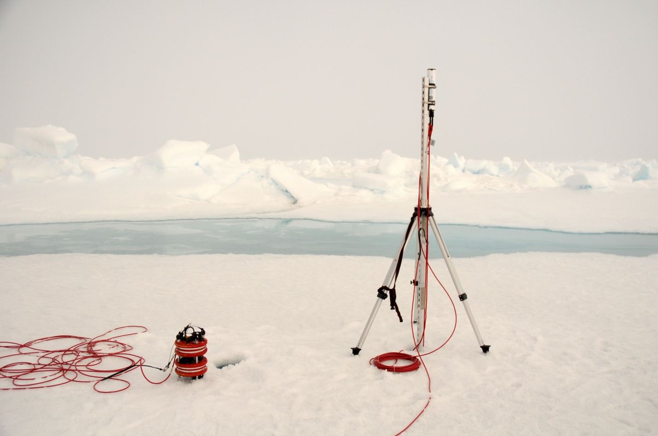
Figure 4. The architecture of the IcePro and IcePod systems for under-ice optical observations. The IcePro includes both an upwelling and downwelling profiler, while the IcePod includes a static surface reference (for normalization of solar conditions) and static under-ice reference (for static observations at the ice-water interface).
Ed0
QCP
ICEPOD
ICEPRO
EdZ
LuZ

5. Highlights of Results
While many of our resulting datasets are still being compiled and analyzed, highlights of our results thus far include under-ice optical measurements and biogeochemical measurements of both melted sea ice and the under-ice water column. A summary of a subset of these results can be found in the following two subsections.

5.1. Under-Ice Optical Measurements
A ubiquitous feature of sea ice cover during June/July in the Chukchi Sea is the extensive distribution of surface melt ponds across the sea ice surface (e.g., Figure 5c). We had the opportunity at most ice stations to investigate the optical characteristics of the water column beneath both “melt pond” surfaces and “bare ice” surfaces (e.g., those sea ice surfaces not impacted by melt ponds, with a distinctive scattering layer at the surface). Because of a lack of the surface scattering layer at melt pond locations, the transmittance of light at all measured wavelengths (including PAR) is significantly higher through melt ponds than through bare ice surfaces (transmittances of ~0.65 vs. ~0.15) (Figures 5a, b). When summarized across all ten ice stations, the average transmittance of light at all wavelengths is greater through melt pond surfaces than through bare ice surfaces (Figure 6). This divergence decreases at longer wavelengths (>750 nm). The dependence of light transmittance on ice surface characteristics also decreases significantly with depth for both UV radiation and PAR (Figure 7), disappearing almost entirely at depths of ~15–20 m below the sea ice surface. While we observe two distinct optical patterns of light transmittance through sea ice cover (i.e., bare ice vs. melt pond), we also observe complex interactions between the two, with light transmittance increasing with depth (i.e., creating a co-called “bulge”) when the water column beneath bare ice “sees” adjacent melt ponds (Figure 8). This suggests that optical characteristics beneath a melt-season sea ice cover are much more complex than previously appreciated.
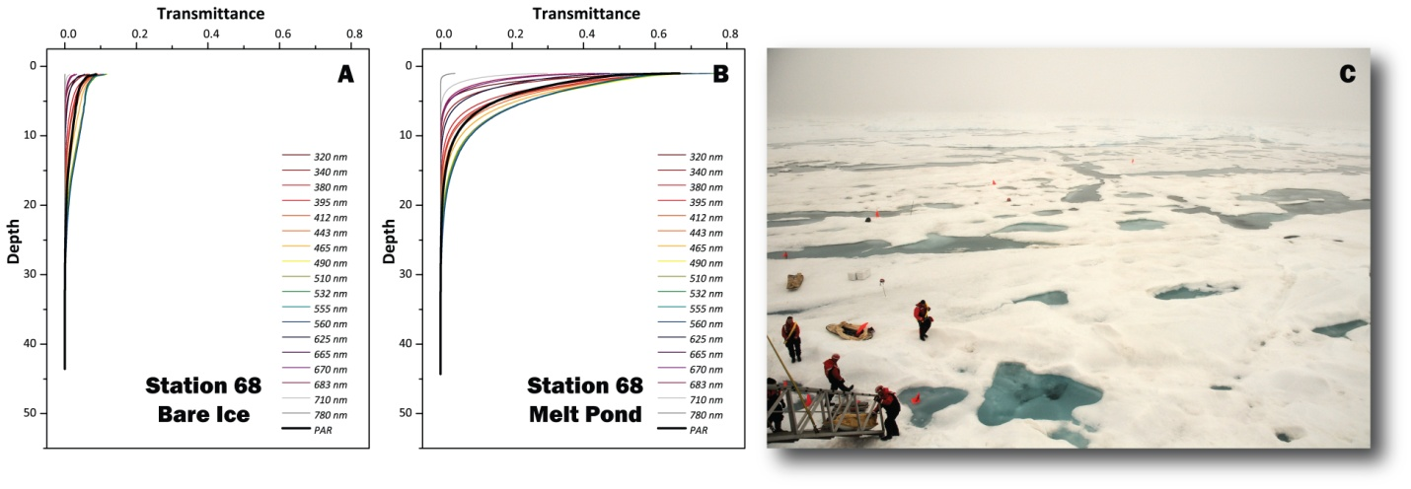
Figure 5. Typical patterns of light transmittance through (a) bare ice and (b) melt pond sea ice surfaces. At the ice-water interface on average, melt ponds allow ~0.65 light transmittance and bare ice surfaces allow ~0.15 light transmittance. Average measured ice thicknesses were relatively similar between sites (~1.1 m for bare ice sites and ~0.8 m for melt pond sites).
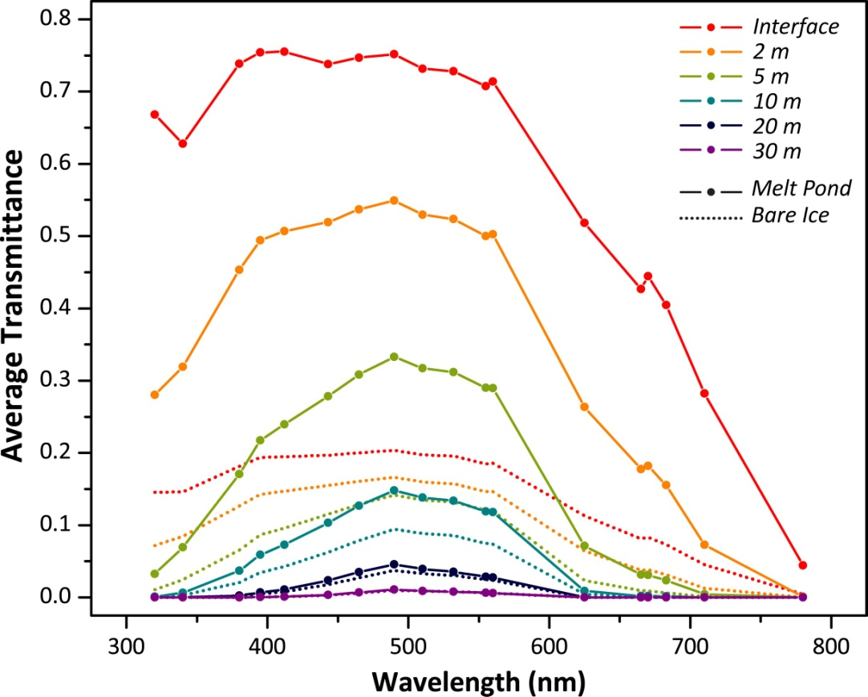
Figure 6. Average transmittance of light at wavelengths from 300–800 nm. Melt pond sites (solid lines) transmit significantly more light at all wavelengths than bare ice sites (dotted lines). The dependence of light transmittance on sea ice surface characteristics decreases with depth in the water column.

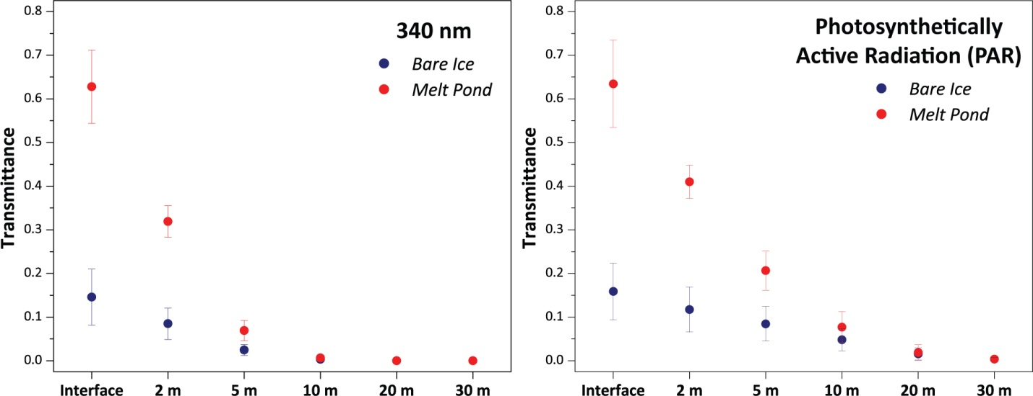
Figure 7. Average transmittance of UV (e.g., 340 nm) and PAR through both bare ice and melt pond sea ice surfaces. Both UV and PAR transmission is several times higher through melt pond surfaces than through bare ice surfaces. The dependence of light transmission on sea ice surface characteristics decreases with depth and disappears entirely ~15–20 m below the sea ice surface.
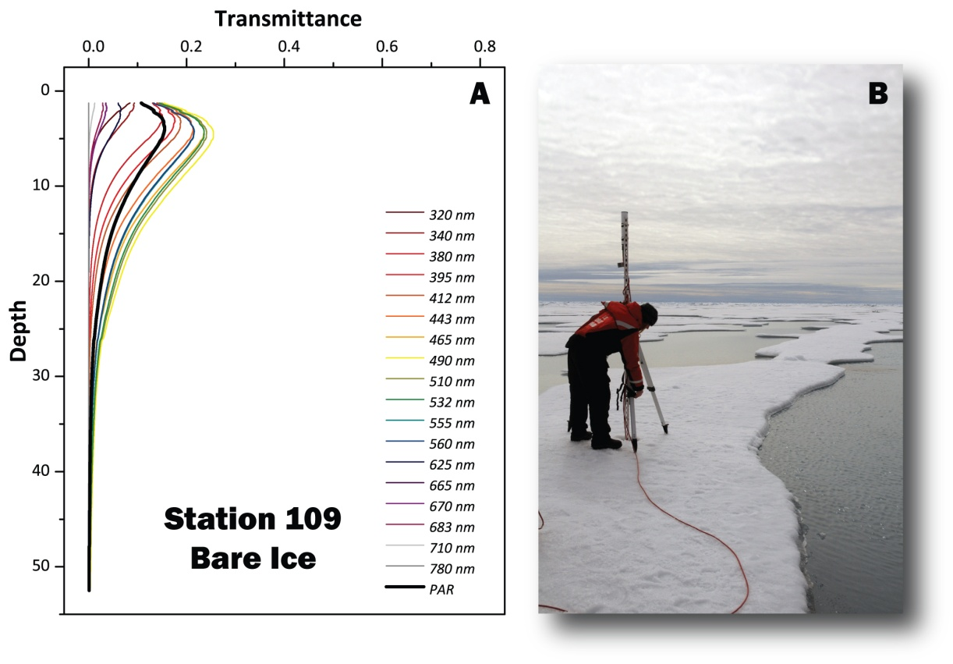

Figure 8. For those bare sea ice surfaces in the vicinity of melt ponds, light transmittance counterintuitively increases with depth, reaching a maximum at ~5m below the ice surface. This never before observed “bulge” of light exists because this portion of the water column “sees” light from adjacent melt ponds, suggesting that optical characteristics of the water column beneath sea ice cover is much more complex than previously realized.

5.2. Biogeochemical Measurements
A full suite of biogeochemical measurements was collected from melt ponds, sea ice, and the under-ice water column (as described in sections 4.3.1. and 4.3.3.). We are particularly interested in the biogeochemical interplay between the sea ice and under-ice water column, as well as how sea ice may serve as a source and/or capacitor of chlorophyll biomass, nutrients, and organic matter (including CDOM) to the water column upon seasonal sea ice melt. This will further our understanding of the importance of sea ice in the overall biogeochemistry of the water column, allowing more accurate calibration of modeling and remote sensing of these systems. A first order comparison between DOC and CDOM of the under-ice water column shows a strong positive relationship between these two constituents (Figure 9), demonstrating that CDOM may be a good proxy for DOC at these short wavelengths. Furthermore, we also see relatively high CDOM absorption in the under-ice water column, with a large range in CDOM of sea ice (Figure 10). This may suggest that sea ice may be an important contributor to CDOM concentrations in the underlying water column upon spring sea ice melt each year.
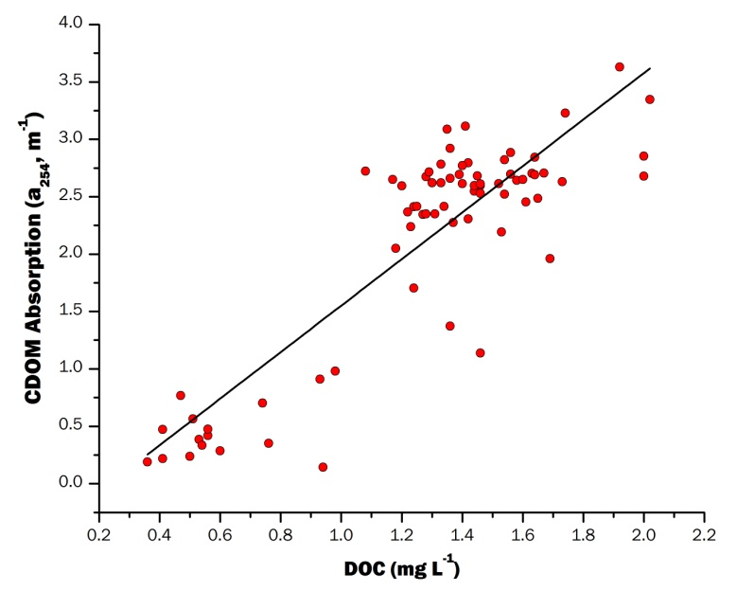

Figure 9. Relationship between DOC concentrations and CDOM absorption at 254 nm for the under-ice water column samples (R² = 0.756, p<0.01).

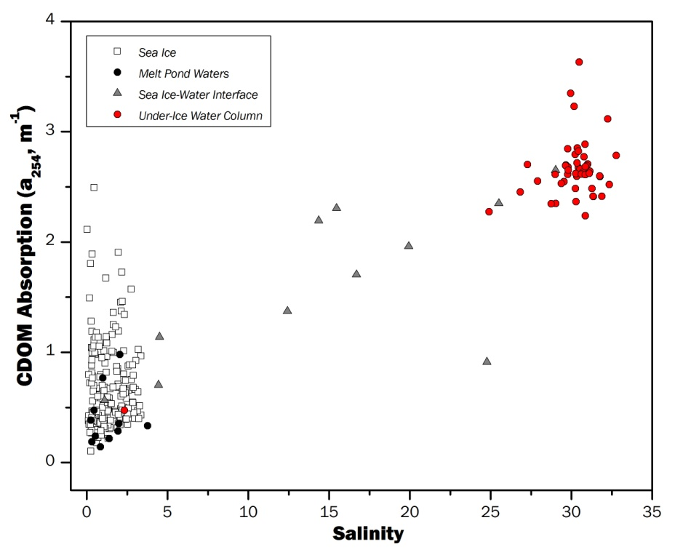
Figure 10. Relationship between CDOM absorption at 254 nm and salinity for sea ice, melt pond waters, sea-ice water interface waters, and the under-ice water column. Sea ice is typically much fresher than the under-ice water column or waters at the ice-water interface. While CDOM in the under-ice water column is generally higher than the other water sample types, sea ice also has a wide range of CDOM absorption. This suggests that sea ice may be an important source of CDOM to the water column upon spring sea ice melt.
5. Next Steps
We are currently in the planning stages for the second ICESCAPE cruise to take place on the USCGC Healy from June 25 – July 29, 2011. Through this second field season, we will continue our measurements of under-ice optics, oxygen isotopes of waters and sea ice, as well as sea ice/water column biological and biogeochemical parameters. We will be adding the use of a Sea-Bird SEACAT SBE 19-02 hand-held CTD (requested by Frey to be brought to the USCGC Healy from the USCGC Polar Sea for use by our team), which includes instruments for measurements of conductivity, temperature, depth, and dissolved oxygen. The ability to utilize this instrument should improve upon our YSI-based under-ice water column profiles described in section 4.3.2. In the meantime, we are continuing to post-process our biogeochemical and optics datasets, and analysis of our ~650 oxygen isotope samples will ensue this spring. Once both field seasons of measurements are collected, the datasets will be combined and further plans for manuscript preparation will be developed.

