The relationship between sea ice break-up, water mass variation, chlorophyll biomass, and sedimentation in the northern Bering Sea

L.W. Cooper
Chesapeake Biological Laboratory, University of Maryland Center for Environmental Science, PO Box 38, Solomons Maryland 20688, U.S.A.

M. Janout
School of Fisheries and Ocean Science, University of Alaska Fairbanks, Fairbanks, Alaska 99775, U.S.A.
Current Address: Alfred Wegener Institute for Polar and Marine Research, Bremerhaven, Germany

K. E. Frey
Graduate School of Geography, Clark University, 950 Main St, Worcester MA 01610

R. Pirtle-Levy
North Carolina State University, Raleigh NC U.S.A.

M. L. Guarinello, J.M. Grebmeier
Chesapeake Biological Laboratory, University of Maryland Center for Environmental Science, PO Box 38, Solomons Maryland 20688, U.S.A.

J.R. Lovvorn
Department of Zoology, Southern Illinois University, Carbondale, Illinois 62901, U.S.A .
Abstract
The northern Bering Sea shelf is dominated by soft-bottom infauna and ecologically significant epifauna that are matched by few other marine ecosystems in biomass. The likely basis for this high benthic biomass is the intense spring bloom, but few studies have followed the direct sedimentation of organic material during the bloom peak in May. Satellite imagery, water column chlorophyll concentrations and surface sediment chlorophyll inventories were used to document the dynamics of sedimentation to the sea floor in both 2006 and 2007, as well as to compare to existing data from the spring bloom in 1994. An atmospherically-derived radionuclide, ⁷Be, that is deposited in surface sediments as ice cover retreats was used to supplement these observations, as were studies of light penetration and nutrient depletion in the water column as the bloom progressed. Chlorophyll biomass as sea ice melted differed significantly among the three years studied (1994, 2006, 2007). The lowest chlorophyll biomass was observed in 2006, after strong northerly and easterly winds had distributed relatively low nutrient water from near the Alaskan coast westward across the shelf prior to ice retreat. By contrast, in 1994 and 2007, northerly winds had less northeasterly vectors prior to sea ice retreat, which reduced the westward extent of low-nutrient waters across the shelf. Additional possible impacts on chlorophyll biomass include the timing of sea-ice retreat in 1994 and 2007, which occurred several weeks earlier than in 2006 in waters with the highest nutrient content. Late winter brine formation and associated water column mixing may also have impacts on productivity that have not been previously recognized. These observations suggest that interconnected complexities will prevent straightforward predictions of the influence of earlier ice retreat in the northern Bering Sea upon water column productivity and any resulting benthic ecosystem re-structuring as seasonal sea ice retreats in the northern Bering Sea.
Introduction
Recent declines in Arctic seasonal sea ice make it imperative to understand the range of ecosystem responses to the climatic warming that seems to be clearly underway at high latitudes. For example, it is thought that declining sea ice coverage will increase light penetration and increase primary production on polar continental shelves (Arrigo et al. 2008), which might be globally significant because the continental shelves in the Arctic are the world’s largest in extent. However, in comparing between chlorophyll biomass in the Bering Sea for two different years with light versus heavy ice coverage, open water conditions in early spring did not lead to significantly higher water column chlorophyll biomass (Clement et al. 2004) possibly because high winds can vertically mix phytoplankton in open water. Lomas et al. (this volume) also point out that the high degree of spatial and temporal variability in biological productivity across the Bering Sea will make it challenging to detect shifts in production that can be attributed solely to declining seasonal sea ice. Consequently it is uncertain if declining sea ice will by itself lead to greater biological production on subarctic shelves despite a greater access to light when ice cover is diminished.
Another potentially important factor impacting the Arctic ecosystem in a declining seasonal sea ice regime is the timing of seasonal sea ice retreat. Currently, the northern Bering and Chukchi continental shelves have short food chains that deposit organic material synthesized during the brief, but intense production period directly to the shallow sea floor without much utilization by zooplankton (Cooper et al. 2002; Lovvorn et al. 2005). Specialized apex predators such as walrus, gray whales, bearded seals and diving sea ducks exploit the rich benthos as a food resource, but there is also evidence that fish are becoming more important in structuring the food web (Grebmeier et al. 2006; Cui et al. 2009). Early retreat of sea ice and later phytoplankton bloom development is hypothesized to prompt better development of zooplankton, which may become more important in intercepting seasonal primary production and increasing the pelagic component of the food web (Hunt et al. 2002, 2011). Ecological plasticity on the part of higher trophic feeders may also lead to changes that further complicate understanding how the ecosystem will adjust as sea ice declines and habitat availability changes (e.g. Pyenson and Lindberg, 2011).
In part to address these uncertainties regarding the biological impacts from changes in seasonal sea ice coverage and duration, we present data here on satellite, water column and benthic observations made during two seasons of ice retreat in May-June of 2006 and 2007 on the northern Bering Shelf aboard the USCGC Healy. In July 2006 and 2007, follow-up sampling well after the spring bloom from the CCGS Sir Wilfrid Laurier facilitated observations of the ultimate fate of sea surface derived organic materials and proxy tracers.
Our sampling builds upon extensive ecological studies have been undertaken in the Bering Sea, dating back to Processes and Resources of the Bering Sea Shelf (PROBES) in the 1970s (summarized by McRoy et al. 1986) and the Inner Shelf Transfer and Recycling (ISHTAR) program in the 1980s (summarized by McRoy et al. 1993), including studies of the biological bloom at the time of ice retreat (e.g. Niebauer 1991; Niebauer et al. 1995). However, there have been only a handful of scientific observations undertaken on the productive northern shelf between St. Matthew Island and Bering Strait at the time of ice retreat, when an ice-associated phytoplankton bloom results in an annual maximum in phytoplankton biomass (Cooper et al. 2002). Our data in particular reflect upon the development and intensity of the bloom and the timing of transmission of particulates to the sea floor. Specifically we determined water column conditions such as salinity and water column structure, as well as concentrations of nutrients that support phytoplankton (i.e. chlorophyll production) in the water column. We also made successive determinations of the viable chlorophyll inventories present on surface sediments and the particle-reactive natural radionuclide ⁷Be (t_{1/2} = 53 d) as indicators for recent sedimentation. Because of the short half-life of this radionuclide, it is not present on the sea floor until after ice retreat (Cooper et al. 2005; Cooper et al. 2009), so it is an indicator of recent particle deposition. Likewise, viable chlorophyll a inventories on surface sediments in the Bering Sea are at low levels at the end of the winter, but increase significantly during and following the spring bloom (Cooper et al. 2002), providing another marker of particle accumulation. The two years studied were compared with each other in addition to a third year, 1994, when early season biological data are also available.
Our intent was to determine what relationships existed between sea ice distributions and subsequent water column chlorophyll concentrations and if there might be predictable consequences for chlorophyll biomass as a result of particular water mass distributions or sea ice retreat. The northern Bering Sea from St. Matthew Island to Bering Strait is entirely continental shelf, so changes in biological productivity and sea ice dynamics would have direct impacts on benthic communities. Decadal biomass declines and changes in Bering Sea benthic communities are underway and clearly coupled to overall water column productivity (Grebmeier et al. 2006). Therefore in putting our work in a biogeochemical context, one of the key questions that arises is the relationship of overall productivity of this Arctic system to changing seasonal sea ice extent and duration, and specifically what is predictable about the transfer of organic materials to the benthos under different sea ice melt scenarios.
Hydrography
The nutrient distribution in the region surrounding St. Lawrence Island (SLI) is governed by the course and extent of the Anadyr Current (AC) from the western side of the Bering Sea. The AC has its origin in the deep Bering Sea and consists of waters, termed Anadyr Water (AW) that upwell onto the Bering shelf from the Bering Slope Current (Kinder et al. 1975; Wang et al. 2009). After the AC travels anticyclonically around the Gulf of Anadyr, it moves eastward, meets the western point of SLI, where it bifurcates into a minor southeastward branch along the south side of SLI and a major northward branch through Anadyr Strait (Grebmeier and Cooper, 1995; Danielson et al. 2005, 2010; Clement et al. 2005). The straits in the northern Bering Sea (Anadyr, Shpanberg, Bering Strait) are energetic and therefore regions of enhanced vertical mixing (Clement et al. 2005).
Another influence on the shelf is the dilute and nutrient-poor Alaska Coastal Water (ACW) to the east of AW. ACW consists of coastal runoff from the western Alaska mainland as well as waters advected through the Aleutian Island passes from the Gulf of Alaska via the Alaska Coastal Current (ACC) (Mordy et al. 2005). After entering the southeastern Bering Sea shelf, the swift ACC becomes less defined and spreads its waters across the shelf. The less distinct water mass with intermediate salinity, termed Bering Shelf Water (c.f. Grebmeier et al. 1989) is found on the mid-shelf and carries characteristics of both AW and ACW.
The northern Bering Sea is a distinct ecosystem, more continental in climate than Bering Sea waters to the south due to the surrounding North American and Asian land masses and SLI. The close proximity of land in the northern Bering Sea also means that wind forcing in the winter has a strong influence on local sea ice boundaries and brine injection through polynya dynamics (Stringer and Groves, 1991). The extreme west-to-east gradient in decreasing nutrient concentrations (and associated salinity) strongly influences biological production, which is concentrated to the west on the northern shelf (Springer et al. 1996). The absence of any continental slope in the study area means that all biological production in the water column is either quickly contributed to the benthos or is advected northward through Bering Strait into the Arctic Ocean (Grebmeier and McRoy, 1989).

Methods
Samples were collected during two cruises of the USCGC Healy (7 May - 6 June 2006 and 16 May - 18 June 2007) during the spring bloom in each year over a wide area of the northern Bering Sea from south of SLI north to Bering Strait (Tables 1, 2). The overall Healy cruise plan in both 2006 and 2007 took advantage of the icebreaker to sample many of the same stations south of SLI with a gap of one-to-two weeks. The object of this repeated sampling, hereafter referred to as Pass 1 (9 May 2006 – 19 May 2006 and 18 May – 29 May 2007 and Pass 2 (28 May 2006 – 6 June 2006 and 5 June – 11 June 2007) was to document changes in water column and sediment characteristics as the ice-edge bloom progressed each year (Figures 1, 2). A smaller sub-set of additional samples collected on the CCGS Sir Wilfrid Laurier (9-21 July 2006 and 9-20 July 2007) provided follow-up observations of mid-summer conditions (Tables 3, 4). For comparison, we also used retrospective data from a 1994 cruise of the RV Alpha Helix (sampling from 8 May to 8 June 1994; additional details in Cooper et al. 2002).
The CTD rosette used aboard Healy consisted of a 12-place rosette with 30-L Niskin bottles and a Sea-Bird Electronics Model 911+ CTD system. Salinities were standardized with a Guideline Autosal salinometer with international seawater standards. The electronics system was calibrated before and after the cruises at the Sea-Bird manufacturing facility in Bellevue, Washington. For samples on the Sir Wilfrid Laurier, the CTD was a Sea-Bird SBE25/33 system mounted on a SBE32 Carousel 12-bottle water sampler with 8-L bottles.
Water collected from the Niskin bottles for nutrient analysis (nitrate + nitrite, ammonium, phosphate and silicate) was frozen shipboard in high density polyethylene bottles. Following the cruise, the samples were shipped frozen to the Marine Science Institute, University of California, Santa Barbara and nutrient analysis was performed in using a Lachat Instruments QuikChem 800 nutrient analyzer.
Optical characteristics of the water column, including Photosynthetic Active Radiation (PAR) and ultraviolet (UV) wavebands were measured at each station occupied during daylight hours with a calibrated Biospherical Instruments PUV510 submersible radiometer.
Water column chlorophyll was measured by filtering 250 mL water samples through 25mm GF/F filters. The filters were initially frozen to fracture cell walls, and then stored in 10 mL of 90% acetone at 4° C for 24 hours in the dark. Extracted chlorophyll a extracted was measured using the Welschmeyer (1994) method with a Turner Designs 10-AU field fluorometer. The fluorometer was calibrated with a Turner Design Part No. 10-850 calibrated chlorophyll standard before and after all sampling, with use of a secondary solid standard (Part No. 10-AU-904) during sampling to identify any possible instrument drift. Integrated chlorophyll a was calculated for individual stations from ocean surface to sediments on a square meter basis, as most stations were 40-60 m in depth.
Surface sediment samples (0-1 cm) for ⁷Be and chlorophyll a were collected on cruises of the USCGC Healy (7 May - 6 June 2006 and 16 May - 18 June 2007) during the spring bloom in each year. A smaller sub-set of additional samples collected on the CCGS Sir Wilfrid Laurier (9-21 July 2006 and 9-20 July 2007) provided follow-up observations of mid-summer conditions. Surface sediments samples collected at some sites on the cruises used a multi- or single-HAPS benthic corer (133 cm²; Kanneworff and Nicolaisen, 1973) but most surface sediment samples were collected from the top of a van Veen grab (0.1 m²) before it was opened. Prior studies have determined that for these shelf sediments, bioturbation is large enough that the less disturbed nature of surface sediments collected by corers relative to grabs is negated (Cooper et al. 1998; Pirtle-Levy et al. 2009).
Duplicate sediment cores for shipboard incubations were collected using a HAPS benthic corer with removable Plexiglas® insert sleeves (133 cm² surface area as described above). Under optimal conditions, the cores recovered were approximately15 cm deep, with a low degree of apparent disturbance. Our criteria for determining low core disturbance during collection included the presence of clear water at the sediment-water interface, the presence of flocculent materials such as fecal pellets at the base of benthic burrows at the sediment surface, and continued filtering activity by macrobenthic invertebrates. Sediment-flux measurements for dissolved oxygen followed the methods of Grebmeier & McRoy (1989). Bottom water for these experiments was collected from the CTD rosette. Enclosed sediment cores with motorized paddles were maintained in the dark at in-situ bottom temperatures for approximately 12-24 h. Point measurements were made at the start and end of the experiment, and flux measurements were calculated, based on concentration differences adjusted to a daily flux per m². Previous shipboard measurements using real-time probe measurements in these cores indicated a steady decline in oxygen values in the overlying water during the course of the incubation. Sediments were sieved upon completing the experiment to normalize oxygen fluxes to infaunal biomass and to determine faunal composition (data to be reported elsewhere).
Surface sediment determinations of ⁷Be were made on samples packed wet into 90 cm³ cans. Corrections for efficiency and calibrations for all samples were made prior to counting with a mixed gamma standard traceable to the National Institute for Standards and Technology. Background corrections and control samples were analyzed prior to counting to verify detector performance. Some samples were off-loaded by helicopter prior to the end of the cruise, which facilitated all samples being analyzed within two half-lives of the date of collection. We used two well-shielded Canberra GR4020/S reverse electrode closed-end coaxial detectors that were at the time of analysis at the University of Tennessee, Knoxville. Sediment data reported have been decay-corrected to the date of collection. Data are reported as ⁷Be detected, not detected, or trace amounts, when counting errors were greater than 50%.
Surface sediment chlorophyll a inventories were measured using the Turner Designs fluorometer without acidification using a standardized method that includes a 12 hour dark incubation in 90% acetone at 4°C (Cooper et al. 2002). Surface sediment inventories reported are the mean of two independent determinations.

Results and Discussion
For our results, we present first the water column data that documents the hydrography of the northern Bering Sea at the time of sampling, and the associated chlorophyll fields and nutrient distributions. Second, we address changes in the phytoplankton bloom that were observable during the course of each cruise, both in the water column, and in the benthic communities below. Third, we compare overall chlorophyll biomass among the three years for which data are available, and explore the relationships between available nutrients in each year and chlorophyll biomass. These analyses led us to finally document atmospheric forcing that influenced nutrient fields, sea ice formation and subsequent break-up.
Hydrography, Nutrients and Chlorophyll Fields
During spring in the northern Bering Sea, near surface waters are highly variable in salinity and temperature as a result of strong impacts by local ice melt, surface warming and winds, while bottom water temperatures are often uniformly near the freezing point (<0°C). In large part for these reasons, we used bottom salinities to determine the water mass distribution.
2006: In May-June 2006, the survey showed a comparatively large influence from fresher ACW (<32), during the two passes through the southern 2/3rds of the study area that was south of SLI (Figure 3a, b). Consistent with the lower nutrient content of ACW, nitrate + nitrite concentrations were distinctly lower (0-3 µg kg⁻¹) but showed a southeast-to-northwest gradient in increasing nitrate + nitrite (to 5-10 µg kg⁻¹) in the higher salinity waters (~32.5) further west (Figure 4a, b).
North of SLI, fresher waters (<32) were absent, which is not typical later in the summer when a strong west to east decreasing gradient in salinity develops as a result of peak seasonal runoff from major rivers on the North American mainland such as the Yukon (e.g. Danielson et al. 2010). However consistent with summer observations (e.g. see Walsh et al. 1989), the highest nitrate + nitrite concentrations (>10 µg kg⁻¹; Figure 4b) in 2006 were found just north of Anadyr Strait, where nutrient rich AW enters the Chirikov Basin that lies between SLI and Bering Strait. Turbulent vertical mixing occurs over the shallow Anadyr Strait, which is reflected in well-mixed water properties at the westernmost stations occupied, particularly to the north of SLI. Some stations close to SLI, occupied in early June (Pass 2, Figure 3b) were impacted by the eastward branch of the AC flowing towards and along the south shore of the island, as reflected in the highest salinity (~33) waters found during the 2006 survey to the west of the island. Similarly, nitrate + nitrite concentrations were highest here (>12 µg kg⁻¹). Bottom temperatures (Figure 5a, b) were near the freezing point of seawater (<-1.6 °C) in most of the study area, although slightly warmer to the north of SLI (~-1 °C) and to the southwest of SLI (Pass 2; Figure 5b) as sampling moved away from the ice-influenced area towards the deep Bering Sea at the end of the cruise. Phosphate and silicate values (not shown) followed a similar distribution as nitrate + nitrite (Figure 4). With some exceptions to the north of SLI, nitrate + nitrite, silicate and phosphate generally followed the salinity trend as observed in prior summer sampling, with higher nutrient concentrations in more saline waters, and low nutrients in the fresher ACW. Surface nutrients by contrast were depleted over much of the area (data not shown), except in the well-mixed, high-energy region of Anadyr and Shpanberg Straits. Ammonium also varied from other nutrient distributions. It was generally found in higher concentrations south of SLI, but did not noticeably vary with water mass and was available even in nitrate-poor ACW to the south of the island (Figure 6a, b). We also observed evidence that bottom water ammonium concentrations increased as the spring bloom progresses (Pass 1 versus Pass 2) over the whole study area (Figure 6a, b), indicating remineralization of inorganic nitrogen from the sea floor in response to particle deposition.
The highest integrated chlorophyll values in 2006 (~1100 mg m⁻²) were found south and west of SLI, as well as in large portions of the Chirikov Basin between SLI and Bering Strait (Figure 7a, b). By and large, high-integrated chlorophyll fields coincided with elevated nutrient concentrations under the influence of the AC. Integrated chlorophyll concentrations were much lower (<100 µg m⁻²) in the area occupied by low nutrient, low salinity ACW (Figure 3a, b).
2007: The spring 2007 survey showed significantly different hydrographic conditions in the northern Bering Sea, when compared with 2006. An additional difference is that sampling was ~10 days later, so some differences are due to the more mature spring bloom in 2007. For example, the higher ammonium concentrations in bottom waters in 2007 (Figure 6c, d) than in 2006 (Figure 6a, b) could reasonably be attributed to more of the bloom having reached the sea floor at the time of the 2007 sampling. The depth of the chlorophyll maximum was also lower in the water column, particularly during Pass 2 in 2007 than in 2006 (Figure 9b, d). While widespread in 2006, low salinity water (<32) was only found in few stations to the south of SLI in 2007 (Figure 3c, d). In general, nutrient concentrations were also higher than in 2006 despite the generally later bloom development. The highest nitrate + nitrite concentrations (~20 µg kg⁻¹) were observed where the AC bifurcates, one branch passing through Anadyr Strait and another branch of the current flowing along the south shore of SLI in (Figure 3c, d), with a salinity of 32.4-32.6. Another feature that was more intensively observed in 2007 relative to 2006 was high salinity (33-33.2) water spreading in an at least a 200 km- long band from Nome to southeast of SLI, and then extending in a westward tongue into the center of the study area to the south of SLI (Figure 3c). In contrast to prior summer observations of high nutrient waters being correlated with more saline waters, bottom nitrate + nitrite in these saline waters was low (<3 µg kg⁻¹; Figure 4c), suggesting the high salinity may simply have resulted from brine rejection during freezing of low nutrient ACW, possibly in late winter/early spring 2007, rather than the advection of more saline AW from the west. Bottom temperatures were low and near freezing point of seawater (~-1.6 C) south of SLI in 2007, as in 2006 (Figure 5) although some indications of bottom water warming can be seen. North of SLI, however in 2007, the western half of the Chirikov Basin had warmer (>-0.5C) bottom waters, with maximum temperatures (-0.5 to +0.5 °C) in a 200-km long, 50-km wide, well mixed band of water that extended due south from Bering Strait (Figure 5c). Characteristics in this band also differed in other ways. These well-mixed waters had salinities of ~32.5, with significantly higher surface salinities relative to most other areas that were more obviously influenced by sea ice melting (data not shown). Higher bottom water nitrate + nitrite (>10 µg kg⁻¹) observed to the west, with continuous linkages to source waters in Anadyr Strait, were found in the southern half of this band (Figure 4c). However, bottom nitrate + nitrite was lower (<5 µg kg⁻¹) to the east near the Alaskan coast (Figure 4c), just to the east of the high chlorophyll concentrations (Figure 7c) that were present in much of a well mixed, relatively warm water tongue (Figure 5c).
Pass 1 versus Pass 2 Dynamics
In both 2006 and 2007, the opportunity to replicate sampling at some of the same stations south of SLI over a two-to-three week time interval during spring production gave us the opportunity to document how conditions changed during a productive period over the shallow (~50 m) continental shelf. Within the water column, a few stations were sampled as many as three times during each cruise, with a classical ice-edge spring bloom proceeding as expected in most cases. For example, at two representative stations south of SLI (VNG3.5 and DLN 4; see Table 2 and Figure 2 for location), each occupied three times in 2007, the later temporal sampling (Figure 8a, b) showed increased surface water temperatures, increased density stratification mirroring salinity, and a fluorescence peak and oxygen maximum (both measured from the CTD) lowering to deeper depths (~40 m). The patterns observed were not always perfect. For example, at Station VNG3.5 (top panels of Figure 8), the depth of chlorophyll maximum was actually lower on Day 159 than on a re-occupation of the same station six days later, but we expect that this represents horizontal advection of a chlorophyll maximum at different stages of development as sea ice locally broke up. The general pattern that was observed over the whole study area was for the depth of the chlorophyll maximum to deepen between Pass 1 and 2 in both years (Figure 9) and the bloom was approaching near-bottom depths by the end of the sampling. This trend was particularly evident during 2007 (Figure 9c, d), but sampling occurred ten days to two weeks later in 2007 than in 2006 (Figure 9a, b). Although the oxygen sensor on the CTD profiler indicated that the dissolved oxygen maximum was often close to the chlorophyll maximum (e.g. Figure 8a, b), we did not make primary production measurements that would confirm production in excess of respiration requirements. Optical measurements in the water column during the later sampling often indicated that the chlorophyll maxima were being observed at water depths where PAR was less than what is thought to be the shade-adapted compensation depth for marine microalgae in Arctic waters (~10 µE m⁻² s⁻¹; Cota and Smith, 1991). For example, at Station DLN 1, occupied on 14 June 2007, the chlorophyll maximum was observed at 30m, approximately 10 m below the apparent shade-adapted compensation depth as determined using the Biospherical Instruments PAR sensor (Figure 10). Of course, the estimate of Cota and Smith (1991) corresponds to the long-term photon flux required to sustain photosynthesis, but our station measurements were made at mid-day, under sunny conditions here and often at other stations. As a result, our profiles generally correspond to high light conditions and observations that the chlorophyll maximum was at depths below the apparent shade-adapted compensation depth were common. The dissolved oxygen maximum often associated with the chlorophyll peak (e.g. Figure 8) indicated apparent active production and not simply a sinking, senescent bloom.
The development and sinking of the phytoplankton bloom as measured via water column chlorophyll was also reflected in the benthic data that were collected during the study. Comparisons of sediment chlorophyll measured in surface sediment in 2006 and 2007 indicated an increase between Pass 1 and Pass 2 (Figure 11a, b, c, d). Surface sediment inventories of chlorophyll were also generally higher in 2007 relative to 2006, consistent with the later date of sampling in 2007. Community oxygen demand, as measured in shipboard cores was higher in many cases during Pass 2 than Pass 1 in both years (Figure 12). Finally, ⁷Be was detected in many surface sediments during both cruises and during the follow-up July sampling from the CCGS Sir Wilfrid Laurier, reflecting the quick transmission of the radioisotope from its atmospheric origin to particles on the sea ice or open water surface (Figure 13). Nevertheless it was less clear that there were consistent sequential increases in ⁷Be inventories between Pass 1 and Pass 2 and the third sampling effort from the Sir Wilfrid Laurier. Deposition of the radionuclide was not observed in samples collected north of SLI, but south of Bering Strait (Chirikov Basin), which is consistent with previous observations in this area (Cooper et al. 2005) and the larger grain sediments and higher current flow regimes in the Chirikov Basin. The Sir Wilfrid Laurier sampling in mid-summer 2007 in particular suggested that sedimentation of the radionuclide occurs in three zones of the Bering and Chukchi Seas that have been previously identified as high deposition zones for soft sediments: (Grebmeier et al. 2006), i.e. southwest of SLI, just north of Bering Strait where currents subside and at the head of Barrow Canyon (also in the Chukchi Sea. However, deposition patterns of the radionuclide do not coincide entirely with indications from biological sedimentation (e.g. Figures 11, 12), so as has been suggested elsewhere, (Cooper et al. 2005, 2009) sedimentation of this particle-reactive radionuclide during sea ice break-up is not tightly tied to biological activity.
Summary of similarities and differences, 2006-2007 ice-edge blooms
In general, the 2006 and 2007 ice edge blooms in the northern Bering Sea were qualitatively similar. As the bloom progressed, melted sea ice and surface warming led to stratification of the upper water column overlying a high biomass of chlorophyll that sank slowly in the water column. Within 2-3 weeks, the maximum chlorophyll concentration was at depths that appeared to be below compensation depths for typical marine phytoplankton, and sediment-based processes such as increased oxygen demand, ammonium regeneration in bottom waters, and sedimentation of chlorophyll to the sediment surface increased. However, quantitatively the intensity of the chlorophyll bloom in each year differed spatially and significantly where it was possible to make direct comparisons south of SLI. While the highest integrated chlorophyll biomass was observed in both years near Bering Strait, in the waters south of SLI, higher inventories of chlorophyll (e.g. >600 mg m⁻²) were more widely distributed in 2007 than in 2006 (Figure 5). Both integrated chlorophyll biomass (in Pass 1) and bottom water nutrient concentrations were significantly higher in 2007 relative to 2006 (Table 5). The significant difference was determined by pair-wise comparisons of stations that were occupied both in 2006 and 2007 for waters south of SLI.
Chlorophyll and bottom water nitrate comparisons among three years
We also were able to compare these data from Pass 1 in 2006 and 2007 with previously published data from a third cruise in May 1994 aboard the RV Alpha Helix (Cooper et al. 2002) where that cruise also occupied many of the same stations. For the three years studied, 1994, 2006, and 2007, 26 stations were occupied on all three cruises at least once and in some cases twice in 2006 and 2007 (Table 5). All of these comparable stations were in waters south of SLI. The mean integrated chlorophyll concentrations for the 26 stations occupied were significantly different each year (Table 6; paired t-tests, p<0.05), with highest mean chlorophyll biomass (south of SLI) observed in 1994 (557 mg m⁻²), followed by 2007 (400 mg m⁻²) with the lowest mean chlorophyll biomass observed in 2006 (246 mg m⁻²). The small subset of stations re-sampled during Pass 2 south of the island in both 2006 and 2007 (n=11 and 13 respectively) in late May and early June also had lower mean chlorophyll biomass than observed in 1994 (Table 5). The differences in water column chlorophyll biomass inventories between 2006 and 2007 during late bloom sampling were not significant (paired t-test; p>0.05). It is worth noting that by the time of Pass 2 sampling in both 2006 and 2007, the chlorophyll maximum was below expected compensation depths and other indicators of sediment metabolism (e.g. oxygen respiration, bottom water ammonium, and sediment chlorophyll) reflected deposition of the bloom to the sea floor. It therefore seems reasonable to assume that the Pass 1 sampling comparison in May 2006 and 2007 better reflects the intensity of the bloom, which led to higher chlorophyll biomass in the waters south of SLI in 2007 than in 2006. Both years however lag behind the very high chlorophyll biomass observed in 1994, when water column inventories >1000 mg m⁻² were observed south of SLI (Cooper et al. 2002). Chlorophyll biomass approached or exceeded 1000 mg m⁻² in 2006 and 2007 only north of SLI, particularly in the immediate vicinity of Bering Strait, where turbulent mixing and remnant melting sea ice increased the overall water column inventory. Our interpretation of the high chlorophyll biomass near Bering Strait is that it includes dense chlorophyll concentrations derived from melting sea ice and the concentrations are higher than would be observed in the water column if contributions from melting ice were not present. Vertical mixing by currents in the Bering Strait also increases the areal inventory of chlorophyll from both sea ice and water column sources to very high levels.
Overall, patterns of chlorophyll biomass were linked to bottom water nitrate + nitrite concentrations, which were lowest in 2006 (Table 6), and higher in 1994 and 2007. Thus it seems reasonable to conclude that bottom water nitrate + nitrite concentrations are good predictors of the intensity of the phytoplankton bloom in any particularly year. We consider the importance of the timing of sea ice break-up as another factor in the following section.
Sea Ice Break-up
Satellite imagery was used to estimate timing of sea ice break-up (based on a 15% sea ice concentration threshold) in 1994, 2006, and 2007 (Figure 14). For the greater northern Bering Sea region, each year varied, but 2007 had arguably earlier ice retreat over a larger area. The 26 stations where direct comparisons among the three years could be made are located primarily to the south and southwest of SLI. In all three years dissolution of sea ice occurred over roughly the same time period, from mid-April to mid-May, although ice retreat directly south of SLI clearly lagged into June during 1994. Given the prevailing northerly winds, open water to the south of SLI is commonly observed in the winter and the transition to spring is often marked by the expansion of the wind-influenced winter polynya into a much larger spring open water feature with fringing, remnant ice to the south and east. One other significant difference among the three years was that in the most nutrient rich areas to the west of SLI and in the vicinity of Anadyr Strait, where both the highest nitrate and integrated chlorophyll was observed in 2007 (Figures 2 and 5, respectively), sea ice breakup was up to several weeks earlier in 2007 and 1994 than it was in 2006. We also saw direct linkage between the intense phytoplankton blooms immediately south of Bering Strait in both 2006 and 2007 and remnant sea ice drifting north towards the Diomede Islands observed from satellites (K. Frey, unpublished data). This suggests that the timing of ice break-up does have influence on the timing of the spring bloom. However, other factors such as pre-formed nutrient content prior to significant biological production and related water mass boundaries as ice begins to break up have a strong influence on the bloom intensity. Atmospheric forcing
While the predominant winds were northerly in 1994, 2006, and 2007 in the months leading up to sea ice break-up, more persistently northeasterly wind vectors were present in March-May 2006 (Figure 15b) than were observed in either March-May 1994 (Figure 15a) or March-May 2007 (Figure 15c). Because the northern Bering Sea is largely confined by continental land masses, winds have a strong influence upon water mass boundaries (e.g. Cooper et al. 2006), and easterly and northeasterly wind vectors such as observed in 2006 might reasonably be expected to limit the eastward influence of high-nutrient AW. These winds, in turn, would have moved fresher and more nutrient-poor ACW across the shelf into the study region. The overall lower salinity and nutrient concentrations in spring 2006 are therefore consistent with prevailing winds having a significant influence on the less intensive bloom south of SLI that was observed in May 2006 relative to those in May 1994 or 2007.
Another factor that may have brought higher nutrient concentrations into the upper water column mixing was late winter brine formation that was clearly stronger in 2007 than in 2006. While direct measurements of nutrients are not available from the late winter months, brine injection with related vertical mixing would bring nutrients into surface waters from depth. The late winter months leading up to the 2007 bloom were characterized by sustained cold air temperatures that would have been conducive to sea-ice formation. For example, based upon US National Weather Service observations in Nome, Alaska (Figure 16) air temperatures in March 2007 were much colder than average relative to March 2006. The impact of this cooling on northern Bering Sea waters would be to increase late winter sea ice formation, which has implications for bottom water formation and increased salinity through brine rejection, as observed in the bottom waters during May and June 2007. Furthermore, northerly winds in March 2007 (Figure 15b) and anomalously cold conditions reduced coastal runoff and transport in the ACC, so that ACW remained confined on the eastern shelf. Hence, western Bering Sea water masses (i.e. AW) spread further east; the high nutrient content of these waters explains the higher salinity and nutrients than found in 2006.
Conclusions
In the northern Bering Sea, the proximity of land margins coupled with wind direction influences water mass boundaries between nutrient-rich AW and nutrient-poor ACW (Cooper et al. 2006). This can lead to different bloom intensities from conditions in the southern Bering Sea, where the timing of sea ice break-up is thought to have the strongest influence on the intensity of the bloom (e.g. Hunt et al. 2002, 2011; Coyle et al. 2011). The results of this study suggest that when the prevailing northerly winds have a significant easterly or northeasterly component in the weeks immediately prior to sea ice break-up such as in 2006 (Figure 15b), more nutrient rich waters associated with the AW will be restricted towards the west and the overall intensity of the bloom in the northern Bering Sea will be lower (Figure 4, Table 5). Several other factors may also influence the chlorophyll biomass in any particular year. We observed for example in 2006 that breakup of sea ice in the Anadyr Strait was several weeks later than in either 1994 or 2007 (Figure 14), which were years when significantly higher chlorophyll biomass was observed. Given the link between sea ice breakup and the initiation of the annual ice edge bloom, it is possible that the lower chlorophyll biomass we observed in 2006 also resulted from late sea ice break-up in high nutrient waters near Anadyr Strait. We also observed evidence for greater brine injection prior to break-up in 2007 (Figure 3), which could have provided for greater vertical mixing and potentially higher nutrient concentrations in surface waters.
Indicators of pelagic-benthic coupling such as the depth of the chlorophyll maximum, bottom water ammonium concentrations, sediment oxygen respiration rates, and surface sediment chlorophyll inventories show changes on this continental shelf on days-to-week timescales, as well as spatial complexity (Figures 6, 9, 11, and 12). These dynamic changes over short-time periods indicate that caution is advised in sampling to adequately account for the processing of organic materials deposited to the benthos even within a single sea ice edge bloom. Other indicators that are not necessarily biologically based, such as the sedimentation of atmospherically-derived ⁷Be, can show clear patterns of recent sedimentation in known areas of fine particle deposition on the sea floor on monthly or seasonal scales (Figure 13). These areas of particle focusing are related to previously documented regions of high benthic biomass in finer, soft sediments (e.g. Grebmeier et al. 2006). This indicates that despite spatial and temporal variability in the sedimentation of labile materials to the benthos, physically-driven sedimentation and redistribution processes help to determine areas of high biomass and benthic productivity on the northern Bering Shelf.

Acknowledgments
The field sampling would not have been possible without strong support from the commanding officer, crew and officers of USCGC Healy on both the 2006 and 2007 cruises. Additional shipboard support was provided by Steve Roberts, Tom Bolmer, Susan Becker, and Scott Hiller. Similar thanks are extended to the commanding officer, crew and officers of the CCGS Sir Wilfrid Laurier. Also at sea, we thank Boris Sirenko, Adam Humphrey, Gay Sheffield, Marjorie Brooks, Mikhail Blikshteyn, Patricia Janes, Samantha Barlow, Kinuyo Kanamaru, Elizabeth Carvellas, Xuehua Cui, Beth Caissie, Kenna Wilkie, and Edward Davis for their help in collecting the data presented here. We also acknowledge the contributions of the late I.L. Larsen for his laboratory efforts that generated the ⁷Be data. Alynne Bayard provided GIS expertise with drafting some of the figures. Financial support was primarily provided by the Office of Polar Programs of the National Science Foundation. We also acknowledge financial support by the North Pacific Research Board, and the Climate Observations Office of the National Oceanic and Atmospheric Administration. BEST-BSIERP contribution XX.
References Cited
Arrigo, K. R., van Dijken, G., S. Pabi, S. 2008. Impact of a shrinking Arctic ice cover on marine primary production, Geophysical Research Letters, 35 (19), L19603. doi: 10.1029/2008GL035028
Clement, J.L., Cooper, L.W., Grebmeier, J.M., 2004. Late winter water column and sea ice conditions in the northern Bering Sea. Journal of Geophysical Research-Oceans 109, C03022, doi:10.1029/2003JC002047 (C3).
Clement, J.L., Maslowski, W., Cooper, L.W., Grebmeier, J.M., Walczowski, W., 2005. Ocean circulation and exchanges through the northern Bering Sea--1979-2001 model results. Deep Sea Research Part II: Topical Studies in Oceanography 52 (24-26), 3509-3540.
Cooper, L.W., Grebmeier, J.M., Larsen, I.L., Dolvin, S., Reed, A.J., 1998. Inventories and distribution of radiocessium in arctic marine sediments: Influence of biological and physical processes. Chemistry and Ecology 15, 27-46.
Cooper, L.W., Grebmeier, J.M., Larsen, I.L., Egorov, V.G., Theodorakis, C., Kelly, H.P., Lovvorn, J.R., 2002. Seasonal variation in sedimentation of organic materials in the St. Lawrence Island polynya region, Bering Sea. Marine Ecology Progress Series 226, 13-26.
Cooper, L.W., Larsen, I.L., Grebmeier, J.M., Moran, S.B., 2005. Detection of rapid deposition of sea ice-rafted material to the Arctic Ocean benthos using the cosmogenic tracer ⁷Be. Deep Sea Research Part II: Topical Studies in Oceanography 52 (24-26), 3452-3461.
Cooper, L.W., Codispoti, L.A., Kelly, V., Sheffield, G., Grebmeier, J.M., 2006. The potential for using Little Diomede Island as a platform for observing environmental conditions in Bering Strait. Arctic 59 (2), 129-141.
Cooper, L. W., C. Lalande, C., Pirtle-Levy, R., Larsen, I.L., Grebmeier, J.M., 2009. Seasonal and decadal shifts in particulate organic matter processing and sedimentation in the Bering Strait Shelf Region. Deep-Sea Res II 56, 1316–1325, doi:1310.1016/j.dsr1312.2008.1310.1025.
Cota, G.F., Smith, R.E.H., 1991. Ecology of bottom ice algae: II. Dynamics, distributions and productivity. Journal of Marine Systems 2, 279 - 295.
Coyle, K.O., Eisner, L.B., Mueter, F.J., Pinchuk, A.I., Janout, M.A., Cieciel, K.D., Farley, E.V., Andrews, A.G., 2011. Climate change in the southeastern Bering Sea: impacts on pollock stocks and implications for the oscillating control hypothesis. Fisheries Oceanography 20 (2), 139-156.
Cui, X., Grebmeier, J.M., Cooper, L.W., Lovvorn, J.R., North, C.A., Seaver, W.L., Kolts, J.M., 2009. Spatial distributions of groundfish in the northern Bering Sea in relation to environmental variation. Marine Ecology Progress Series 393, 147-160, doi: 110.3354/meps08275.
Danielson, S., Aagaard, K., Weingartner, T., Martin, S., Winsor, P., Gawarkiewicz, G., Quadfasel, D., 2006. The St. Lawrence polynya and the Bering shelf circulation: New observations and a model comparison. J. Geophys. Res. 111 (C9), C09023.
Danielson, S., Eisner, L., Weingartner, T., Aagaard, K., 2011. Thermal and haline variability over the central Bering Sea shelf: Seasonal and interannual perspectives. Continental Shelf Research doi:10.1016/j.csr.2010.12.010.
Grebmeier, J.M., McRoy, C.P., 1989. Pelagic-benthic coupling on the shelf of the northern Bering and Chukchi Seas. III. Benthic food supply and carbon cycling. Marine Ecology - Progress Series 53, 79-91.
Grebmeier, J.M., Feder, H.M., McRoy, C.P., 1989. Pelagic-Benthic Coupling on the Shelf of the Northern Bering and Chukchi Seas.II. Benthic Community Structure. Marine Ecology-Progress Series 51 (3), 253-268.
Grebmeier, J.M., Cooper, L.W., 1995. Influence of the St. Lawrence Island Polynya upon the Bering Sea Benthos. Journal of Geophysical Research 100 (c3), 4439-4460.
Grebmeier, J.M., Cooper, L.W., Feder, H.M., Sirenko, B.I., 2006. Ecosystem dynamics of the Pacific-influenced northern Bering, Chukchi, and East Siberian Seas. Progress in Oceanography 71, 331-361.
Hunt, G.L., Stabeno, P., Walters, G., Sinclair, E., Brodeur, R.D., Napp, J.M., Bond, N.A., 2002. Climate change and control of the southeastern Bering Sea pelagic ecosystem. Deep-Sea Research Part Ii-Topical Studies in Oceanography 49 (26), 5821-5853.
Hunt, G.L., Coyle, K.O., Eisner, L.B., Farley, E.V., Heintz, R.A., Mueter, F., Napp, J.M., Overland, J.E., Ressler, P.H., Salo, S., Stabeno, P., 2011. Climate impacts on eastern Bering Sea foodwebs: a synthesis of new data and an assessment of the Oscillating Control Hypothesis. ICES Journal of Marine Science, doi:10.1093/icesjms/fsr036
Kanneworff, E., Nicolaisen, W., 1973. The "HAPS:" A frame supported bottom corer. Ophelia Supplement 10, 119-129.
Kinder, T.H., Coachman, L.K., Galt, J.A., 1975. The Bering slope current system. Journal of Physical Oceanography 5 (4), 231-244.
Lovvorn, J.R., Cooper, L.W., Brooks, M.L., De Ruyck, C.C., Bump, J.K., Grebmeier, J.M., 2005. Organic matter pathways to zooplankton and benthos under pack ice in late winter and open water in late summer in the north-central Bering Sea. Marine Ecology-Progress Series 291, 135-150.
Lomas, M.W., Moran, S.B., Casey, J.B., Bell, D.W., Tiahlo, M., Whitefield, J., Kelly, R.P., Mathis, J.T., Cokelet, E.D., this volume. Spatial and seasonal variability of primary production on the Eastern Bering Sea shelf. Deep Sea Research II.
McRoy, C.P., Hood, D.W., Coachman, L.K., Walsh, J.J., Goering, J.J., 1986. Processes and resources of the Bering Sea Shelf (PROBES): the development and accomplishments of the project. Continental Shelf Research 5 (1/2), 5-21.
McRoy, C.P., 1993. ISHTAR, the project: an overview of Inner Shelf Transfer and Recycling in the Bering and Chukchi seas. Continental Shelf Research 13, 473-479.
Mordy, C. W., P. J. Stabeno, P.J., Ladd, C., Zeeman, S., Wisegarver, D.P., Salo, S., Hunt, G.L., 2005. Nutrients and primary production along the eastern Aleutian Island Archipelago. Fisheries Oceanography 14, 55-76.
Niebauer, H. J., 1991. Bio-physical oceanographic interactions at the edge of the Arctic ice pack. Journal of Marine Systems 2, 209-232.
Niebauer, H. J., Alexander, V., Heinrichs, S. M., 1995. A time series study of the spring bloom at the Bering Sea ice edge I. Physical processes, chlorophyll and nutrient chemistry. Continental Shelf Research 15, 1859-1877.
Pirtle-Levy, R., Grebmeier, J.M., Cooper, L.W., Larsen, I.L., 2009. Seasonal variation of chlorophyll a in Arctic sediments implies long persistence of plant pigments. Deep-Sea Research 56 (2009), 1326–1338.
Pyenson, N.D., Lindberg, D.R., 2011. What Happened to Gray Whales during the Pleistocene? The ecological impact of sea-level change on benthic feeding areas in the North Pacific Ocean. PLoS ONE 6(7): e21295. doi:10.1371/journal.pone.0021295
Springer, A.M., McRoy, C.P., Flint, M.V., 1996. The Bering Sea Green Belt: Shelf-edge processes and ecosystem production. Fisheries Oceanography 5 (3-4), 205-223.
Stringer, W.J., Groves, J.E., 1991. Location and areal extent of polynyas in the Bering and Chukchi Seas. Arctic 44, 164-171.
Walsh, J.J., McRoy, C.P., Coachman, L.K., Goering, J.J., Nihoul, J.J., Whitledge, T.E., Blackburn, T.H., Parker, P.L., Wirick, C.D., Shuert, P.G., Grebmeier, J.M., Springer, A.M., Tripp, R.D., Hansell, D.A., Djenidi, S., Deleersnijder, E., Henricksen, K., Lund, B.A., Andersen, P., Müller-Karger, F.E., Dean, K., 1989. Carbon and nitrogen cycling within the Bering/Chukchi Seas: Source regions for organic matter effecting AOU demands of the Arctic Ocean. Progress in Oceanography 22, 277-359.
Wang, J., Hu, H., Mizobata, K., Saitoh, S., 2009. Seasonal variations of sea ice and ocean circulation in the Bering Sea: A model-data fusion study. Journal of Geophysical Research 14, C02011.
Welschmeyer, N.A., 1994. Fluorometric analysis of chlorophyll a in the presence of chlorophyll b and pheopigments. Limnology and Oceanography 39, 1985-1992.
Figure Captions
Note to Reviewers: Due to file size limitations, the figures attached to the Word document that was submitted are Portable Network Graphics format and are not as sharp as the original uncompressed files. A 50 MB Adobe Portable Document file containing all of the uncompressed figures is available at:
http://arctic.cbl.umces.edu/Cooper_et_al_figures_uncompressed.pdf
Figure 1. Sampling locations in 2006, during cruises of the USCGC Healy and CCGS Sir Wilfrid Laurier.
Figure 2. Sampling locations in 2007, during cruises of the USCGC Healy and CCGS Sir Wilfrid Laurier.
Figure 3. Bottom water salinity in 2006 (a, b) and 2007 (c, d) for two separate occupations (termed Pass 1 and Pass 2) south of St. Lawrence Island, as well as intervening sampling north of St. Lawrence Island. Conditions were generally more saline in 2007. Pass 1: 9 May 2006 – 19 May 2006 and 18 May – 29 May 2007; Pass 2: 28 May 2006 – 6 June 2006 and 5 June – 11 June 2007. Symbols correspond to the available data; color gradations are estimated (predicted) interpolations and are created using inverse distance weighting method (default settings) of Geospatial Analyst Extension for ArcMap 9.3 (ESRI, Redlands, California).
Figure 4. Bottom water nitrate + nitrite (µM) in 2006 (a, b) and 2007 (c, d) for two separate occupations (termed Pass 1 and Pass 2) south of St. Lawrence Island, as well as intervening sampling north of St. Lawrence Island. Nitrate + nitrite (and other nutrient, data not shown, were generally higher in 2007. Pass 1: 9 May 2006 – 19 May 2006 and 18 May – 29 May 2007; Pass 2: 28 May 2006 – 6 June 2006 and 5 June – 11 June 2007. Symbols correspond to the available data; color gradations are estimated (predicted) interpolations and are created using inverse distance weighting method (default settings) of Geospatial Analyst Extension for ArcMap 9.3 (ESRI, Redlands, California).
Figure 5. Bottom water temperature in 2006 (a, b) and 2007 (c, d) for two separate occupations (termed Pass 1 and Pass 2) south of St. Lawrence Island, as well as intervening sampling north of St. Lawrence Island, Bering Sea. Pass 1: 9 May 2006 – 19 May 2006 and 18 May – 29 May 2007; Pass 2: 28 May 2006 – 6 June 2006 and 5 June – 11 June 2007. Symbols correspond to the available data; color gradations are estimated (predicted) interpolations and are created using inverse distance weighting method (default settings) of Geospatial Analyst Extension for ArcMap 9.3 (ESRI, Redlands, California).
Figure 6. Bottom water ammonium in 2006 (a, b) and 2007 (c, d) for two separate occupations (termed Pass 1 and Pass 2) south of Saint Lawrence Island, as well as intervening sampling north of St. Lawrence Island, Bering Sea. Increases in ammonium in bottom water between Pass 1 and Pass 2 both years were interpreted as a result of increased benthic biological activity as the spring bloom reached the sea floor. Pass 1: 9 May 2006 – 19 May 2006 and 18 May – 29 May 2007; Pass 2: 28 May 2006 – 6 June 2006 and 5 June – 11 June 2007. Symbols correspond to the available data; color gradations are estimated (predicted) interpolations and are created using inverse distance weighting method (default settings) of Geospatial Analyst Extension for ArcMap 9.3 (ESRI, Redlands, California). Pass 1: 9 May 2006 – 19 May 2006 and 18 May – 29 May 2007; Pass 2: 28 May 2006 – 6 June 2006 and 5 June – 11 June 2007
Figure 7. Integrated chlorophyll a inventories (mg m⁻²) in 2006 (a,b) and 2007 (c,d) for two separate occupations (termed Pass 1 and Pass 2) south of St. Lawrence Island, as well as intervening sampling north of St. Lawrence Island, Bering Sea. The integrated chlorophyll a inventories are based upon bottle measurements of chlorophyll a concentrations at discrete depths, which were summed from surface to seafloor. Symbols correspond to the available data; color gradations are estimated (predicted) interpolations and are created using inverse distance weighting method (default settings) of Geospatial Analyst Extension for ArcMap 9.3 (ESRI, Redlands, California).
Figure 8a, b. Water temperature, salinity, dissolved oxygen, and chlorophyll fluorescence profiles as measured from the CTD profiler at two representative stations (VNG3.5; Figure 8a and DLN 4; Figure 8b), each occupied three times in 2007, showing progressive changes in water column properties following ice dissolution. The three Julian dates of sampling are provided in the upper right hand corner of each sub-figure.
Figure 9. The depth of the chlorophyll maximum as determined from the fluorescence sensor on the CTD 2006 (a,b) and 2007 (c,d), during two separate occupations (termed Pass 1 and Pass 2) south of St. Lawrence Island, as well as intervening sampling north of St. Lawrence Island. Pass 1: 9 May 2006 – 19 May 2006 and 18 May – 29 May 2007; Pass 2: 28 May 2006 – 6 June 2006 and 5 June – 11 June 2007. Symbols correspond to the available data; color gradations are estimated (predicted) interpolations and are created using inverse distance weighting method (default settings) of Geospatial Analyst Extension for ArcMap 9.3 (ESRI, Redlands, California).
Figure 10. Photosynthetic active radiation, measured by profiling radiometer and chlorophyll concentrations as directly measured from rosette bottles at a representative station, DLN1, occupied on 14 June 2007.
Figure 11. Chlorophyll a inventories present in surface (0-1 cm) sediments, 2006 (a, b, c) and 2007 (d, e, f) during three separate occupations (termed Pass 1, Pass 2, and Pass 3) south of St. Lawrence Island, as well as intervening sampling north of St. Lawrence Island. Symbols correspond to the available data; color gradations are estimated (predicted) interpolations and are created using inverse distance weighting method (default settings) of Geospatial Analyst Extension for ArcMap 9.3 (ESRI, Redlands, California). Because of limited sampling from the Sir Wilfrid Laurier in July 2006 and 2007 no color interpolations are shown for Pass 3.
Figure 12. Sediment oxygen consumption as measured in duplicate 133 cm² cores incubated shipboard for 12-24 hours in both 2006 (a,b) and 2007 (c,d) during two sequential passes through the study area each year. Pass 1: 9 May 2006 – 19 May 2006 and 18 May – 29 May 2007; Pass 2: 28 May 2006 – 6 June 2006 and 5 June – 11 June 2007. Symbols correspond to the available data; color gradations are estimated (predicted) interpolations and are created using inverse distance weighting method (default settings) of Geospatial Analyst Extension for ArcMap 9.3 (ESRI, Redlands, California). Because of limited sampling from the Sir Wilfrid Laurier in July 2006 and 2007 no color interpolations are shown for Pass 3.
Figure 13a, b, c, d, e, f. Presence of ⁷Be (Bq m⁻²) in surface sediments following ice retreat, 2006 and 2007 during sequential sampling each year.
Figure 14. Timing of sea ice retreat in 1994, 2006, and 2007, based on passive microwave satellite imagery, with the first threshold of 15% sea ice cover considered the sea ice break-up date. Satellite data from 1994 are based on 25 km Special Sensor Microwave/Imager (SSM/I) sea ice concentrations available from the National Snow and Ice Data Center (www.nsidc.org). Satellite data from 2006 and 2007 are based on 6.25 km Advanced Microwave Scanning Radiometer for EOS (AMSR-E) sea ice concentrations available from the University of Hamburg (www.ifm.zmaw.de).
Figure 15. Wind field intensity and vectors at the National Weather Service station at the Nome Airport from March through May, in 1994 (a), 2006 (b), and 2007 (c), based upon 3-hour interval measurements (upper three panels). Arrows indicate the direction of surface winds relative to the four compass points, velocity is indicated by the length of the arrow. The highest winds during this period observed in 2006 were directed in a westerly direction (easterly origin), suggesting a linkage with the lower salinity, nutrients, and chlorophyll observed in May 2006. Mean March and April wind speed and direction from monthly mean NCEP winds over the Bering Sea in 2006 and 2007 (lower two map panels). The 2006 and 2007 wind comparison used the National Centers
for Environmental Prediction (NCEP) reanalyzed estimates of zonal and meridional winds (http://www.esrl.noaa.gov/psd/data/reanalysis/reanalysis.shtml).
Figure 16. Air temperatures observed at the Nome Airport, March-May 1994, 2006, and 2007. Sustained low air temperatures in March 2007 are hypothesized to be associated with high salinity water derived from brine injection that was observed in May 2007 on the eastern side of the Bering Sea (Figure 5c, d), where typically low salinity Alaska Coastal Water predominates.

Table 1. HLY0601 Station Information
Pass | Station Number | Station Name | Date | Latitude °N | Longitude °W | Depth (m)
1 | 1 | NEC5 | 5/9/2006 | 61.389 | -171.947 | 62
1 | 2 | SEC5 | 5/9/2006 | 61.564 | -172.899 | 66
1 | 3 | SIL5 | 5/9/2006 | 61.720 | -173.604 | 62
1 | 4 | SWC5 | 5/10/2006 | 61.887 | -174.375 | 67
1 | 5 | VNG1 | 5/10/2006 | 62.007 | -175.069 | 73
1 | 6 | NWC5 | 5/10/2006 | 62.053 | -175.190 | 75
1 | 7 | DLN5 | 5/11/2006 | 62.166 | -176.011 | 95
1 | 8 | NWC4 | 5/11/2006 | 62.399 | -174.583 | 68
1 | 9 | NWC4A | 5/11/2006 | 62.578 | -174.177 | 63
1 | 10 | VNG3 | 5/12/2006 | 62.573 | -173.831 | 61
1 | 11 | SWC4 | 5/12/2006 | 62.262 | -173.713 | 62
1 | 12 | SIL4 | 5/12/2006 | 62.079 | -172.946 | 60
1 | 13 | SEC4 | 5/12/2006 | 61.938 | -172.224 | 57
1 | 14 | NEC4 | 5/13/2006 | 61.783 | -171.297 | 47
1 | 15 | SIL3 | 5/13/2006 | 62.440 | -172.318 | 53
1 | 16 | POP4 | 5/13/2006 | 62.403 | -172.690 | 58
1 | 17 | SWC4A | 5/13/2006 | 62.428 | -173.404 | 63
1 | 18 | SWC3 | 5/14/2006 | 62.581 | -173.086 | 67
1 | 19 | VNG3.5 | 5/14/2006 | 62.574 | -173.559 | 60
1 | 20 | CD1 | 5/14/2006 | 62.678 | -173.390 | 64
1 | 21 | VNG4 | 5/14/2006 | 62.755 | -173.426 | 69
1 | 22 | NWC3 | 5/15/2006 | 62.783 | -173.873 | 72
1 | 23 | DLN3 | 5/15/2006 | 62.902 | -174.577 | 65
1 | 24 | DLN4 | 5/15/2006 | 62.513 | -175.303 | 72
1 | 25 | NWC2.5 | 5/15/2006 | 63.036 | -173.480 | 65
1 | 26 | NWC2 | 5/16/2006 | 63.103 | -173.164 | 72
1 | 27 | DLN2 | 5/16/2006 | 63.282 | -173.744 | 75
1 | 28 | VNG5 | 5/16/2006 | 62.971 | -172.989 | 68
1 | 29 | SWC3A | 5/17/2006 | 62.752 | -172.683 | 58
1 | 30 | POP3A | 5/17/2006 | 62.571 | -172.298 | 51
1 | 31 | SEC2.5 | 5/17/2006 | 62.496 | -171.841 | 48
1 | 32 | SEC3 | 5/17/2006 | 62.286 | -171.569 | 47
1 | 33 | NEC3 | 5/18/2006 | 62.063 | -170.624 | 50
1 | 34 | NEC2 | 5/18/2006 | 62.440 | -170.059 | 38
1 | 35 | NEC2.5 | 5/18/2006 | 62.472 | -170.918 | 43
1 | 36 | SEC2 | 5/18/2006 | 62.612 | -170.919 | 45
1 | 37 | SIL2 | 5/19/2006 | 62.752 | -171.672 | 50
1 | 38 | SWC2 | 5/19/2006 | 62.928 | -172.305 | 58
1 | 39 | VNG5 | 5/19/2006 | 62.963 | -172.978 | 67
1 | 40 | NWC2 | 5/19/2006 | 63.118 | -173.116 | 69
1 | 41 | NWC2.5 | 5/19/2006 | 63.035 | -173.455 | 72
1 | 42 | DLN2 | 5/19/2006 | 63.266 | -173.747 | 74
1 | 43 | DLN0 | 5/20/2006 | 64.285 | -171.611 | 50
1 | 44 | KIV1 | 5/20/2006 | 64.234 | -170.864 | 35
1 | 45 | KIV2 | 5/20/2006 | 64.189 | -170.116 | 39
1 | 46 | KIV3 | 5/20/2006 | 64.134 | -169.354 | 38
1 | 47 | KIV4 | 5/21/2006 | 64.064 | -168.615 | 35
1 | 48 | KIV5 | 5/21/2006 | 64.010 | -167.860 | 37
1 | 49 | NOM5 | 5/21/2006 | 64.368 | -168.042 | 37
1 | 50 | NOM4 | 5/21/2006 | 64.351 | -168.629 | 40
1 | 51 | NOM3 | 5/21/2006 | 64.394 | -169.279 | 41
1 | 52 | NOM2 | 5/22/2006 | 64.421 | -170.057 | 43
1 | 53 | NOM1 | 5/22/2006 | 64.474 | -170.831 | 43
1 | 54 | RUS1 | 5/22/2006 | 64.685 | -170.566 | 49
1 | 55 | RUS2 | 5/22/2006 | 64.658 | -169.934 | 46
1 | 56 | RUS3 | 5/22/2006 | 64.675 | -169.086 | 45
1 | 57 | RUS4 | 5/23/2006 | 64.645 | -168.127 | 35
1 | 58 | RUS4A | 5/23/2006 | 64.803 | -169.007 | 47
1 | 59 | KNG1 | 5/23/2006 | 64.953 | -169.855 | 47
1 | 60 | CPW1 | 5/23/2006 | 65.189 | -169.664 | 46
1 | 61 | KNG2 | 5/23/2006 | 64.997 | -169.134 | 48
1 | 62 | CPW2 | 5/24/2006 | 65.186 | -169.007 | 54
1 | 63 | KNG3 | 5/24/2006 | 64.989 | -168.411 | 47
1 | 64 | CPW3 | 5/24/2006 | 65.191 | -168.391 | 48
1 | 65 | LDI2 | 5/24/2006 | 65.424 | -168.422 | 59
1 | 66 | BRS-A8 | 5/24/2006 | 65.463 | -167.853 | 27
1 | 67 | BRS-A7 | 5/25/2006 | 65.482 | -167.986 | 40
1 | 68 | BRS-A6 | 5/25/2006 | 65.506 | -168.136 | 40
1 | 69 | BRS-A5 | 5/25/2006 | 65.516 | -168.319 | 58
1 | 70 | BRS-A4 | 5/25/2006 | 65.547 | -168.455 | 62
1 | 71 | BRS-A3 | 5/25/2006 | 65.553 | -168.619 | 59
1 | 72 | BRS-A2 | 5/25/2006 | 65.578 | -168.779 | 54
1 | 73 | BRS-A1 | 5/25/2006 | 65.609 | -168.946 | 50
1 | 74 | LDI3 | 5/25/2006 | 65.711 | -168.913 | 46
1 | 75 | LDI4 | 5/25/2006 | 65.665 | -168.840 | 50
1 | 76 | LDI1 | 5/25/2006 | 65.409 | -168.989 | 55
1 | 77 | SPH6 | 5/26/2006 | 64.316 | -166.531 | 26
1 | 78 | SPH5 | 5/26/2006 | 64.201 | -166.813 | 32
1 | 79 | SPH4 | 5/26/2006 | 64.049 | -167.184 | 31
1 | 80 | SPH3 | 5/26/2006 | 63.842 | -167.598 | 35
1 | 81 | SPH2 | 5/26/2006 | 63.684 | -167.945 | 32
1 | 82 | SPH1 | 5/27/2006 | 63.480 | -168.291 | 29
1 | 83 | NEC1 | 5/27/2006 | 62.750 | -169.588 | 42
1 | 84 | SEC1 | 5/27/2006 | 62.987 | -170.261 | 30
1 | 85 | SEC2 | 5/27/2006 | 62.613 | -170.943 | 45
2 | 86 | NEC-5A | 5/28/2006 | 61.408 | -171.996 | 60
2 | 87 | SEC4 | 5/28/2006 | 61.938 | -172.212 | 58
2 | 88 | SIL4 | 5/28/2006 | 62.077 | -172.944 | 57
2 | 89 | POP4 | 5/28/2006 | 62.403 | -172.690 | 58
2 | 90 | SWC-3A | 5/29/2006 | 62.757 | -172.711 | 63
2 | 91 | SWC-2B | 5/29/2006 | 62.862 | -172.248 | 57
2 | 92 | SWC-2C | 5/29/2006 | 62.983 | -171.725 | 53
2 | 93 | SWC-2D | 5/29/2006 | 63.095 | -171.294 | 50
2 | 94 | SIL1 | 5/29/2006 | 63.166 | -170.917 | 33
2 | 95 | SWC1 | 5/29/2006 | 63.284 | -171.673 | 49
2 | 96 | VNG5 | 5/29/2006 | 62.973 | -173.021 | 70
2 | 97 | NWC2.5 | 5/29/2006 | 63.026 | -173.469 | 71
2 | 98 | NWC2 | 5/30/2006 | 63.104 | -173.136 | 73
2 | 99 | NWC1 | 5/30/2006 | 63.488 | -172.353 | 52
2 | 100 | ANS-A | 5/30/2006 | 63.505 | -172.566 | 55
2 | 101 | ANS-B | 5/30/2006 | 63.525 | -172.717 | 58
2 | 102 | ANS-C | 5/31/2006 | 63.556 | -172.897 | 63
2 | 103 | DLN1 | 5/31/2006 | 63.573 | -173.027 | 62
2 | 104 | VNG4 | 5/31/2006 | 62.756 | -173.426 | 70
2 | 105 | CD1 | 5/31/2006 | 62.679 | -173.377 | 67
2 | 106 | SWC-4A | 5/31/2006 | 62.414 | -173.421 | 63
2 | 107 | VNG3.5 | 5/31/2006 | 62.570 | -173.592 | 67
2 | 108 | NWC3 | 6/1/2006 | 62.780 | -173.850 | 73
2 | 109 | DLN3 | 6/1/2006 | 62.899 | -174.552 | 80
2 | 110 | NWC4 | 6/1/2006 | 62.396 | -174.545 | 71
2 | 111 | NWC5 | 6/1/2006 | 62.060 | -175.207 | 80
2 | 112 | VNG1 | 6/2/2006 | 62.024 | -175.065 | 80
2 | 113 | DBS-A | 6/2/2006 | 62.020 | -176.349 | 100
2 | 114 | DBS-B | 6/2/2006 | 61.611 | -177.132 | 117
2 | 115 | DBS-C | 6/2/2006 | 61.234 | -177.791 | 145
2 | 116 | DBS-D | 6/3/2006 | 60.837 | -178.504 | 174
2 | 117 | DBS-E | 6/3/2006 | 60.505 | -179.101 | 430
2 | 118 | DBS-1 | 6/3/2006 | 60.047 | -179.663 | 2366

Table 2. HLY0702 Station Information

Pass | Station Number |  | Station Name |  | Date |  | LAT |  | LONG |  | Depth (m)
1 | 1 | NEC5 |  | 5/18/2007 |  | 61.389 |  | -171.951 |  | 62
1 | 2 | SEC5 |  | 5/18/2007 |  | 61.573 |  | -172.906 |  | 67
1 | 3 | SIL5 |  | 5/18/2007 |  | 61.724 |  | -173.605 |  | 71
1 | 4 | SWC5 |  | 5/19/2007 |  | 61.885 |  | -174.368 |  | 75
1 | 5 | VNG1 |  | 5/19/2007 |  | 62.018 |  | -175.061 |  | 80
1 | 6 | NWC5 |  | 5/19/2007 |  | 62.063 |  | -175.207 |  | 82
1 | 7 | DLN5 |  | 5/19/2007 |  | 62.148 |  | -176.028 |  | 96
1 | 8 | DLN4 |  | 5/20/2007 |  | 62.513 |  | -175.296 |  | 81
1 | 9 | NWC4 |  | 5/20/2007 |  | 62.135 |  | -175.979 |  | 74
1 | 10 | NWC4A |  | 5/20/2007 |  | 62.559 |  | -174.180 |  | 72
1 | 11 | VNG3 |  | 5/20/2007 |  | 62.548 |  | -173.835 |  | 69
1 | 12 | VNG3.5 |  | 5/20/2007 |  | 61.922 |  | -172.159 |  | 67
1 | 13 | SWC4A |  | 5/21/2007 |  | 62.412 |  | -173.434 |  | 63
1 | 14 | SWC4 |  | 5/21/2007 |  | 62.243 |  | -173.743 |  | 65
1 | 15 | SIL4 |  | 5/21/2007 |  | 62.081 |  | -172.940 |  | 58
1 | 16 | SEC4 |  | 5/21/2007 |  | 61.929 |  | -172.215 |  | 58
1 | 17 | NEC4 |  | 5/22/2007 |  | 61.771 |  | -171.314 |  | 57
1 | 18 | NEC3 |  | 5/22/2007 |  | 62.057 |  | -170.625 |  | 50
1 | 19 | SEC3 |  | 5/22/2007 |  | 62.277 |  | -171.565 |  | 47
1 | 20 | SEC2.5 |  | 5/22/2007 |  | 62.500 |  | -171.848 |  | 50
1 | 21 | POP3A |  | 5/23/2007 |  | 62.567 |  | -172.290 |  | 51
1 | 22 | SIL3 |  | 5/23/2007 |  | 62.431 |  | -172.316 |  | 52
1 | 23 | POP4 |  | 5/23/2007 |  | 62.399 |  | -172.696 |  | 60
1 | 24 | SWC3 |  | 5/23/2007 |  | 62.578 |  | -173.086 |  | 65
1 | 25 | CD1 |  | 5/24/2007 |  | 62.501 |  | -171.850 |  | 68
1 | 26 | VNG4 |  | 5/24/2007 |  | 62.749 |  | -173.411 |  | 70
1 | 27 | NWC3 |  | 5/24/2007 |  | 62.782 |  | -173.886 |  | 74
1 | 28 | DLN3 |  | 5/24/2007 |  | 62.896 |  | -174.587 |  | 80
1 | 29 | DLN2 |  | 5/25/2007 |  | 63.274 |  | -173.751 |  | 76
1 | 30 | NWC2.5 |  | 5/25/2007 |  | 63.040 |  | -173.438 |  | 72
1 | 31 | NWC2 |  | 5/25/2007 |  | 63.110 |  | -173.175 |  | 70
1 | 32 | VNG5 |  | 5/25/2007 |  | 62.965 |  | -173.026 |  | 69
1 | 33 | SWC3A |  | 5/25/2007 |  | 62.753 |  | -172.712 |  | 62
1 | 34 | SWC2 |  | 5/26/2007 |  | 62.921 |  | -172.288 |  | 56
1 | 35 | SIL2 |  | 5/26/2007 |  | 62.755 |  | -171.674 |  | 51
1 | 36 | SEC2 |  | 5/26/2007 |  | 62.608 |  | -170.949 |  | 46
1 | 37 | NEC2.5 |  | 5/26/2007 |  | 62.471 |  | -170.965 |  | 44
1 | 38 | NEC2 |  | 5/27/2007 |  | 62.429 |  | -170.057 |  | 38
1 | 39 | NEC1.5 |  | 5/27/2007 |  | 62.609 |  | -169.814 |  | 42
1 | 40 | NEC1 |  | 5/27/2007 |  | 62.758 |  | -169.589 |  | 44
1 | 41 | SEC1 |  | 5/27/2007 |  | 62.997 |  | -170.267 |  | 41
1 | 42 | SIL1 |  | 5/27/2007 |  | 63.169 |  | -170.918 |  | 36
1 | 43 | SIL0A |  | 5/27/2007 |  | 63.268 |  | -170.804 |  | 30
1 | 44 | SIL0B |  | 5/27/2007 |  | 63.248 |  | -171.174 |  | 38
1 | 45 | SWC2D |  | 5/27/2007 |  | 63.098 |  | -171.302 |  | 50
1 | 46 | SWC2C |  | 5/27/2007 |  | 62.988 |  | -171.729 |  | 55
1 | 47 | SWC1 |  | 5/28/2007 |  | 63.294 |  | -171.708 |  | 52
1 | 48 | NWC1 |  | 5/28/2007 |  | 63.498 |  | -172.373 |  | 53
1 | 49 | ANSA |  | 5/28/2007 |  | 63.506 |  | -172.574 |  | 56
1 | 50 | ANSB |  | 5/28/2007 |  | 63.528 |  | -172.705 |  | 58
1 | 51 | ANSC |  | 5/28/2007 |  | 63.559 |  | -172.889 |  | 61
1 | 52 | DLN1 |  | 5/28/2007 |  | 63.507 |  | -172.581 |  | 66
1 | 53 | DLN0B |  | 5/28/2007 |  | 63.805 |  | -172.565 |  | 50
1 | 54 | DLN0A |  | 5/29/2007 |  | 64.035 |  | -172.098 |  | 53
1 | 55 | DLN0 |  | 5/29/2007 |  | 64.591 |  | -171.611 |  | 51
1 | 56 | KIV1 |  | 5/29/2007 |  | 64.225 |  | -170.858 |  | 36
1 | 57 | KIV2 |  | 5/29/2007 |  | 64.174 |  | -170.091 |  | 37
1 | 58 | KIV3 |  | 5/29/2007 |  | 64.126 |  | -169.341 |  | 38
1 | 59 | KIV4 |  | 5/29/2007 |  | 64.066 |  | -168.618 |  | 36
1 | 60 | KIV5 |  | 5/30/2007 |  | 64.019 |  | -167.874 |  | 40
1 | 61 | NOM5 |  | 5/30/2007 |  | 64.361 |  | -168.033 |  | 37
1 | 62 | NOM4 |  | 5/30/2007 |  | 64.364 |  | -168.644 |  | 41
1 | 63 | NOM3 |  | 5/30/2007 |  | 64.379 |  | -169.286 |  | 40
1 | 64 | NOM2 |  | 5/31/2007 |  | 64.422 |  | -170.072 |  | 45
1 | 65 | NOM1 |  | 5/31/2007 |  | 64.471 |  | -170.849 |  | 46
1 | 66 | RUS1 |  | 5/31/2007 |  | 64.692 |  | -170.588 |  | 49
1 | 67 | RUS2 |  | 5/31/2007 |  | 64.662 |  | -169.941 |  | 47
1 | 68 | RUS3 |  | 6/1/2007 |  | 64.676 |  | -169.102 |  | 48
1 | 69 | RUS4 |  | 6/1/2007 |  | 64.647 |  | -168.127 |  | 36
1 | 70 | KNG3 |  | 6/1/2007 |  | 65.013 |  | -168.420 |  | 48
1 | 71 | RUSA |  | 6/1/2007 |  | 64.805 |  | -169.026 |  | 46
1 | 72 | KNG2 |  | 6/2/2007 |  | 64.991 |  | -169.139 |  | 50
1 | 73 | KNG1 |  | 6/2/2007 |  | 64.955 |  | -169.886 |  | 44
1 | 74 | CPW1 |  | 6/2/2007 |  | 65.182 |  | -169.662 |  | 45
1 | 75 | CPW2 |  | 6/2/2007 |  | 65.176 |  | -169.042 |  | 52
1 | 76 | CPW3 |  | 6/2/2007 |  | 65.182 |  | -168.393 |  | 50
1 | 77 | LDI2 |  | 6/3/2007 |  | 65.418 |  | -168.430 |  | 61
1 | 78 | BRSA-8 |  | 6/3/2007 |  | 65.445 |  | -167.847 |  | 30
1 | 79 | BRSA-7 |  | 6/3/2007 |  | 65.468 |  | -167.972 |  | 40
1 | 80 | BRSA-6 |  | 6/3/2007 |  | 65.493 |  | -168.107 |  | 37
1 | 81 | BRSA-5 |  | 6/3/2007 |  | 65.501 |  | -168.287 |  | 54
1 | 82 | BRSA-4 |  | 6/3/2007 |  | 65.529 |  | -168.444 |  | 60
1 | 83 | BRSA-3 |  | 6/3/2007 |  | 65.544 |  | -168.649 |  | 57
1 | 84 | BRSA-2 |  | 6/3/2007 |  | 65.566 |  | -168.793 |  | 52
1 | 85 | BRSA-1 |  | 6/3/2007 |  | 65.595 |  | -168.950 |  | 50
1 | 86 | LDI-A |  | 6/3/2007 |  | 65.732 |  | -168.947 |  | 33
1 | 87 | ACW1 |  | 6/4/2007 |  | 65.113 |  | -168.110 |  | 48
1 | 88 | ACW2 |  | 6/4/2007 |  | 64.928 |  | -167.552 |  | 32
1 | 89 | ACW3 |  | 6/4/2007 |  | 64.678 |  | -167.159 |  | 30
1 | 90 | ACW4 |  | 6/4/2007 |  | 64.499 |  | -166.851 |  | 27
1 | 91 | SPH6 |  | 6/4/2007 |  | 64.323 |  | -166.522 |  | 27
1 | 92 | SPH6A |  | 6/4/2007 |  | 64.446 |  | -165.430 |  | 23
1 | 93 | SPH6B |  | 6/4/2007 |  | 64.384 |  | -166.010 |  | 26
1 | 94 | SPH5 |  | 6/4/2007 |  | 64.200 |  | -166.797 |  | 32
1 | 95 | SPH4 |  | 6/4/2007 |  | 64.040 |  | -167.183 |  | 44
1 | 96 | SPH3 |  | 6/4/2007 |  | 63.849 |  | -167.608 |  | 33
1 | 97 | YUK1 |  | 6/4/2007 |  | 63.977 |  | -171.006 |  | 28
1 | 98 | YUK2 |  | 6/5/2007 |  | 63.332 |  | -167.209 |  | 26
1 | 99 | YUK3 |  | 6/5/2007 |  | 63.014 |  | -166.993 |  | 35
1 | 100 | YUK4 |  | 6/5/2007 |  | 63.069 |  | -167.440 |  | 36
1 | 101 | YUK5 |  | 6/5/2007 |  | 63.110 |  | -167.834 |  | 33
1 | 102 | YUK6 |  | 6/5/2007 |  | 63.349 |  | -168.096 |  | 29
1 | 103 | SPH1 |  | 6/5/2007 |  | 63.501 |  | -168.312 |  | 29
1 | 104 | NSL4 |  | 6/5/2007 |  | 63.795 |  | -168.733 |  | 34
1 | 105 | NSL3 |  | 6/5/2007 |  | 63.863 |  | -169.484 |  | 35
1 | 106 | NSL2 |  | 6/5/2007 |  | 63.928 |  | -170.252 |  | 39
1 | 107 | NSL1 |  | 6/5/2007 |  | 63.979 |  | -171.006 |  | 29
2 | 108 | DLN0A |  | 6/6/2007 |  | 64.031 |  | -172.100 |  | 49
2 | 109 | NWC2 |  | 6/6/2007 |  | 63.115 |  | -173.137 |  | 71
2 | 110 | VNG5 |  | 6/6/2007 |  | 62.971 |  | -172.979 |  | 66
2 | 111 | NWC2.5 |  | 6/6/2007 |  | 63.028 |  | -173.432 |  | 72
2 | 112 | NWC3 |  | 6/6/2007 |  | 62.780 |  | -173.879 |  | 74
2 | 113 | VNG4 |  | 6/7/2007 |  | 62.752 |  | -173.401 |  | 70
2 | 114 | CD1 |  | 6/7/2007 |  | 62.674 |  | -173.360 |  | 68
2 | 115 | VNG3.5 |  | 6/7/2007 |  | 62.570 |  | -173.567 |  | 68
2 | 116 | SWC3 |  | 6/7/2007 |  | 62.579 |  | -173.079 |  | 63
2 | 117 | POP4 |  | 6/8/2007 |  | 62.403 |  | -172.691 |  | 60
2 | 118 | SEC2.5 |  | 6/8/2007 |  | 62.492 |  | -171.838 |  | 49
2 | 119 | SEC3 |  | 6/8/2007 |  | 62.286 |  | -171.565 |  | 47
2 | 120 | NEC2.5 |  | 6/8/2007 |  | 62.470 |  | -170.957 |  | 45
2 | 121 | NEC2 |  | 6/8/2007 |  | 62.431 |  | -170.064 |  | 39
2 | 122 | NEC1.5 |  | 6/9/2007 |  | 62.613 |  | -169.810 |  | 40
2 | 123 | NEC1 |  | 6/9/2007 |  | 62.760 |  | -169.579 |  | 40
2 | 124 | MK1 |  | 6/9/2007 |  | 62.748 |  | -168.962 |  | 34
2 | 125 | MK2 |  | 6/9/2007 |  | 62.749 |  | -168.400 |  | 34
2 | 126 | MK3 |  | 6/9/2007 |  | 62.739 |  | -167.840 |  | 27
2 | 127 | MK4 |  | 6/9/2007 |  | 62.738 |  | -167.262 |  | 36
2 | 128 | MK5 |  | 6/9/2007 |  | 62.736 |  | -166.583 |  | 25
2 | 129 | MK6 |  | 6/9/2007 |  | 62.434 |  | -166.864 |  | 30
2 | 130 | MK7 |  | 6/9/2007 |  | 62.392 |  | -167.377 |  | 42
2 | 131 | MK8 |  | 6/9/2007 |  | 62.338 |  | -167.892 |  | 32
2 | 132 | MK9 |  | 6/9/2007 |  | 62.276 |  | -168.416 |  | 32
2 | 133 | MK10 |  | 6/9/2007 |  | 62.232 |  | -168.937 |  | 36
2 | 134 | MK10A |  | 6/10/2007 |  | 62.476 |  | -169.304 |  | 32
2 | 135 | MK11 |  | 6/10/2007 |  | 62.179 |  | -169.465 |  | 32
2 | 136 | MK12 |  | 6/10/2007 |  | 62.112 |  | -170.018 |  | 43
2 | 137 | NEC3 |  | 6/10/2007 |  | 62.055 |  | -170.632 |  | 49
2 | 138 | SEC4 |  | 6/10/2007 |  | 61.927 |  | -172.214 |  | 57
2 | 139 | SEC5 |  | 6/11/2007 |  | 61.565 |  | -172.921 |  | 70
2 | 140 | SIL5 |  | 6/11/2007 |  | 61.725 |  | -173.616 |  | 70
2 | 141 | SWC5 |  | 6/11/2007 |  | 61.892 |  | -174.364 |  | 77
2 | 142 | VNG1 |  | 6/11/2007 |  | 62.019 |  | -175.062 |  | 80
2 | 143 | NWC5 |  | 6/12/2007 |  | 62.052 |  | -175.198 |  | 83
2 | 144 | DLN5 |  | 6/12/2007 |  | 62.147 |  | -176.023 |  | 95
2 | 145 | DLN4 |  | 6/12/2007 |  | 62.512 |  | -175.300 |  | 80
2 | 146 | NWC4 |  | 6/12/2007 |  | 62.389 |  | -174.552 |  | 71
2 | 147 | SWC4A |  | 6/13/2007 |  | 62.413 |  | -173.441 |  | 63
2 | 148 | SWC3 |  | 6/13/2007 |  | 62.580 |  | -173.079 |  | 65
2 | 149 | VNG3.5 |  | 6/13/2007 |  | 62.571 |  | -173.574 |  | 68
2 | 150 | CD1 |  | 6/13/2007 |  | 62.675 |  | -173.363 |  | 68
2 | 151 | VNG4 |  | 6/13/2007 |  | 62.753 |  | -173.411 |  | 69
2 | 152 | VNG5 |  | 6/13/2007 |  | 62.966 |  | -172.986 |  | 68
2 | 153 | NWC2.5 |  | 6/13/2007 |  | 63.030 |  | -173.442 |  | 72
2 | 154 | DLN1 |  | 6/14/2007 |  | 63.579 |  | -173.051 |  | 65
2 | 155 | DL-A |  | 6/14/2007 |  | 63.392 |  | -173.472 |  | 74
2 | 156 | DL-B |  | 6/14/2007 |  | 63.212 |  | -173.854 |  | 78
2 | 157 | DL-C |  | 6/14/2007 |  | 63.027 |  | -174.236 |  | 77
2 | 158 | DL-D |  | 6/14/2007 |  | 62.848 |  | -174.609 |  | 78
2 | 159 | DL-E |  | 6/14/2007 |  | 62.666 |  | -174.987 |  | 70
2 | 160 | DL-F |  | 6/14/2007 |  | 62.486 |  | -175.374 |  | 81
2 | 161 | DL-G |  | 6/14/2007 |  | 62.261 |  | -175.844 |  | 72
2 | 162 | DBS-A |  | 6/14/2007 |  | 62.019 |  | -176.340 |  | 100
2 | 163 | DL-H |  | 6/15/2007 |  | 61.826 |  | -176.703 |  | 114
2 | 164 | DBS-B |  | 6/15/2007 |  | 61.611 |  | -177.138 |  | 119
2 | 165 | DL-I |  | 6/15/2007 |  | 61.418 |  | -177.445 |  | 129
2 | 166 | DBS-C |  | 6/15/2007 |  | 61.235 |  | -177.786 |  | 148
2 | 167 | DL-J |  | 6/15/2007 |  | 61.034 |  | -178.120 |  | 150
2 | 168 | DBS-D |  | 6/15/2007 |  | 60.836 |  | -178.503 |  | 174
2 | 169 | DL-K |  | 6/15/2007 |  | 60.648 |  | -178.839 |  | 228
2 | 170 | DBS-E |  | 6/15/2007 |  | 60.506 |  | -179.101 |  | 438
2 | 171 | DL-L |  | 6/16/2007 |  | 60.284 |  | -179.358 |  | 868
2 | 172 | DBS-1 |  | 6/16/2007 |  | 60.025 |  | -179.657 |  | 2420

Table 3. Laurier 2006 Station Information

Pass | Station Number | Station Name | Date | LAT | LONG | Depth (m)
3 | 39 | SLIP1 | 7/12/2006 | 62.01 | -175.05 | 80
3 | 40 | SLIP2 | 7/12/2006 | 62.04 | -175.22 | 82
3 | 41 | SLIP3 | 7/12/2006 | 62.39 | -174.57 | 67
3 | 42 | SLIP5 | 7/13/2006 | 62.57 | -173.55 | 66
3 | 43 | SLIP4 | 7/13/2006 | 63.03 | -173.46 | 73
3 | 45 | UTBS5 | 7/14/2006 | 64.67 | -169.92 | 47
3 | 46 | UTBS2 | 7/14/2006 | 64.68 | -169.09 | 46
3 | 47 | UTBS4 | 7/14/2006 | 64.96 | -169.88 | 49
3 | 48 | UTBS1 | 7/14/2006 | 64.99 | -169.14 | 49

Table 4. Laurier 2007 Station Information

Pass |  | Station Number | Station Name | Date | LAT | LONG | Depth (m)
3 | 32 |  | SLIP1 | 7/13/2007 | 62.014 | -175.056500 | 80
3 | 33 |  | SLIP2 | 7/14/2007 | 62.05066667 | -175.205000 | 82
3 | 34 |  | SLIP3 | 7/14/2007 | 62.394 | -174.569333 | 67
3 | 35 |  | SLIP5 | 7/14/2007 | 62.56311667 | -173.554050 | 74
3 | 36 |  | SLIP4 | 7/14/2007 | 63.02898333 | -173.456500 | 36
3 | 45 |  | UTBS5 | 7/15/2007 | 64.6665 | -169.921167 | 47
3 | 46 |  | UTBS2 | 7/15/2007 | 64.683 | -169.099 | 45
3 | 47 |  | UTBS4 | 7/15/2007 | 64.95933333 | -169.884500 | 49
3 | 48 |  | UTBS1 | 7/15/2007 | 64.992 | -169.136 | 47
3 | 62 |  | UTN1 | 7/16/2007 | 66 42.5 | -168 23.895 | 35
3 | 63 |  | UTN2 | 7/17/2007 | 67 3.019 | -168 43.885 | 47
3 | 64 |  | UTN3 | 7/17/2007 | 67 20.061 | -169 0.003 | 50
3 | 65 |  | UTN4 | 7/17/2007 | 67 30.065 | -168 54.604 | 50
3 | 66 |  | UTN5 | 7/17/2007 | 67 40.222 | -168 57.465 | 51
3 | 67 |  | UTN6 | 7/17/2007 | 67 144.169 | -168 26.298 | 50
3 | 68 |  | UTN7 | 7/17/2007 | 67 59.944 | -168 56.009 | 58
3 | 72 |  | BC2 | 7/19/2007 | 71 24.75 | -157 29.6 | 124
3 | 73 |  | BC3 | 7/19/2007 | 71 34.7 | -156 1.1 | 186
3 | 74 |  | BC4 | 7/19/2007 | 71 55.8 | -154 53.22 | 599

Table 5. Mean ± SE for mean integrated chlorophyll (surface to seafloor) and bottom water nitrate + nitrite for stations compared south of Saint Lawrence Island, May 1994, 2006, 2007
Sampling Dates  Ship platform | Mean integrated chlorophyll a (mg m⁻²) | Mean bottom water nitrate + nitrite (µM) | Number of stations
RV Alpha Helix  26 May-6 June 1994 | 556.7 ± 52.5 | 10.70 ± 1.03 | 30
USCGC Healy  9-19 May 2006  28 May - 6 June 2006 | 246.0 ± 49.5  395.2 ± 61.8 | 6.42 ± 0.85  8.32 ± 0.96 | 26  11
USCGC Healy  18-29 May 2007  5-11 June 2007 | 400.4 ± 21.3  256.1 ± 20.6 | 12.28 ± 1.45  12.04 ± 0.63 | 30  13
Table 6. Paired t-test results; 26-paired stations sampled on three cruises; May 1994 and Pass 1 on 2006 and 2007 Healy cruises

t-test comparison  Integrated chlorophyll a | Versus 2006 | Versus 2007
1994 t-ratio | 4.934 p<0.001 | 3.26 p=0.016
2006 t-ratio |  | 2.394 p=0.001
Bottom nitrate + nitrite
1994 t-ratio | 6.529 p<0.001 | 0.192 p=0.42
2006 t-ratio |  | 6.322 p<0.001

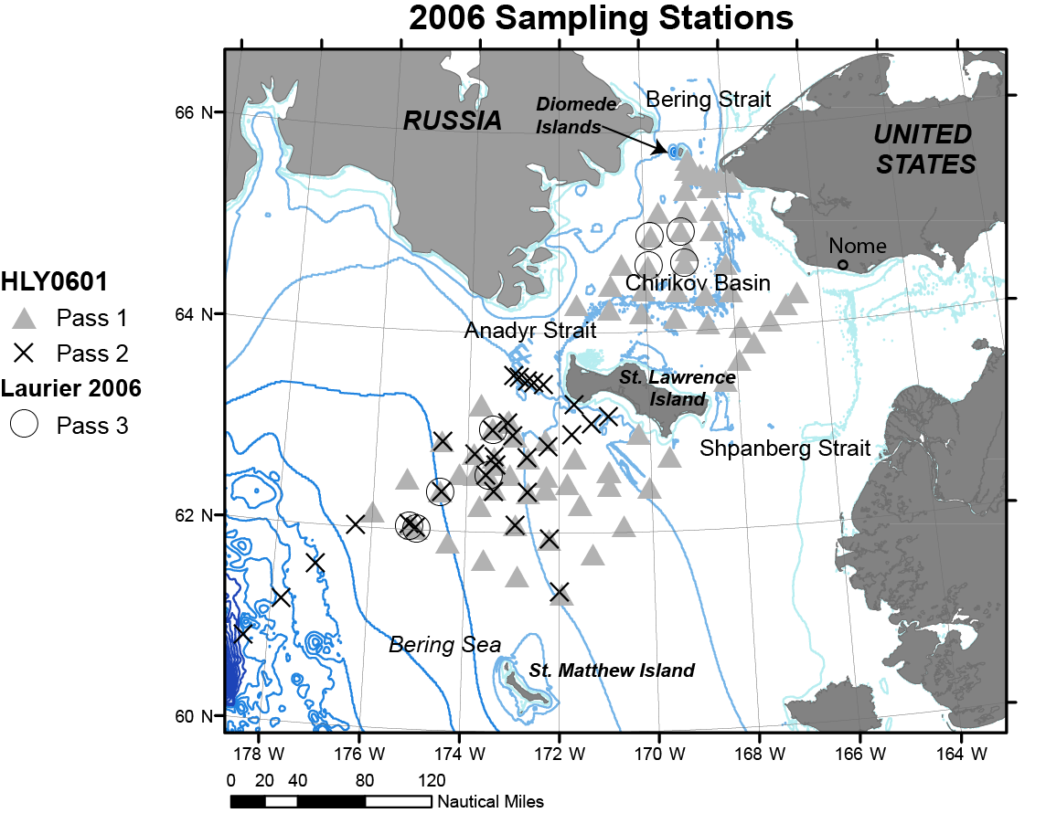Figure 1
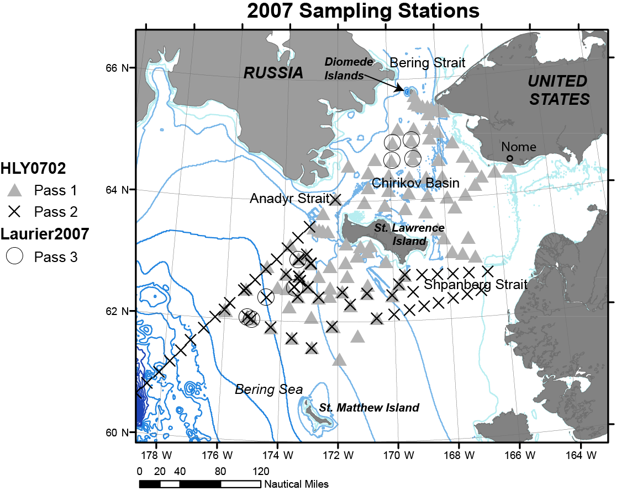Figure 2
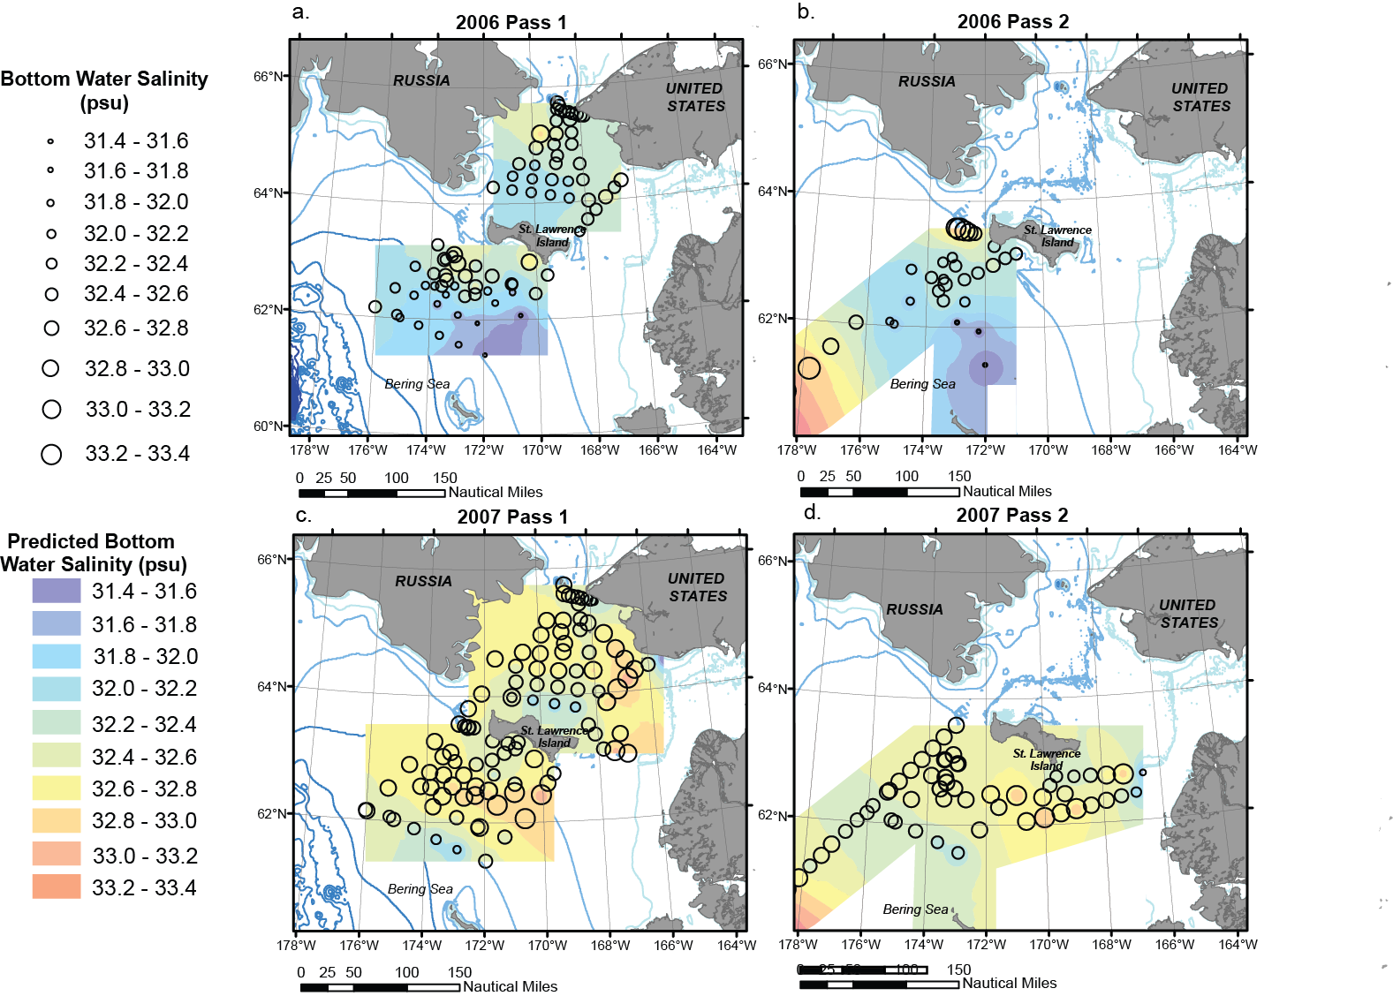Figure 3
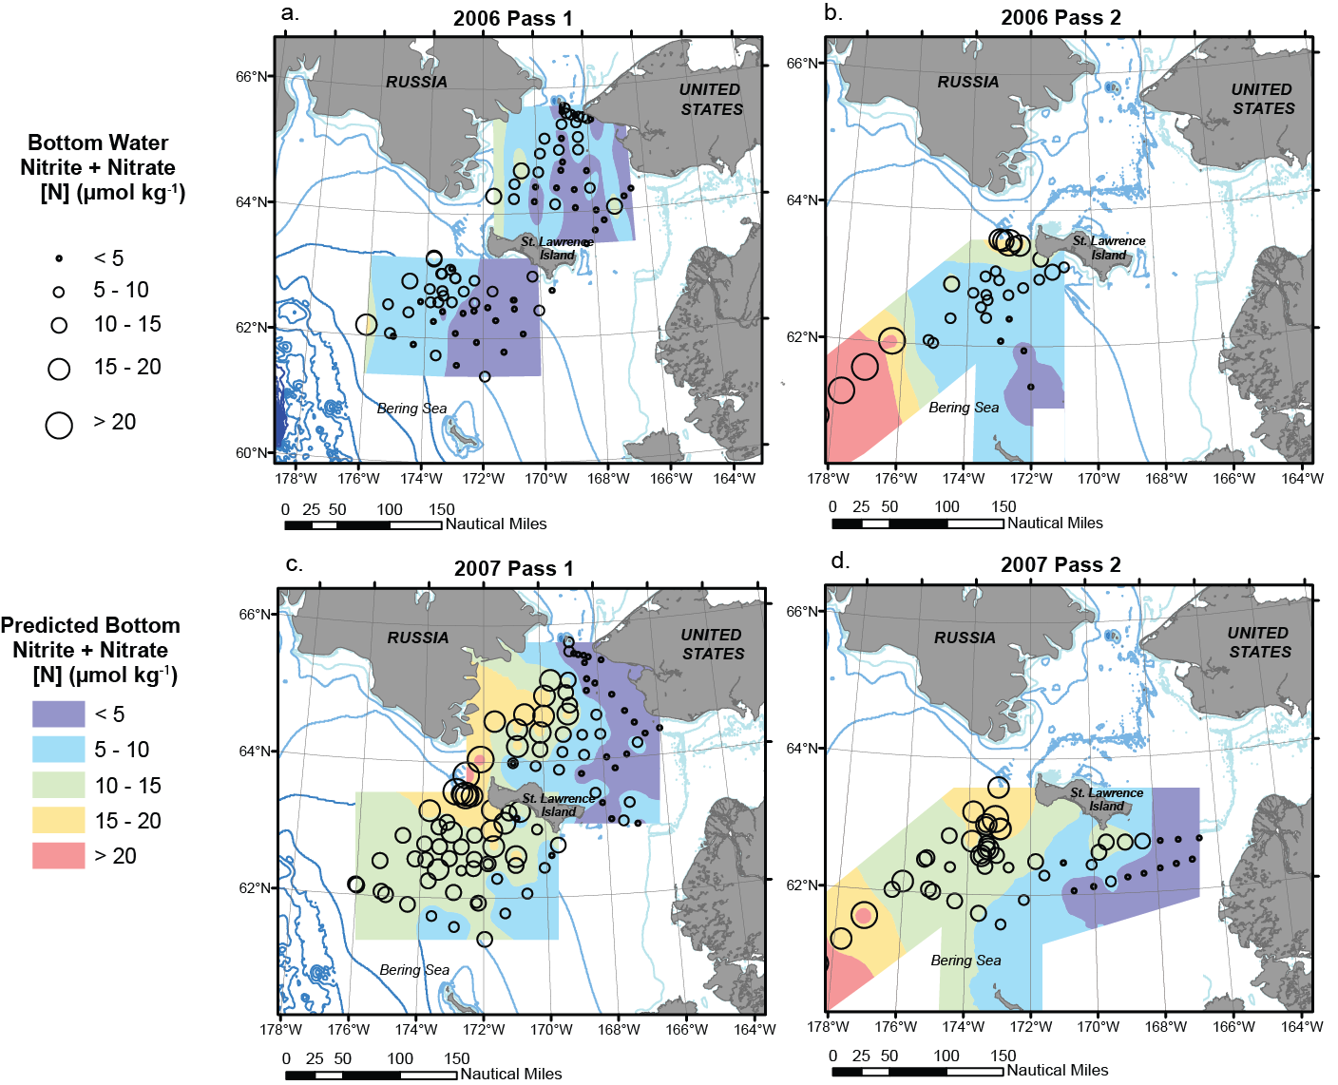Figure 4
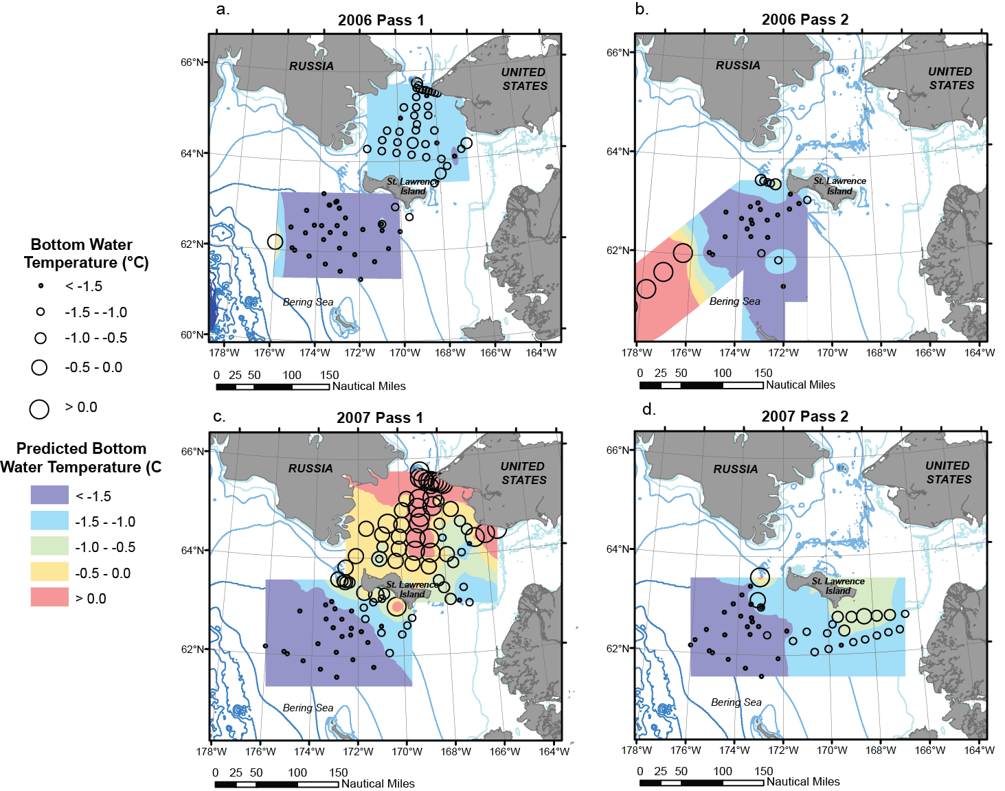 Figure 5
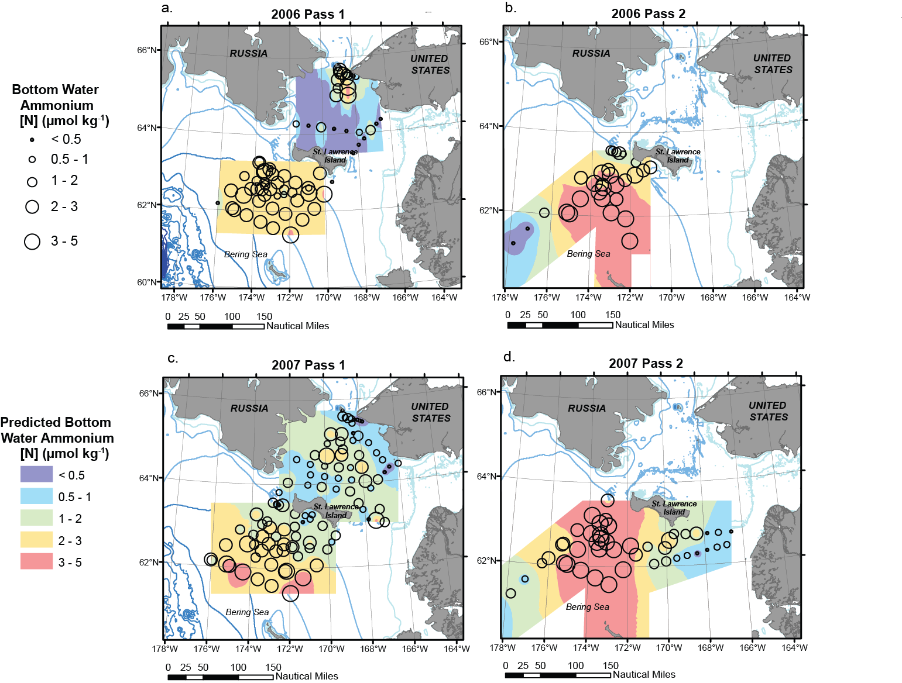Figure 6
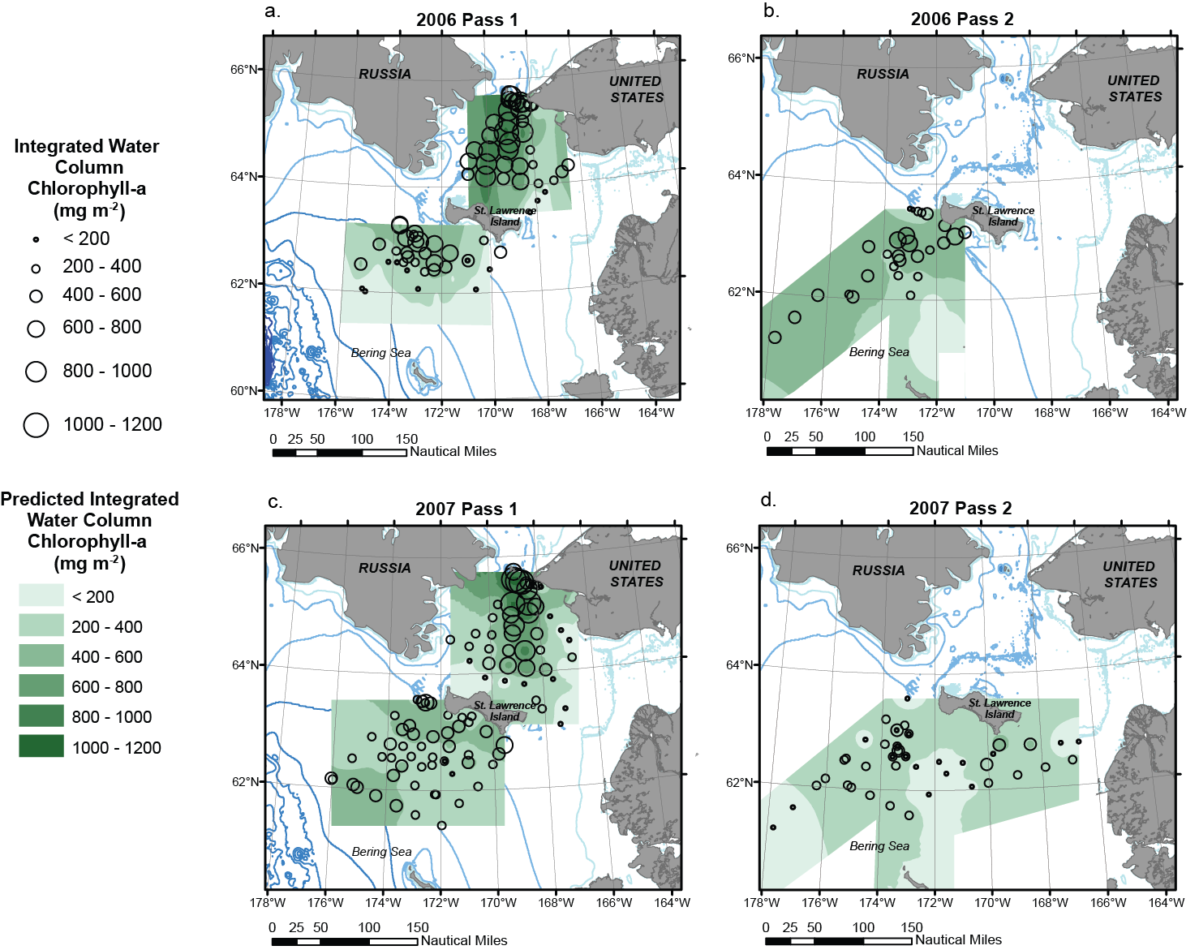Figure 7Fig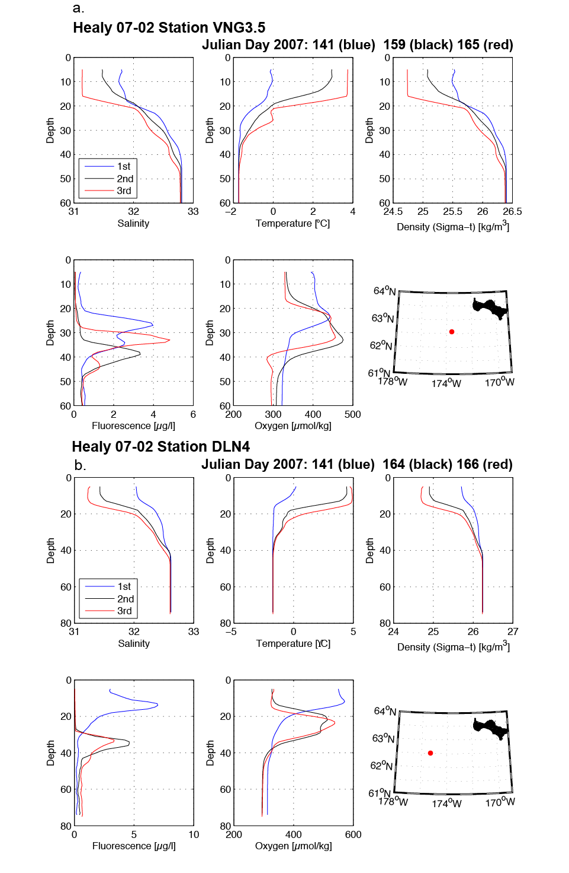Figure 8
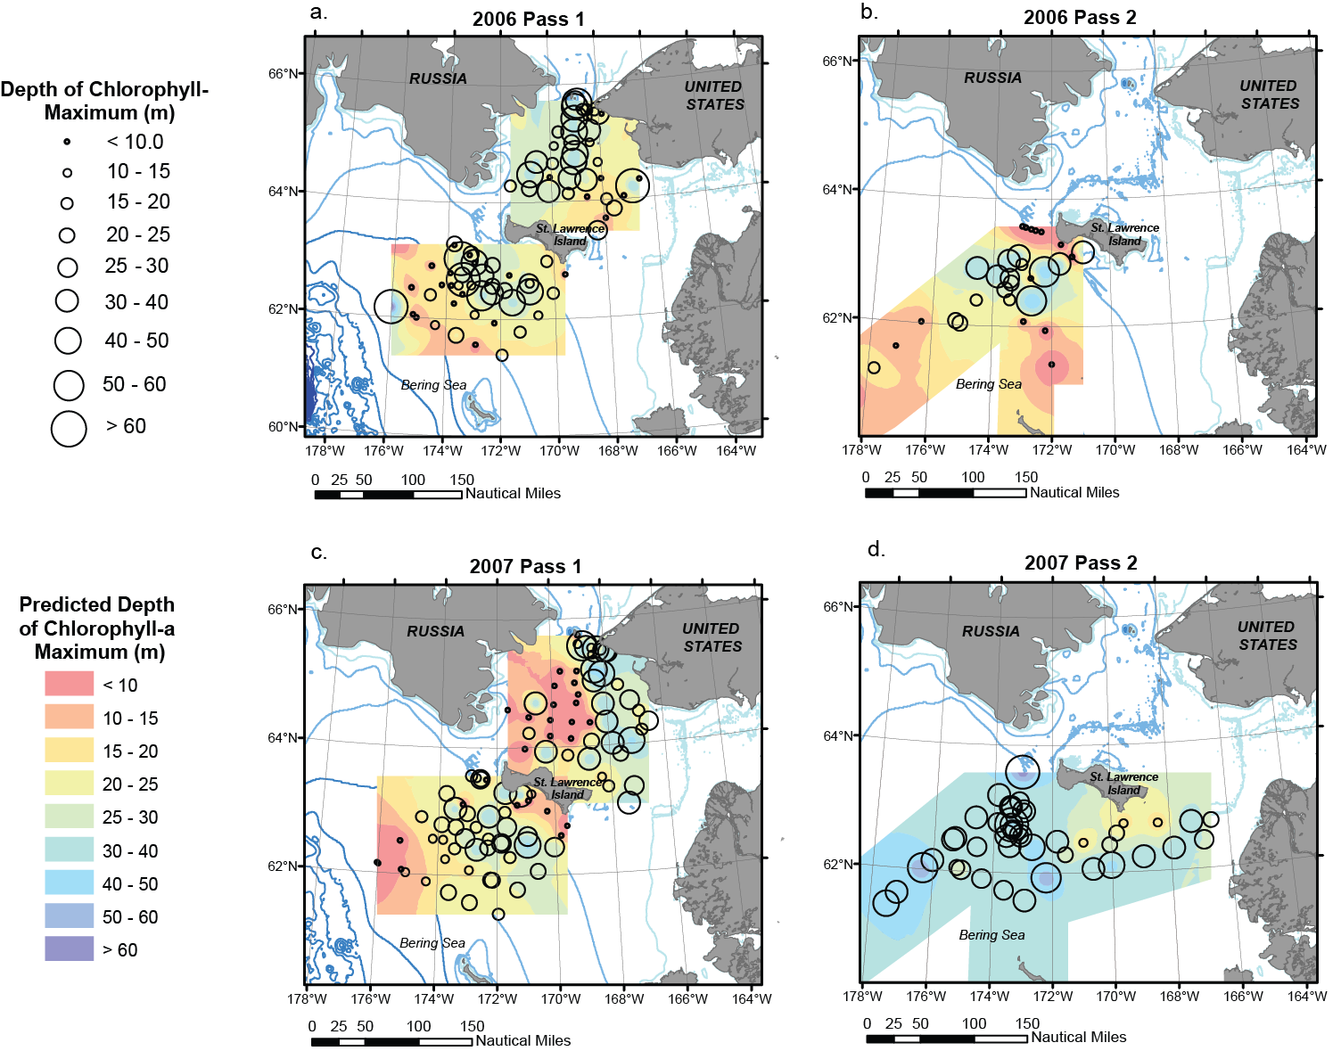Figure 9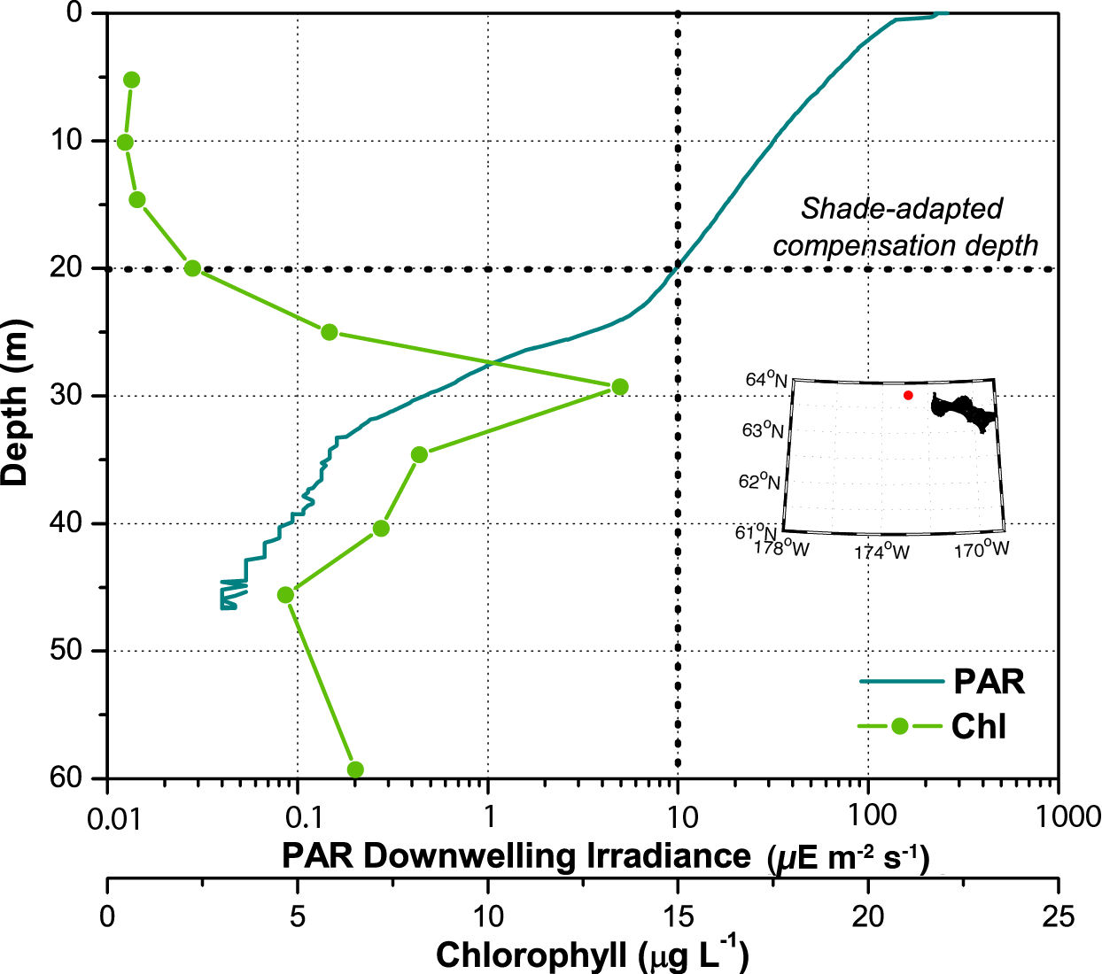Fig 10
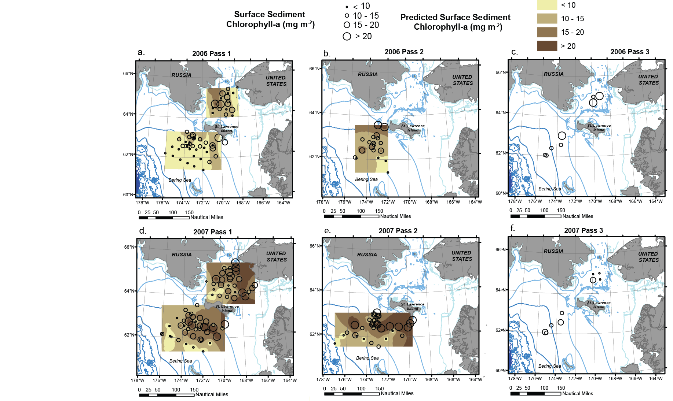Fig. 11
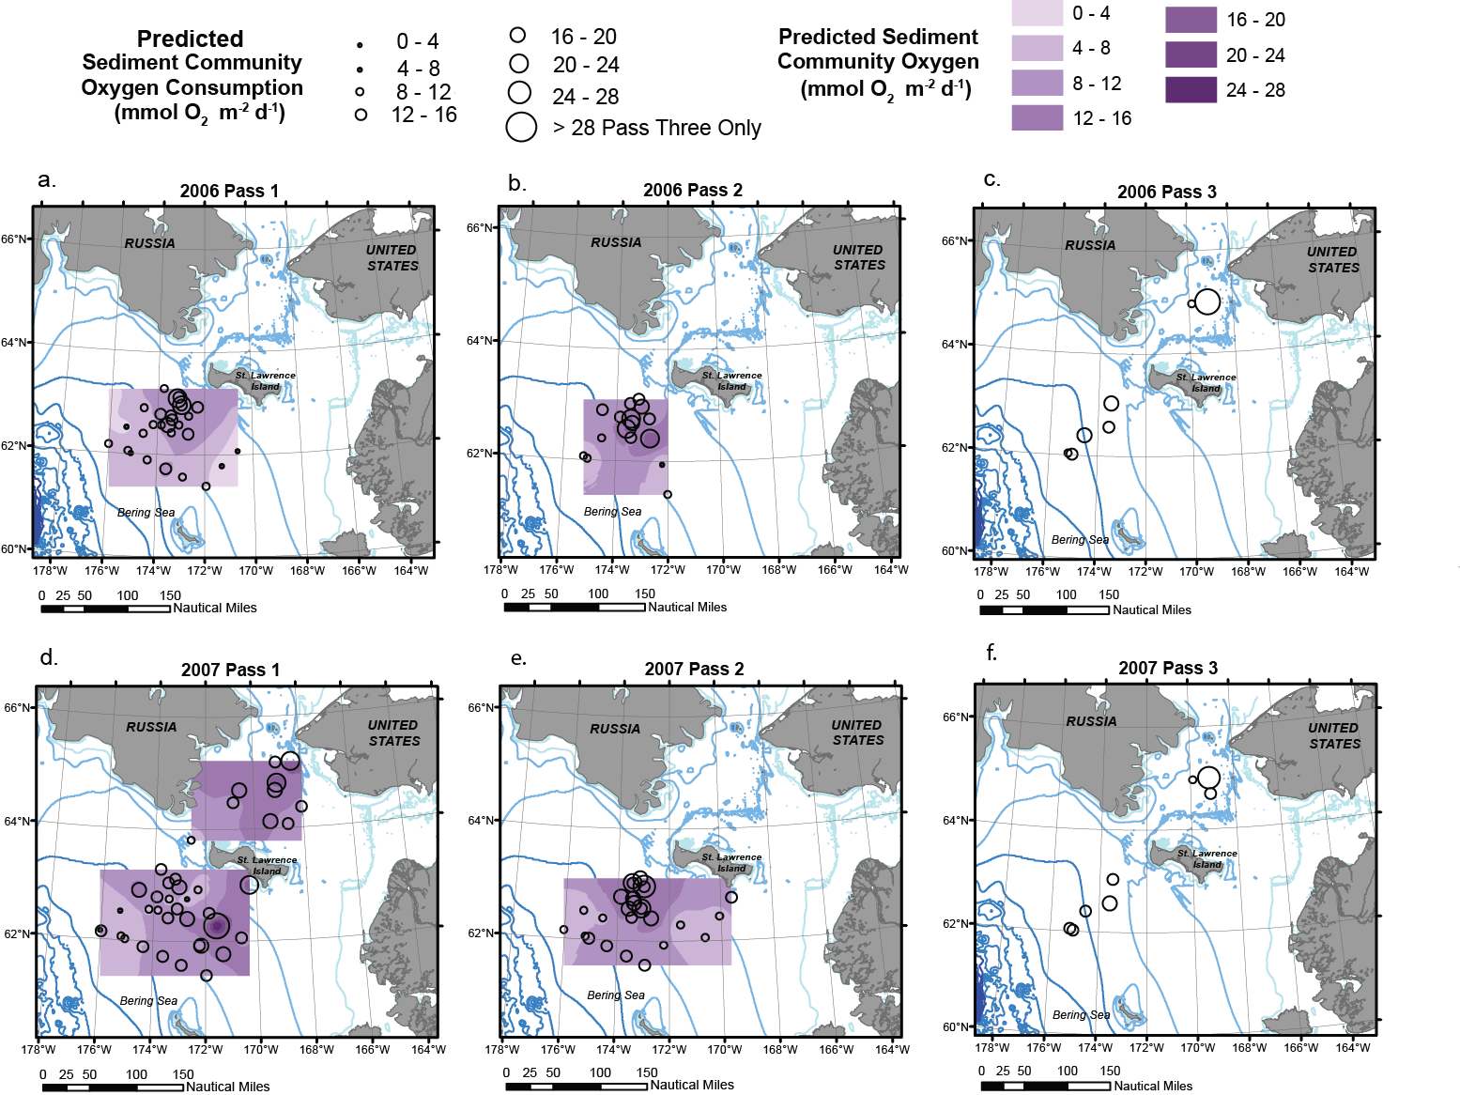Fig. 12
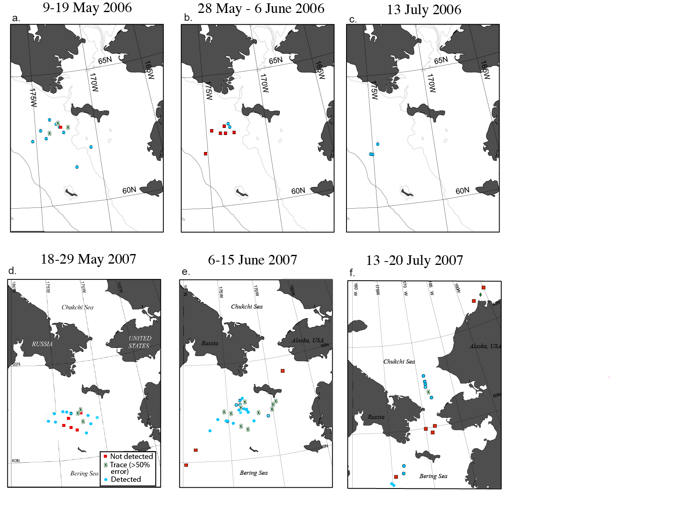Fig. 13
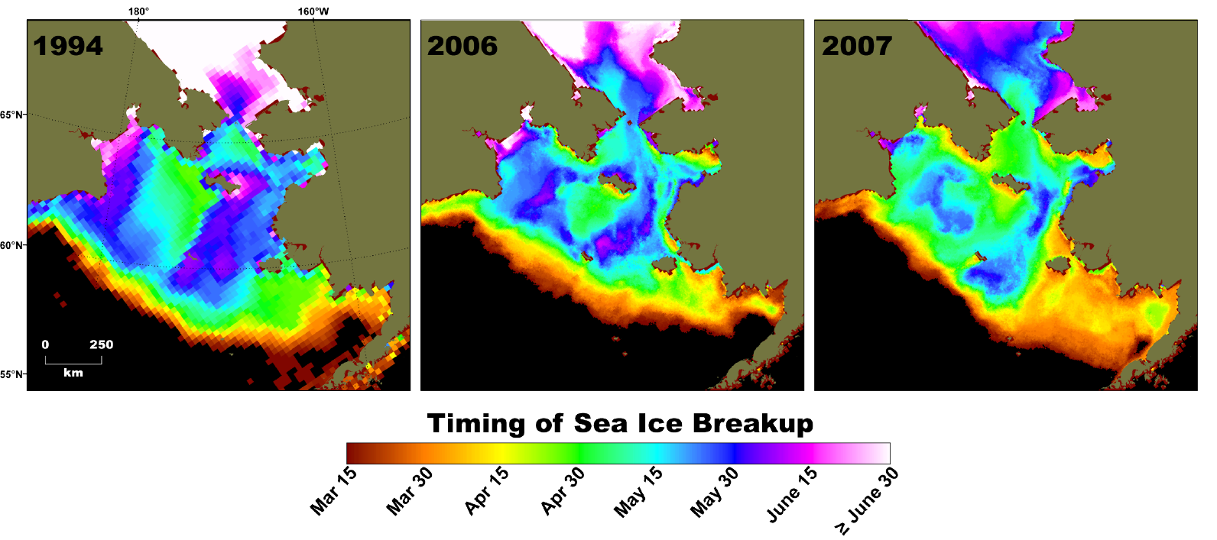Fig. 14
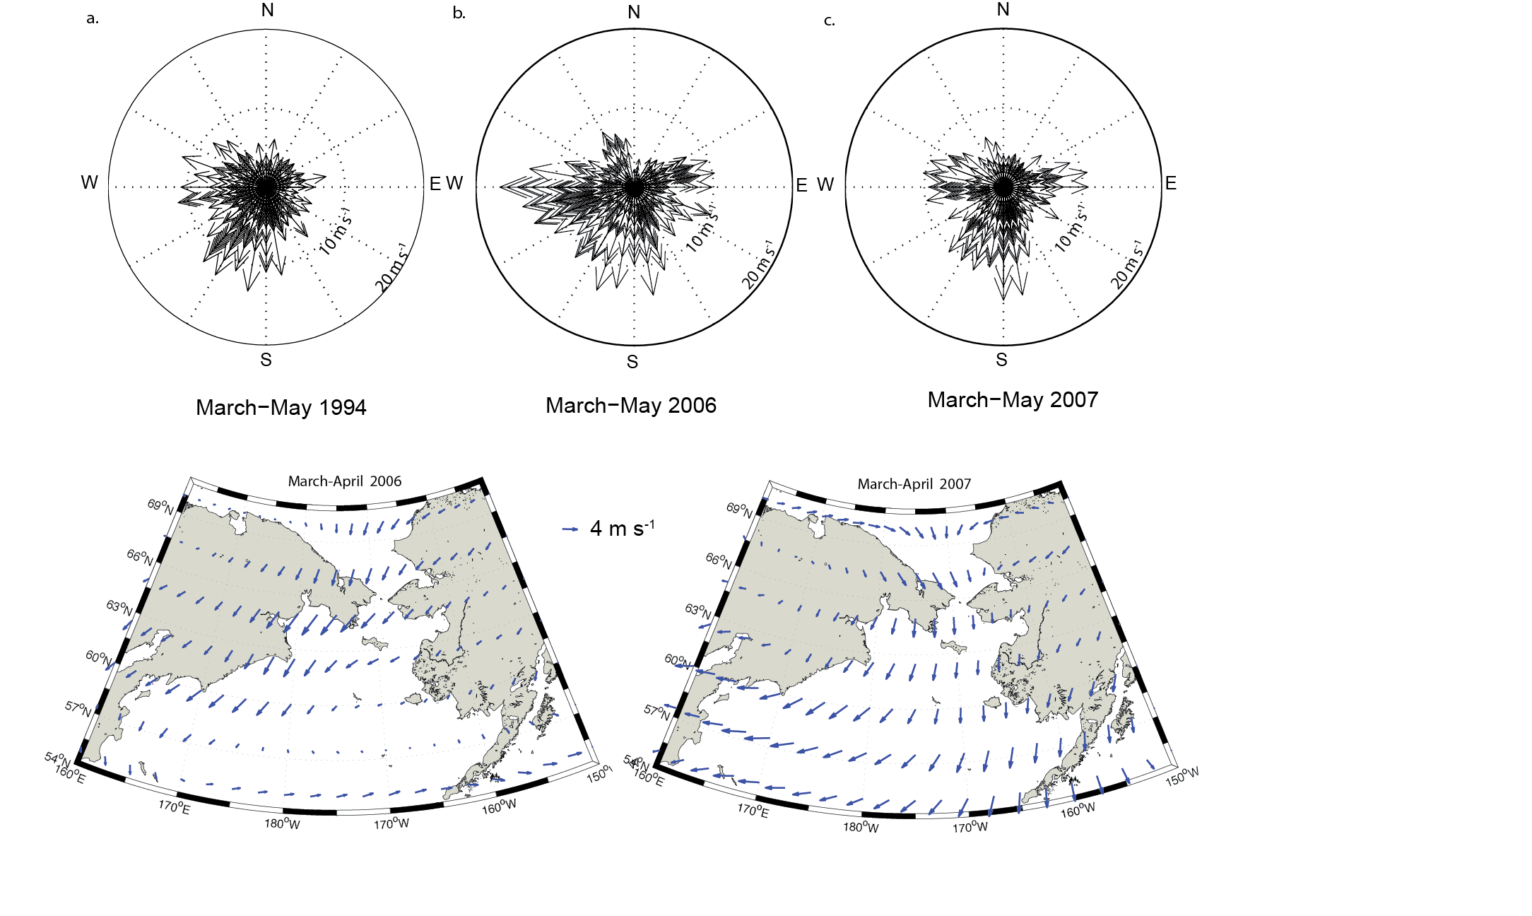Fig. 15
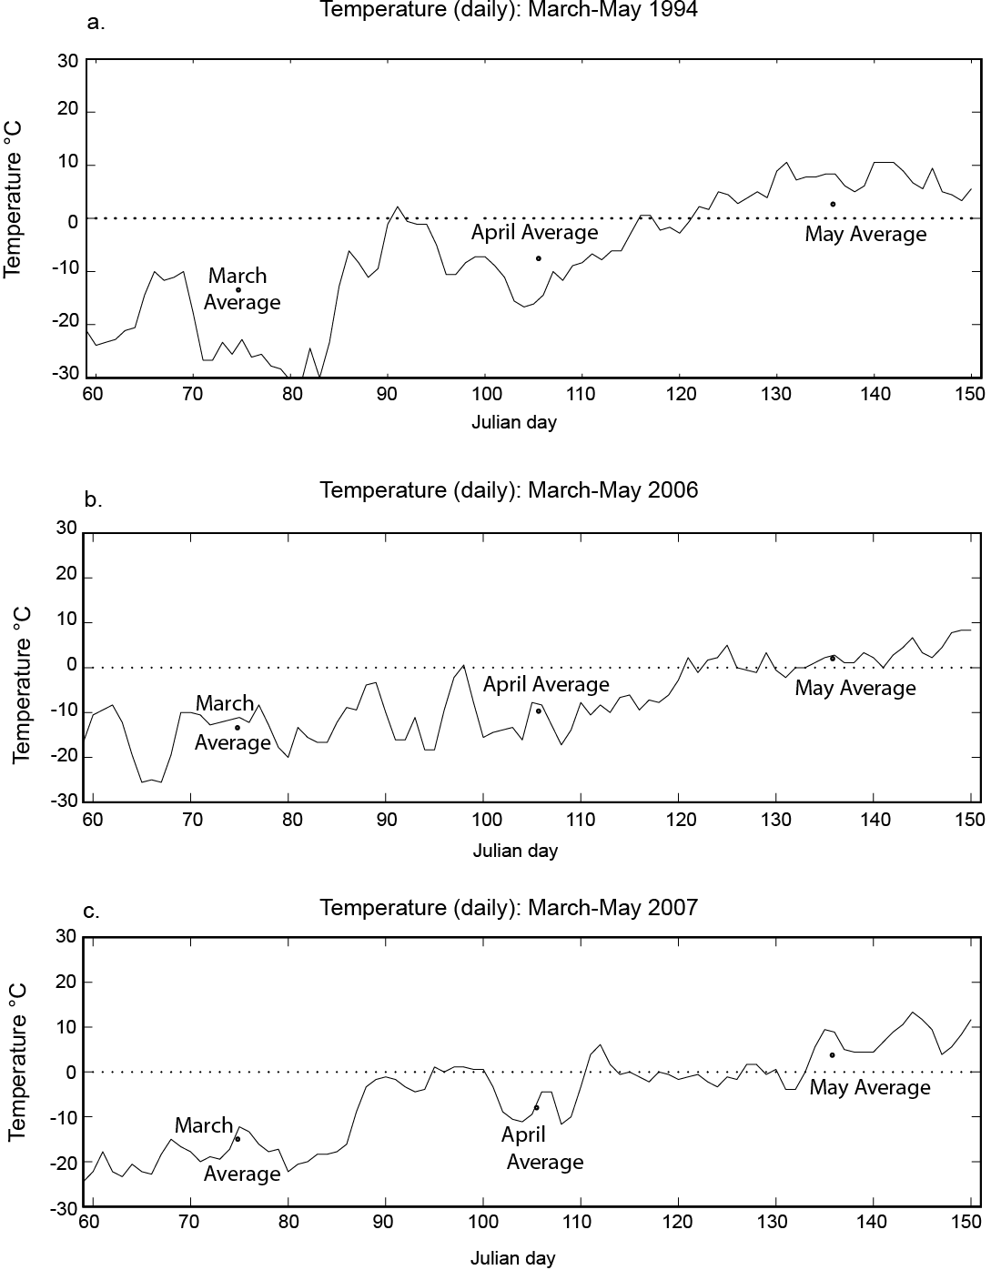Fig. 16

